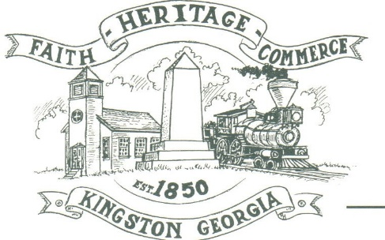
CITY OF KINGSTON
30 West Main St., Kingston, GA 30145
COUNCIL MEETING – CITY HALL
September 13, 2021 – 6:00 p.m.

The meeting began at 6:00 p.m. in attendance was council members, Louise Young-Harris, Michael McFarland, Payton Silvers, Mayor Elbert Wise, Chief T.J. Sosebee, and City attorney Brandon Bowen. Absent was Louise Howell, there was 5 attendees.

The meeting began with Louise Young-Harris leading the invocation. The Pledge of Allegiance followed.

SIGN IN PERMISSION TO SPEAK
None

APPROVAL OF PREVIOUS MINUTES
Michael McFarland made a motion to approve previous minutes. The motion was seconded by Louise Young-Harris. Motion was carried unanimously.

APPROVAL OF AGENDA
Payton Silvers made a motion to approve the agenda. The motion was seconded by Michael McFarland. Motion was carried unanimously.

DDA UPDATE
No update at this time

AUDIT RESULTS-CHRISTIAN HATCH
Christian Hatch presented the audit results to council and all areas are reporting correctly.

APPROVE ELECTION AGREEMENT WITH BARTOW COUNTY
Payton Silvers made a motion to approve the Election agreement with Bartow County. The motion was seconded by Louise Young-Harris. Motion was carried unanimously.

COUNCIL COMMENTS
Charlie Pecchio announced the Back Road Century bicycle race through the city on Saturday, September 18, 2021.
Payton Silvers stated grass cutting getting better, wants to revisit the ARPA fund to give hourly employees a bonus and new hires an incentive bonus in next council meeting.
Louise Young-Harris requested a lunch area for office employees to be added on the next agenda
Mayor Wise Thanked everyone for coming and thanked all the employees for their dedication.

ADJOURNMENT
Payton Silvers made a motion to adjourn at 6:32 p.m. Michael McFarland seconded the motion. Motion was carried unanimously.

_____________________________ ________________________
Mayor Elbert “Chuck” Wise, Jr. City Clerk, Kelly L. Ensley

