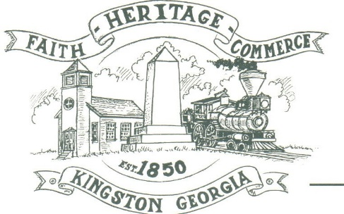
CITY OF KINGSTON
30 West Main St., Kingston, GA 30145
COUNCIL MEETING – CITY HALL
September 14, 2020 – 6:00 p.m.

The meeting began at 6:15 p.m. in attendance was Mayor Elbert “Chuck” Wise, council members, Payton Silvers (Zoom), and Louise Howell, Michael McFarland, Louise Young-Harris, Chief T.J. Sosebee and Attorney Ryan Brumbelow. There were 4 attendees.

The meeting began with Louise Young-Harris leading the invocation. The Pledge of Allegiance followed.

SIGN IN PERMISSION TO SPEAK
Nellie Applin spoke of Herbert “Rap” Dixon the Kingston native to be inducted into the National Baseball Hall of Fame

APPROVAL OF PREVIOUS MINUTES
Louise Young-Harris made a motion to approve previous minutes. The motion was seconded by Michael McFarland. Motion was carried unanimously.

APPROVAL TO CHANGE AGENDA
Louise Young-Harris made a motion to change the agenda on item number 6 to Clean tanks. The motion was seconded by Michael McFarland. Motion was carried unanimously.

APPROVAL OF AGENDA
Louise Howell made a motion to approve the agenda. The motion was seconded by Michael McFarland. Motion was carried unanimously.

AUDIT RESULTS
Lloyd Williamson presented Audit results to council and stated the City was in a good financial position and for the last 3 years the City has had good audits. Michael McFarland made a motion to approve the audit results. The motion was seconded by Louise Young-Harris. Motion carried unanimously.

APPROVAL TO ADOPT COMMUNITY CAT PROGRAMS-ANIMAL CONTROL 2nd READ
Louise Young-Harris made a motion to approve the Community Cat program. The motion was seconded by Louise Howell. Motion was carried unanimously.

APPROVAL TO CLEAN FUEL TANKS AND PUMPS FOR GAS AND PURCHASE A POLE BARN/AWNING
Payton Silvers made a motion to approve the cleaning of the fuel tanks and pumps and to look into an awning/pole barn over tanks. The motion was seconded by Michael McFarland. Motion was carried unanimously.

APPROVAL TO PUT A DRIVE THRU ON CITY HALL
Louise Young-Harris made a motion to put a drive thru on City Hall as soon as the County gets City Hall back into City of Kingston name. The motion was seconded by Louise Harris-Young. Motion was carried unanimously

COUNCIL COMMENTS
Mayor Wise thanked Mrs. Applin for her hard work

ADJOURNMENT
Payton Silvers made a motion to adjourn at 7:36 p.m. Louise Howell seconded the motion. Motion was carried unanimously.

_____________________________ ________________________
Mayor Elbert “Chuck” Wise, Jr. City Clerk, Kelly L. Ensley

