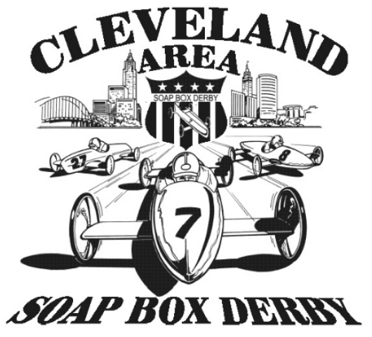
2021 Cleveland Area Soap Box Derby
Championship Race
Entry Form
May 22, 2021

Name Racer #1 ______________________________________________Birth date ___________________

(Circle One); Division Masters Super Stock Stock T-Shirt Size (adult) _____________

Name Racer #2 ______________________________________________Birth date ________________

(Circle One); Division Masters Super Stock Stock T-Shirt Size (adult) _____________

Name Racer #3 ______________________________________________Birth date ________________

(Circle One); Division Masters Super Stock Stock T-Shirt Size (adult) _____________

Address: ___________________________________________________________________________________________

City: ______________________________________State: ____________________ Zip: __________________________

Parent/Guardian Name: ______________________ Phone: ___________________Email:_________________________

Age requirements: Drivers age will be determined by their age on race day. Cannot turn older than upper age before 7/31

Stock - ages 7 –13 yrs Super Stock - ages 9–18yrs Masters – ages 10-20 yrs

Mandatory Car Inspection Thursday, May 20th for all Cars.
Gates open at 5pm must be in line by 6pm.

To be filled out by parent or guardian of the racer:

I, _________________________________hereby grant permission to my son/daughter/ward(s)

______________,________________,_______________, to enter the Cleveland Area Soap Box Derby on May 22, 2021. I will not hold Cleveland Area Soap Box Derby responsible for any injuries that may occur. The CASBD has put in place preventative measures to reduce the spread of COVID-19; however, the CASBD cannot guarantee that you will not become infected with COVID-19. Further, attending any CASBD event could increase your risk of contracting COVID-19.

By signing this, I acknowledge the contagious nature of COVID-19 and voluntarily assume the risk that I (parent/guardian, and/or my son/daughter/ward) may be exposed to or infected by COVID-19 by attending an event that such exposure or infection may result in personal injury, illness, permanent disability, and death. I understand and agree that this release includes any claims based on the actions, omissions, or negligence of the CASBD, its Board, volunteers, participants, or others, whether a COVID-19 infection occurs before, during or after participation in any CASBD sanctioned events.

__________________________________ (parent signature)
Mail check or money order to: Anne Dyer 38567 Misty Meadow Trail N.Ridgeville, OH 44039
Payable to the Cleveland Area Soap Box Derby (CASBD) for following amount:

1st Racer $35. $_________
2nd/3rd Racer $25 (each additional racer in the same family) $_________

Cleveland SBD annual family membership fee $20.00 due $ 20.00
$_________ Total
Contact Joe Markowski with any questions: janssunoco@aol.com 216-970-6564
This form needs to be received by Friday, May 7th to participate.

