Churchill Society of Tennessee
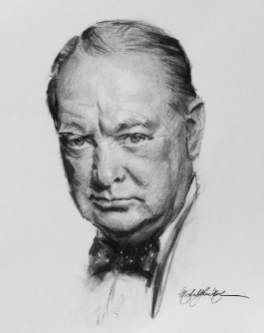
APPLICATION FORM FOR MEMBERSHIP
Please complete this sheet and return to by mail, along with a check for $25 for Annual dues. You will subsequently receive a formal letter of welcome and a membership card.

Name: First, Last
Prefix (Mr. Mrs. MS. Dr. Lord)
Preferred name (This is for the Name Tag)
Name of Spouse or Significant other, including preferred name for the Name Tag
Mailing Address:

Telephone Numbers: Mobile, Fax and Other. (e.g. Home)
Mobile Fax Other

e-Mail address (preferred)

Are you a Churchill Centre member? YES or NO

Mail with a $25 check made payable to CSOT and return to:
Membership Secretary
The Churchill Society of Tennessee,
2009 Overhill Drive
Nashville, TN 37215-3414

