The Coach
and Manager’s Handbook

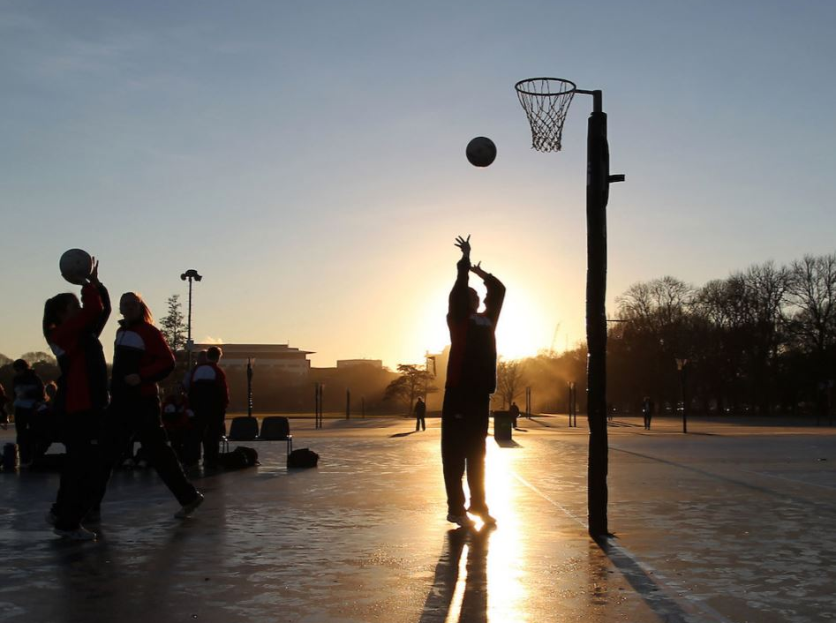

Contents

___

1. Introduction and Contact Details

2. The Team Coach’s Role

3. The Team Manager’s Role

4. Equipment

5. Playing Policy and Values
6. Communication

7. Umpires

8. Local Netball Centre Rules

9. NetballSmart

10. Nutrition, Hydration and Player Welfare

11. Concussion

12. Rules of the Game

13. Game Scoring, Timing and Statistics

14. Health and Safety

15. Netball New Zealand (NNZ) Code of Conduct and Ethics

16. Common Questions and Answers

1. Introduction and Contact Details

Introduction
Welcome to netball at [insert club/school name].

[Insert background information about when Netball was first played, how many teams you have or values that you are proud to uphold, etc.]

Contact
The first point of contact for the [club/school] is [name, position held, mobile number, email].

Other contacts are:
[name, position held, mobile number, email]
[name, position held, mobile number, email]
[name, position held, mobile number, email]

Game Day Contact
There will be a club/school representative at the courts on game day. Please notify us immediately of any incidents at the time that they occur. Go to the control room if an incident occurs and find the club/school representative to come to the court.

Contact number for Game Day
- Contact person 1, phone number.
- Contact person 2, phone number.

2. The Team Coach’s Role

The team coach is responsible for the areas that relate to the on-court environment, from the preparation of players to the team’s performance out on court. The coach will also lead the overall direction and governance of the team. This could involve:
- Player welfare. Player welfare comes first; the athlete’s well-being is always the priority.
- Trainings. Planning, running and reflecting on training sessions and content.
- Position decisions. Deciding which combinations will be out on court and any changes to be made.
- Team talks. Instigating and holding space for the pre-, during and post-game team-talks.
- Game strategy.
- Playing time. Using principles of ‘Balance is Better’ and following the playing policy that is in place.

It is important to work closely with the manager to ensure these roles are clearly defined right from the start of your relationship.

3. The Team Manager’s Role

A key part of the team manager’s role is to be the link of communication between the team, coach, parents and administrators of the [club/school]. Be prepared to deal with the day-to-day matters of the team so the coach is available to coach.

The team manager is responsible for planning and organising the logistics that relate to the team in the off-court environment. This could involve:
- Communication. Keeping players and parents informed of game time and court venue including alerting players to cancelled training/games because of weather.
- Co-ordination. Co-ordinating training times and attendance of players to both trainings and games.
- Administration tasks. For example, [signing the team in on the day].
- Uniform. Ensure that all players are in the correct uniform, fingernails are cut short and that players have removed their jewellery.
- Scoring. For example, [ensuring someone is rostered to score on the day or collecting the scorecard prior to the game].
- First aid, including support of any injured players and the correct injury reporting process.
- Washing. For example, [collecting the playing bibs to be washed after each game].
- Extra players. Assisting the coach with the administrative process to find extra players as required.
A team manager is not involved in any on-court or positional decisions regarding the game. It is important to work closely with the coach to ensure these roles are clearly defined right from the start of your relationship.
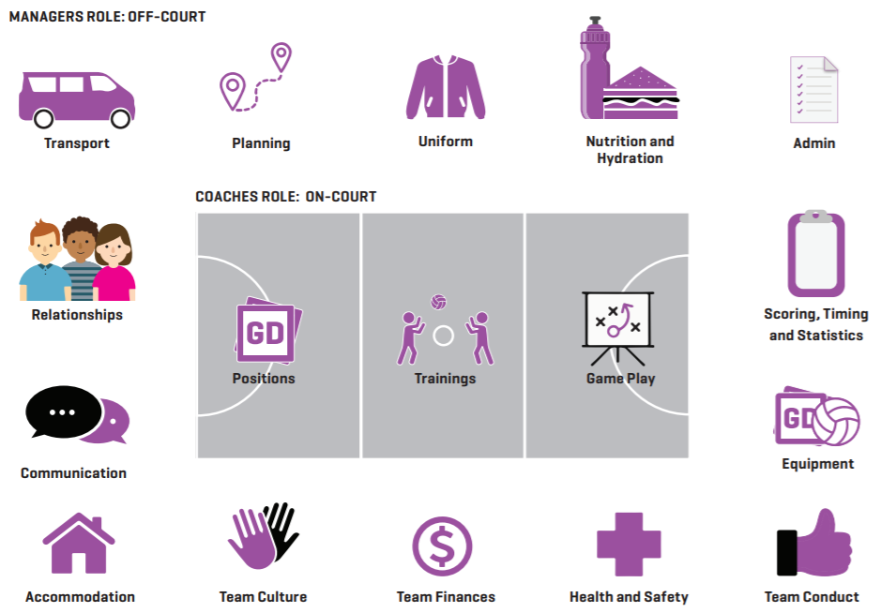
Note: The image depicts some team manager’s tasks but not all of these may be required e.g. transport and finance.
4. Equipment

At the start of the season, you will receive a team ball bag which will need to be returned at the end of the season. It is up to you whether the coach or manager will keep this but take into account that you will need the balls for training sessions.
- 1 set of Velcro game bibs
- 1 set of elastic training bibs
- A stack of cones
- Between 3 and 6 balls
- A small first-aid kit

5. Playing Policy and Values

Our club/school playing policy is [insert your policy here].

NNZ has a junior playing policy ensuring opportunities are provided to all children and young people to develop and enrich their lives through the sport of Netball in a consistent, safe and nurturing environment.

You can find the junior playing policy here: Junior Policy

6. Communication

The main form of communication the [club/school] will use to communicate with you is [email, Facebook, messaging, WhatsApp, etc]. Please note that we are usually available between [8am and 3pm weekdays] and will respond within this time frame.

In terms of communicating with your netball team, there are multiple apps that can be used, e.g. Team Reach, WhatsApp or Heja. It is suggested that you discuss your accepted form of communication at your initial team meeting [including informing parents as needed] so this is clear from the start of the season.

Please make it clear that team messaging should be kept for important and game-related messages only. It is advised you do not enter into a one-to-one conversation over messaging with a young person without their parent being included or stay behind at the end of training with only one player being present. This is for your own safety and peace of mind.

7. Umpires

The umpiring roster for each week will be [emailed to you/posted on our social media page. This will have the name of the person who is umpiring for you, your game time, court and a contact phone number for them].

Umpires are [allocated for Netball games and are paid on the day/paid into their supplied bank account. As a team manager, you do/do not need to pay them].

We have a back-up system in place to ensure you do have an umpire on the day which is [explain umpire back-up system here].

If an umpire does not show up, [please contact the dedicated game-day contact as previously mentioned].

8. Local Netball Centre Rules

Currently, our local Netball Centre has the following requirements:
- Sign in. [Before every game you must complete the team attendance on the Centre database].
- The team bench. [The area is the motorway side of all courts. This space is for the team, coach, manager and scorers. All parents and spectators are to stand on the opposite side of the court].
- Injury time. [If an injury occurs on court, you have 30 seconds to get that player off court and put another player on. The injured player must indicate to the umpire that they need to come off. The game does not stop for any longer than 30 seconds, unless it is a serious injury and the player cannot be moved from the court].
- COVID-19 [You may like to include any current COVID-19 requirements as needed. These are subject to change].

9. NetballSmart

In an effort to reduce Netball-related injuries, we encourage you to use the NNZ’s NetballSmart Dynamic Warm-up at all times for all teams. There are some different versions available including a Year 7 & 8, umpire, power (short and sharp) and social warm-up.

NetballSmart Dynamic Warm-up: NetballSmart Warmup

You can watch an intro to the warm-up video by signing into the NNZ Sport Tutor here: Warmup video

Smart tip: Contact your local NetballSmart Development Officer to book in a session for your school/team. Contact your local Netball Centre or check the NetballSmart website for a current contact list.

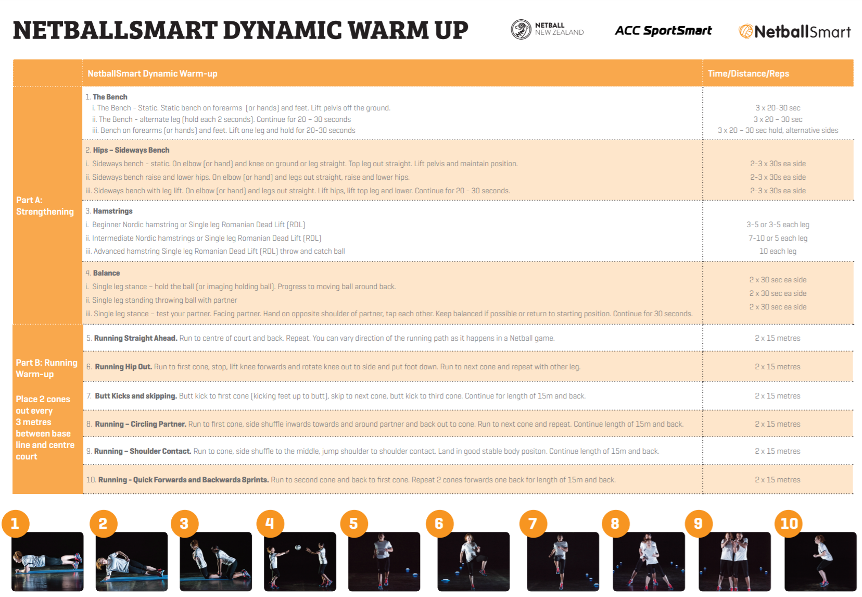

10. Nutrition, Hydration and Player Welfare

It is good for us to remember that player welfare comes before winning at all times. Please encourage the players to take responsibility for their pre-, during and post-game hydration and nutrition. Small helpful ideas such as having a drink bottle holder or dedicated time to sit and eat after the game together will help get players into a positive routine. Reminding them of this or having someone taking care of post-game snacks could be useful.

In terms of player welfare, please ensure you consider players’ mental, emotional as well as their physical well-being. A doctor or physiotherapist’s clearance and return to play is standard procedure following an injury. A simple check in of 1 to 5 by a show of hands at the start of training or a game can give a quick overview of where players are. You may like to follow up individually later with anyone who reveals they are feeling like a 2/5 or lower. Building a positive and trustworthy relationship from the start should increase the amount people are willing to share.

Smart tip: Contact your local NetballSmart Development Officer to work directly with your team to improve performance, injury prevention and player well-being. Contact your local Netball Centre or check the NetballSmart website for a current contact list.

The NetballSmart website has a large selection of resources for teams from NetballSmart Dynamic Warm-up, the Six Principles, through to Recovery and Nutrition.

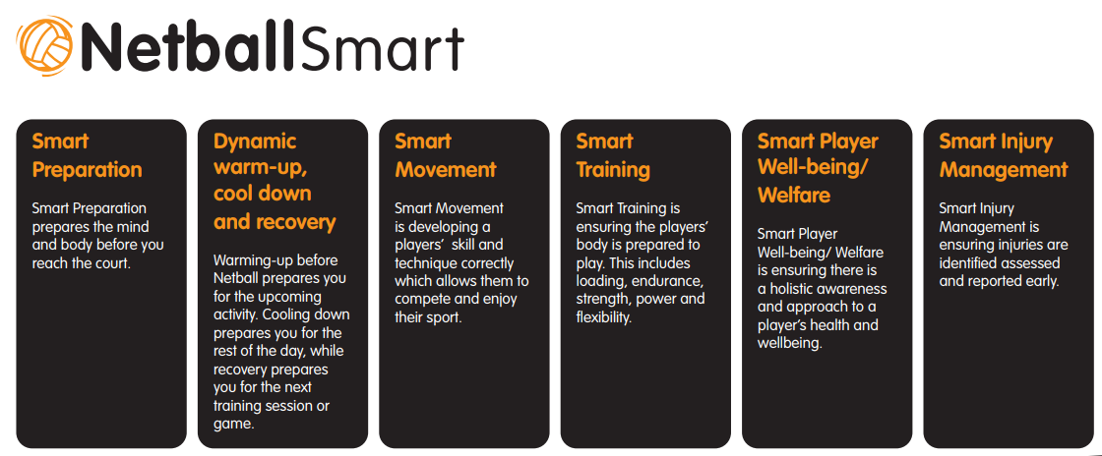

You can find more awesome NetballSmart resources here: NetballSmart resources

11. Concussion

Concussion can vary in degree of seriousness; however, any suspected concussion should be treated as concussion until diagnosed by a medical professional. Please take this seriously and if in doubt, remove a player from the court.

[Insert your Return to Play club/school regarding concussion here.]

NetballSmart has published Netball-specific Concussion Guidelines here: Concussion Guidelines

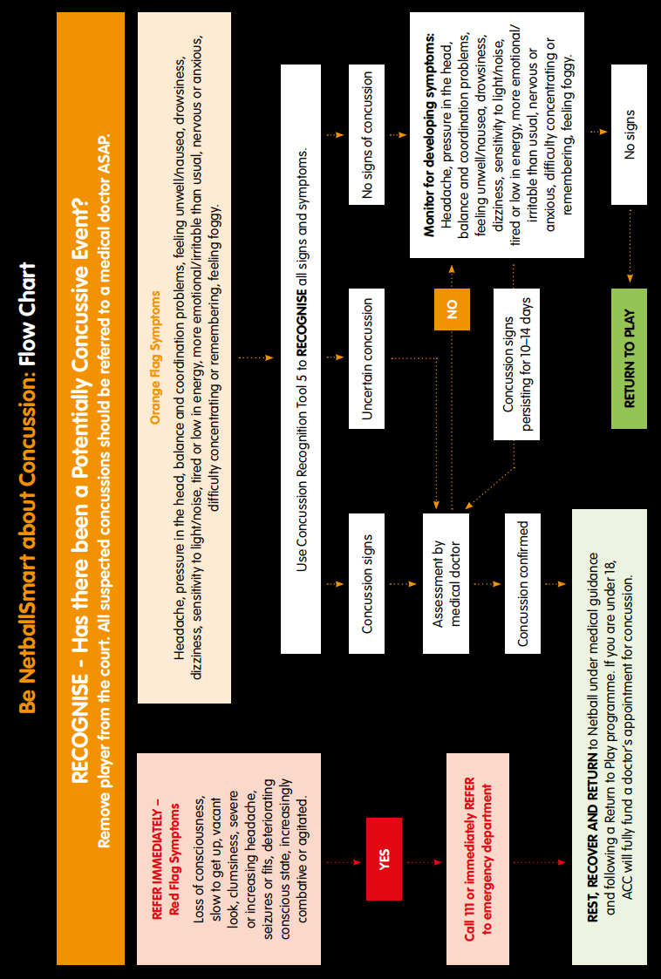

12. Rules of the Game

Rules
It is helpful to have a good, basic understanding of the rules of the game. World Netball has produced an app which you may like to look at. You can find a copy of the rules, as well as a great ‘Introduction to Umpiring’ resource, on the NNZ website.

Uniform
The team should all be in the same sports uniform [specify uniform]. Team management should ensure that they are regularly reminding players about wearing the correct uniform. Check with your local Centre as to specific safety rules around jewellery and taping.

13. Game Scoring, Timing and Statistics

Team management need to understand the basics around scoring and timing a Netball game at your required level.

Game scoring
A demonstration of scoring and timing can often be provided by the Centre/club/school or an umpire. Be aware that different competitions (and often tournaments) may use different methods of scoring and timing. Discuss whether the coach or manager (or parents) will be responsible for scoring.

Timing
Timing game breaks enables the coach and players to ensure they are ready to take the court at the appropriate time to recommence play. Team managers, discuss with your coach if this is needed and if so, how they like to receive time updates during breaks, e.g. a tap on the shoulder or calling out the time left in the break once there is 30 seconds remaining.

Statistics
Collecting game statistics is something some teams will do, although this typically applies to higher-level teams. It is advised that you have a discussion at the start of the season to identify your need and expectations around game statistics. There are statistic templates you can download available on the NNZ website.

14. Health and Safety

Please ensure you are familiar with our [clubs/schools] health and safety policies and procedures.

[Insert club/school’s Health and Safety Policy here. Ensure the process for who to report to and when is understood in the instance of a serious incident, accident or health and safety concern.]

The following is a list of some of the aspects that may need to be addressed during the season:

- Players’ health conditions and contact details (next of kin or parent)
- Unsafe environment; potential risks/hazards
- Illness
- Injury
- Potential impact of COVID-19
- Breaches of team conduct – lateness, negativity, misconduct
- Traffic issues affecting players getting to/from trainings and games
- Last-minute changes to training location or allocated game court

Regardless of how much organisation and planning is done, due to the nature of any team
environment there may be aspects that don’t go to plan and are out of your control. Be as prepared as you can be and know when to escalate a situation and ask for help.

15. Code of Conduct and Ethics

Regardless of your code of conduct established by your [club/school], all players, coaches, team managers, umpires and match officials fall under the NNZ Code of Conduct and Ethics. All team managers should be familiar with the following information.

CODE OF CONDUCT AND ETHICS

As a member of Netball New Zealand (NNZ), you must meet the following requirements in regard to your conduct during any activity held by or under the auspices of NNZ, a Zone or a Netball Centre and in any role you hold within NNZ, a Zone or a Netball Centre:

1. Respect the rights, dignity and worth of others.
2. Be fair, considerate and honest in all dealings with others.
3. Be professional in, and accept responsibility for, your actions.
4. Make a commitment to providing quality service.
5. Demonstrate a high degree of individual responsibility, especially when dealing with persons under 18 years of age.
6. Be aware of, and maintain an uncompromising adhesion to, NNZ standards, rules regulations and policies.
7. Operate within the rules of Netball, including national and international guidelines which govern NNZ, the Zone and Netball Centres.
8. Understand your responsibility if you breach or are aware of any breaches of this Code of Conduct and Ethics.
9. Do not use your involvement with NNZ, a Zone or Netball Centre to promote your own beliefs, behaviours or practices where these are inconsistent with those of NNZ, a Zone or a Netball Centre.
10. Wherever possible, avoid unaccompanied and unobserved activities with persons under 18 years of age.
11. Refrain from any form of abuse towards others.
12. Refrain from any form of harassment towards, or discrimination of, others.
13. Provide a safe environment for the conduct of any Netball or Netball-related activity.
14. Show concern and caution towards others who may be sick or injured.
15. Be a positive role model.

16. Common Questions and Answers

- What do I do if I forget my ball bag or bibs on game day?
Stay calm. There are other Netball teams around that you could potentially borrow gear from. [There is a game-day supervisor at the courts who will be able to help you out too. The Netball Centre control room also have extra bibs if needed - please ensure all borrowed gear is returned as soon as your game is finished].
- What do I do if only six players arrive to play?
These things happen. The rules state that you can start the game with fewer players than required - a minimum of five players is needed. Remember to fill out the team card with any extra players that you use. Extra players must come from a lower-graded team. Check with your local Centre but you can generally use the same fill-in player twice before they become a member of your team permanently and cannot move back down.
- What do I do if only a few players turn up to training?
Setting clear expectations at the start of the season should prevent this from occurring. Be prepared for this during the season and have some activities that only need three to four players, e.g. practise getting free or one-on-one defence.
- What do I do if a player is continually missing practice, but turns up to play the games?
Firstly, talk to the player and ask for the reason as to why they are not showing up to training. If they do not have a reason, calmly and politely let them know that you expect them to be at the next training. If you do not feel comfortable doing this, notify the [Club President/Sports Department] and get them to do it for you. This should be avoided if you set ground rules and expectations from the start of the season.

- What do I do if I have injured players but they come to training?
Commend the players for still making the effort to get there. You are still able to use them in your training as a post or passer and involve them in team-talks. You may still be able to walk them through team tactics, depending on the severity of their injury. Player welfare comes first at all times so use your best judgement in each circumstance.
- What do I do if a parent on the sideline of a game questions what I am doing or sends me an email?
If this does happen, please reply that you cannot currently talk to them about this at this time and would be happy to set up a meeting with the [the Club President/Sports Department]. Please do feel free to speak to us if you are ever unsure of the process. We are here to support you in your role.

