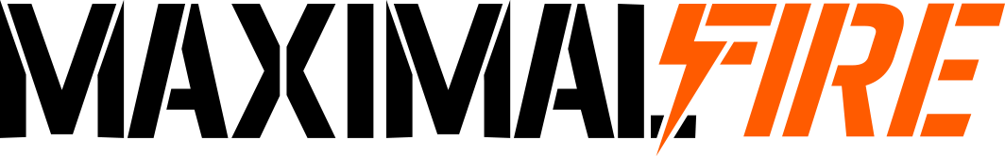Legions Imperialis
Tournament

EVENT ESSENTIALS
Date: 9th and 10th May 2026
Location: Entoyment Wargaming Centre, Poole
Game SYSTEM: Legions Imperialis
REGISTRATION: Saturday 8:30-9am
ARMY Size: 3,000 Points
Game Length: 3 Hours +15 minutes Deployment
Board Size: 5’x4’
Number of Games: Four
MISSIONS: Matched Play Missions from the Legions Imperialis Rulebook
TOOLS OF WAR: Attendees are expected to bring their army, dice, a tape measure, minimum of 3 objectives each, tokens and a copy of their army list
AWARDS: 1st, 2nd and 3rd, Master Artificer Award (Best Painted), Esteemed Princeps (Best Sport) and Wooden Spoon.
Painting & modelling: All models should be painted with at least three colours, and based as standard. All models should clearly represent their entry in your army roster
List Submission: Best Coast Pairings is planned to be used for event placements and scoring. As such you must sign up to the event on Best Coast Pairings in advance of the event (please download the app in advance) and submit your Battlegroup roster via the app no later than midnight Sunday the 3rd May 2026.

EVENT TIMETABLE

DAY ONE:
08:30 - 09:00: REGISTRATION
09:00 - 09:15: WELCOME/INSTRUCTIONS
09:15 – 12:30: GAME 1
12:30 - 13:30: LUNCH (Painted Comp Entries)
13:30 – 13:45: Break for ADMIN
13:45 – 17:00: GAME 2
17:00: GO HOME

DAY TWO:
09:00 - 12:15: GAME 3
12:15 - 13:15: LUNCH
13:13 – 13:30: Break for Pairings
13:30 - 16:45: GAME 4
16:45 – 17:00: Break for ADMIN
17:00- 17:30: AWARDS
17:30: EVENT ENDS

EVENT SPECIFICS
The Maximal Fire Legions Imperialis Tournament is a two day, four game individual tournament event run at the Entoyment Wargaming Centre in Poole. This is a Swiss style Tournament Matched Play event utilising the Matched Play rules from the Legions Imperialis Rulebook.

SCHEDULE: Players will play 4 games over two days. Each game will last for 3 hours plus an additional 15 minutes for set up and deployment (3 hours 15 minutes per round accordingly). After finishing Game 1 on Day one, anyone wishing to enter the Best Painted Competition should arrange their army on their table with their name clearly indicated in front of their models. Players are encouraged to look and choose their favourite army (not including their own) during the Lunch break of Day 1 to cast their Best Painted vote.

LATENESS: It is not acceptable to be unreasonably late to the start of the event. This not only impacts your own enjoyment of the weekend but also damages your opponent’s enjoyment as well. If you are more than 15 minutes late to arrive for the start of the round then your game maybe forfeited with an automatic win assigned to your opponent. Obviously, some situations are unavoidable and we understand that problems may arise. If you anticipate lateness to the start of a round, please contact the TO’s as soon as possible. The TO’s may take this into account if your opponent is happy to continue to wait for your arrival.

ARMY CONSTRUCTION: Players must select one 3,000 point army following the rules for Mustering an Army that can be found in the Legions Imperialis Rulebook. Each players army list should be presented in a clear format with all relevant weapon selections and detachment upgrades along with anything else that should be selected prior to a game.

MODELLING AND PAINTING: Legions Imperialis is a game with a strong narrative pedigree. Although this is a tournament it is expected that all players provide fully painted and based armies which have been painted to the Games Workshop Battle Ready Standard. This means their main areas painted and a simple finish on their bases as a minimum. Physreps are permitted however it should be obvious and pointed out to your opponent what those are meant to represent. Physreps which are not GW standard should be the same size as the existing range with no modelling for advantage. If your model is taller or shorter than the equivalent model its adjusted size should be ignored and played as if they are of the intended height. TO’s reserve the right to make rulings where this is not obviously apparent. Titans and Knights can be based on either the Legions Imperialis Bases, or original Adeptus Titanicus bases. This is not considered to be modelling for advantage.

PAIRINGS: Your Opponent for your first game will be randomly selected. Subsequent rounds will be paired based on a swiss style system. If you find yourself playing against an opponent you have already played, please contact a member of the TO team.

SCORING: At the end of each round, please enter your results into Best Coast Pairings. These will then be used to calculate the event standings.

TOOLS OF WAR: The Event will provide tables and terrain. Players are expected to bring everything else they require to play each game including:
- Their Army.
- All necessary dice
- A tape mesasure
- A copy of any required rulebooks and publications
- Any required Status Markers and order counters.
- A mobile device with Best Coast Pairings downloaded onto it (with an active account).
- A physical copies of their Army roster.
- At least three 32mm Objective Markers.

TABLE TERRAIN: The tables at our event are laid out to provide interesting and narrative challenges to people playing on those boards. Some tables will be more densely populated than others and this is intentional. Although we attempt to set up what we would consider to be a “fair” table to play on, will not be perfectly balanced. It is the responsibility of both players to agree before the game starts what type each item of terrain represents, however, as a rule of thumb these will have been set out with the following intentions:

- Blocking Terrain: Any complete building, silo, rock, tall ruin or similar. Anything that physically blocks line of sight. You cannot shoot through the middle of blocking terrain even if there are items which allow you to see through (ruined windows etc.). You must consider the terrains silhouette when drawing line of sight.
- Difficult Terrain: Rubble, River style features, pools, pipes or craters.
- Impassible Terrain: Is a feature we avoid adding to tournament tables. No item should be considered impassible.
- Obstructing Terrain: Areas of ruins, and terrain features which have a defined ‘footprint’ including woodland and craters.
- Obstacles: Low walls, tank traps, pipes, small low sections of scatter terrain.

If both players agree they can make small changes to the terrain format such as moving items or removing items. If any change to the table is made it MUST be returned to how the table looked prior after the game is concluded. Any handling of the terrain must be completed with care and any breakages immediately reported to a TO.

PLAYER CONDUCT: Legions Imperialis is a game of fictional sci-fi toy soldiers. All participants are expected to act in a mature and courteous manner and arguments and poor sportsmanlike behaviour will not be tolerated. In the event of disagreement either roll a D6 and let the dice decide the interpretation or alert a Tournament Organiser to request mediation and a ruling. TO rulings are final and must be accepted, they may not get it right in the heat of the moment but this should be accepted and respected. The TO’s reserve the right to issue warnings to players for poor behaviour should it occur, which may include black listing from future Maximal Fire events. Everyone is here for a weekend of dice throwing and playing games. In the words of Shakespeare “DON’T BE A DICK”.

LOCATION INFORMATION

LUNCH: Entoyment offers a selection of food that can be purchased and eaten on location. Alternatives are available a short walk away from the location.
PARKING: Entoyment has limited parking on site. Usually, the building next door allows tournament players to use their parking at the weekends. Where possible please park there unless notified. This ‘overflow parking’ is the entrance immediately before Entoyment on the right.

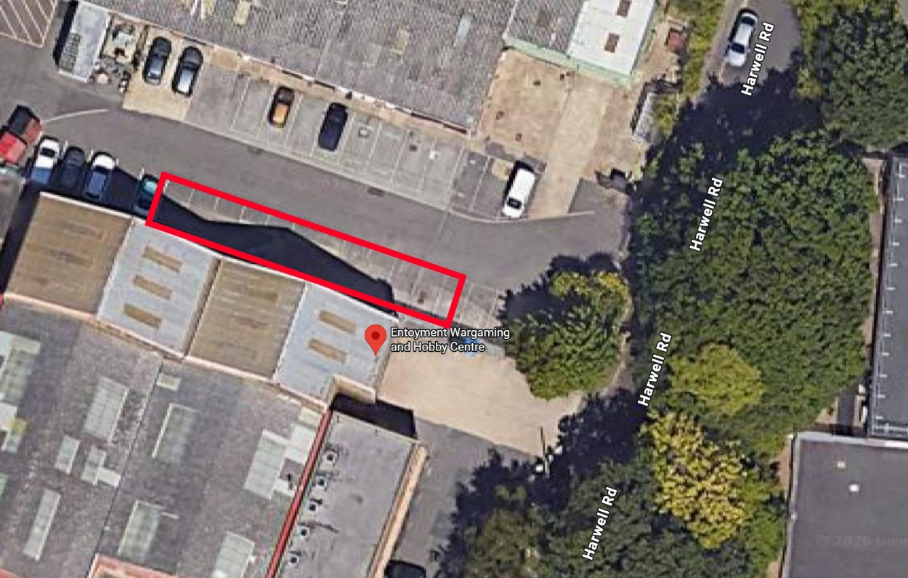

CONTACT INFORMATION

EMAIL: MaximalFire@gmail.com
PHONE (In an Emergency only): 07590 841428
DISCORD SERVER: https://discord.gg/BugEUrRx

