Silverleaf POA Meeting Minutes

Date: 09 November 2024

Time: 11:00 am at Western Watauga Community Center & Zoom

Purpose: Annual Meeting of Board Members and residents

Board attendees: Frances Crucet, Donald Richardson, Kevin Tierney

Description of Meeting

The primary goal of this annual meeting was to replace board members by vote, and to discuss any new or old business that might affect the community.

Quorum
A role call was taken, and twenty members were present in person, sixteen were present via Zoom and three proxies were sent in by residents unable to attend the meeting, totaling thirty-nine attendees, or 51% of members in good standing. Names of attendees and proxies have been listed in detail in Attachment A.
Based on the number of residents in attendance plus proxies, a quorum of at least 30% was achieved. The Interim President called the meeting to order at 11:10 am.

Reading of Prior Minutes
Don Richardson requested that the members approve the 2022 Annual POA minutes as written. He noted that the proposed bylaws had come under some debate as to whether the bylaws had been approved. Nicky Rousseau said that she had asked Don to fix several errors in the minutes prior to the meeting, including typographical errors, and that the proposed bylaws were discussed but not approved. The minutes reflected that once the new changes had been made, they would be sent out to the residents for review before they were signed. However, the bylaws were signed by the President and Secretary and posted the day after the meeting. Don said that the only thing that was not correct was that the bylaws were not sent back out for a vote, and that was the President’s decision. Walter Fields pointed out that the minutes said the proposed bylaws were approved, but there was no record of the vote in the minutes, only that voting was recorded for the two Board member elections. Walter said that he was at the meeting and did not think we had voted on the bylaws, but he did not take detailed notes. Suzanne Gerard suggested that the new board form a bylaws committee to resolve the issue of the voting and approval of the proposed bylaws. Bill Wakeman said that he thought that Nicky has good points and that the board table the approval of the minutes. Bill made a motion to table the approval of the draft 2022 Annual POA minutes, the motion was seconded, and it was voted unanimously in favor with none opposed.

Report of Officers
Financial Report
- Kevin Tierney said that the current bank balance is close to $50,000 with some outstanding bills due to recent storm recovery.
- The cashflow statement from January 1- October 31, 2024 was shared and has been included in Attachment B. The statement shows inflows of $42,434 and outflows of $26,894, leaving a surplus of $15,539. Costs have been mostly consistent with prior year.
- We have 5 residents who are not current on their annual dues and therefore are not considered to be in good standing for quorum count and voting.
- The proposed budget for 2025 has a 5% increase plus a line-item for legal fees to cover reviews needed for bylaws and covenants.
- Fran Crucet confirmed that attorney Dale Howard has been retained to review the governance documents (Clement Law Office, 756 West King Street, Boone, NC 28607, 1-828-264-6411).
- Gate remotes for sale for $40 a piece, if desired.

Report of Committees
Road Maintenance
- Kevin Tierney provided an update on road repairs due to the recent storm. They plan to get the culverts done before winter and will put down more gravel when it is available. He requested that owners of 4-wheel drive vehicles engage their 4-wheel drive at all times to help maintain the road.
- Suzanne Gerard requested that a mirror be installed at the blind corner on Goat Mountain Road because speeding cars make it very dangerous. Kevin Tierney has a mirror and will investigate installing it.
Road Paving
- Fran Crucet shared the Pulse Survey results relating to support of a possible road paving feasibility project. Survey respondents rejected doing further analysis with 60% of votes, and 66% said that they would be unlikely or highly unlikely to support a paved road at a cost of $8,000 per family. Fran said that she had not received the three quotes from Dean to share at the meeting, but Don Richardson said that the quotes were for twelve feet of asphalt for a cost of $6,000- $8,000 per family. Given all the unanswered questions that were raised in the community discussion board relating to maintenance, driving with chains in winter and other concerns, no further analysis was performed.

Election of Directors
- Fran Crucet confirmed that all five board positions were up for renewal, and that there was a nomination for each position. There were no additional write-in nominations or nominations on the floor. A motion was made to proceed with the board elections, the motion was seconded, and voting commenced. A total of 34 votes with no opposition were cast for each of the Board members:
  - President- Steve Taylor
  - Vice President- Walter Fields
  - Member-at-Large- Kevin Tierney
  - Secretary- Nicky Rousseau
  - Treasurer- Fran Crucet
- Walter Fields thanked the previous board members for their involvement.

Unfinished/ Old Business
- Drew Alexander requested that the Board share a directory of owners, as had been discussed in the previous meeting. The board will provide owners with an opt-out option and add privacy protection such as a password-protected document or a members-only website. A motion was made to proceed with the directory project, the motion was seconded, and it was voted unanimously in favor with none opposed.

New Business
- Chuck Small requested that the Board place burn ban notices at the community entrance and fire safety tips on rental guidelines. He said that fire safety is a major concern in the mountains because water is not readily available.
- Fran Crucet suggested that the board form a social committee to plan occasional gatherings for the neighborhood, which was supported by several owners. A motion was made to establish the committee, the motion was seconded, and it was voted unanimously in favor with none opposed.

The meeting was adjourned at 12:20 pm
Respectfully submitted by Nicky Rousseau, Secretary

Attachment A—Member Attendees

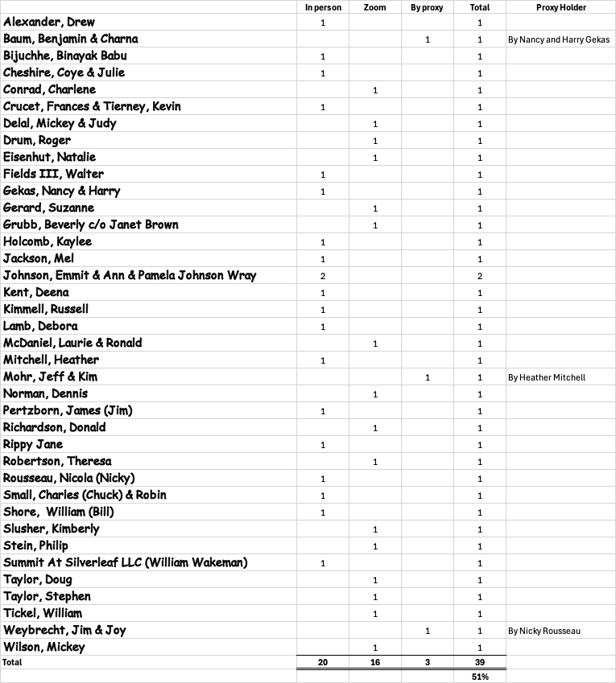

Attachment B—Silverleaf POA Cash Flow Statement

