March 2020

piatto di la rosa di Norcia prosciutto from the shoulder, 18 months aged pink peppercorn 20
oyster mushrooms carpaccio pickled, cipollini onion, asparagus, parmigiano 20 
roasted leeks, ajo bianco, pomogranate, grissini 18
cabbage roll, mushrooms, stracciatella 20
piccola zuppa di pesce, fish of the day 22
organic romaine lettuce, crostini, parmigiano cheese, anchovy dressing 16
kale leaves, brussels sprouts, hazelnuts, tahini-yogurt sauce, pecorino cheese 16

pappardelle with a ‘chestnut hint’ Italian porcini 29
rigatoni, pistacchio pesto, fresh ricotta 28
gnocchi Sorrentina, pomodoro & fior di latte 28
chitarra, Icelandic Cod, purple potatoes 34
Daily Hunt and Daily Catch … please ask server

Gluten free pasta option add 6 dollars

the best pepperoni pizza in town fior di latte, pomodoro, smoked provolone, nduja, iberico salame 29
Joe’s margherita fior di latte, pomodoro, caramelized leeks, ricotta stracciatella 17
genovese (white pizza) fior di latte, pesto, chicken, eggplant, goat cheese 29
margherita classica pomodoro, fior di latte, Grana 14
calabrese pomodoro, fior di latte, crotonese, soppressata, roasted peppers, black olives 24
Napoli pomodoro, fior di latte, onions, anchovies, black olives, capers 24
gorgonzola (white pizza) fior di latte, gorgonzola, caramelized onion, arugola, walnuts 29
add prosciutto 6

Gluten free pizza option add 6 dollars

Rice Pudding, Fruit Compote 14
Tiramisu 14
Ricotta Cheese cake 14
Almond Cake 14
Chocolate Flourless Cake 14
Cheese Plate – Bianco Ubriaco, Fontina, Avonlea 20

We politely decline any modifications, however, kindly inform your server of any allergies

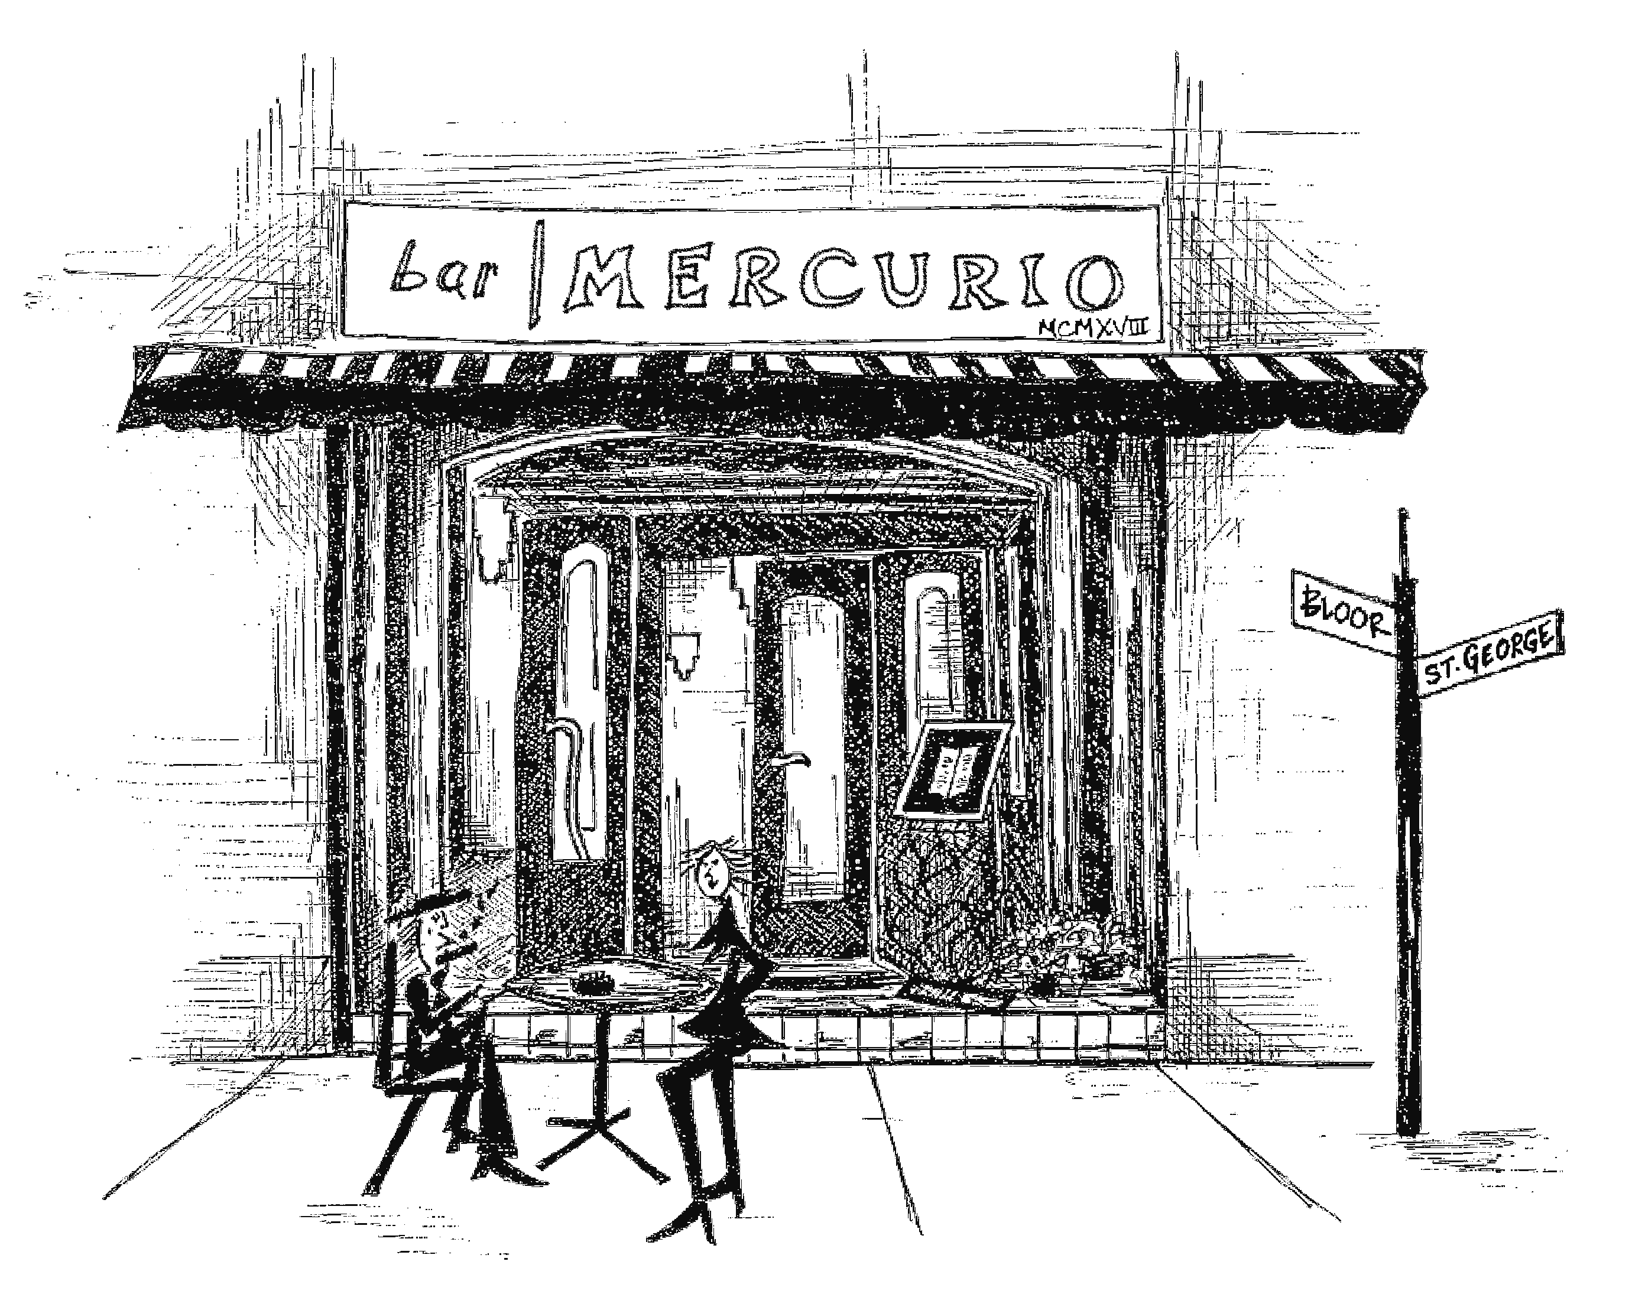

A NOTE from the owner

March 2020

RE: what’s up this month

Dearest

So if you love mushrooms, please consider the pickled oyster mushroom carpaccio.

If you do not, the roasted leeks might be for you.

Sincerely,

Giuseppe Mercurio
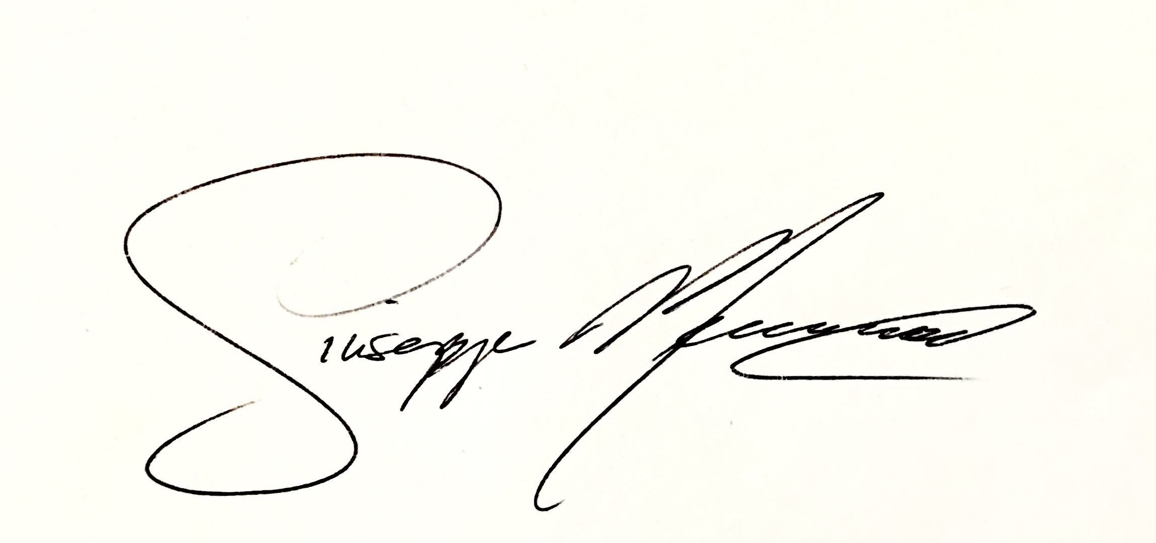

carciofi pomodoro, fior di latte, artichokes hearts, garlic, parsley, basil 24

funghi pomodoro, fior di latte, mix mushrooms, roasted peppers 24
carciofi pomodoro, fior di latte, artichokes hearts, garlic, parsley, basil 24

