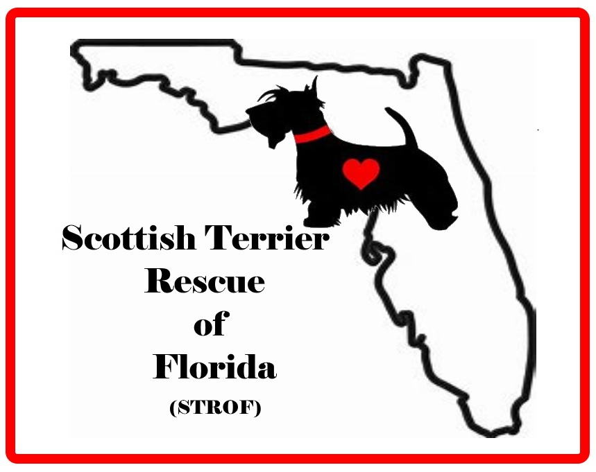
OWNER SURRENDER AGREEMENT

INSTRUCTIONS

Please read this agreement, fill in the blanks, sign it and return it to the Scottish Terrier Rescue of Florida (referred to as “We/Us”). OUR INSURANCE COMPANY REQUIRES THAT ALL INCOMING DOGS MUST HAVE, AT A MINIMUM, A CURRENT RABIES VACCINATION. IF YOUR DOG DOES NOT HAVE THIS, PLEASE HAVE IT DONE PRIOR TO SURRENDER AT A LOCAL VETERINARIAN, ANIMAL SHELTER, OR VACCINE CLINIC.

Please do not omit any information about your dog in order to help us find a suitable home for him/her. The information is vital so that we can find a suitable match for your dog’s disposition, age and health. Use a separate agreement for each dog.

Please provide us your dog’s veterinary records, and all collars, tags, bowls, toys, favorite blanket and a week's supply of his/her current food (if available) when you surrender the dog. This will help him/her to acclimate to their new surroundings.

THE AGREEMENT

In consideration for the mutual promises contained in this agreement, and other goods and valuable consideration, intending to legally bind, the Scottish Terrier Rescue of Florida and the undersigned (present Owner) agree as follows:

PERMANENT SURRENDER. You are permanently surrendering to us the puppy/dog described as:

Name __________________________________________________________________

Age ______ Sex _______ Date of Birth _____________________________

Spayed/Neutered Yes ______ No ______ Eye Color ______________

Weight________________ Body Coloring ______________________________________

Distinguishing Characteristics _________________________________________________________________________________________

__________________________________________________________________________________________

You agree that you, your spouse and/or co-owners, if any, are irrevocably transferring and relinquishing to us the legal ownership of the puppy/dog on the date of surrender. This gives us complete authority to take whatever actions, in our sole judgment, are necessary and in the best interest of the puppy/dog.

PET INFORMATION. You are providing the following information which you believe to be true, complete and correct (to the best of your knowledge) on the date of this agreement.

GENERAL INFORMATION:

Are you the first owner? Yes ______ No ______ Are you the only owner? Yes _____ No _____

If not, do you know what happened with the prior placement?

__________________________________________________________________________________________
Was your dog purchased from a breeder? Yes ______ No ______

Breeder’s Name ____________________________________________________________________________

Breeder’s Phone number and/or e-mail address ___________________________________________________

Did you contact the breeder for help finding a home? Yes ______ No ______

Do you have AKC papers? Yes ______ No ______

Was your dog purchased from a pet store? _______ Shelter _______ Other _______

What is the main reason you have to place your dog at this time?

__________________________________________________________________________________________

How long did you own the puppy/dog? _______________________________

HEALTH INFORMATION:

Spayed/Neutered Yes ______ No ______ Date _____________________

Veterinarian _________________________________________________________

Telephone Number _______________________ Email_____________________________________________

Please advise your Vet to release your dog’s record to the STROF upon request.

Physical problems or allergies? Yes _____ No ______ Details ______________________________________

__________________________________________________________________________________________

Last de-worming date _______________________ Rabies Vaccination date _________________________

Distemper Vaccination date ________________________ Parvo ____________________________

Name of heartworm preventative and date last given ________________________________

Brand of food dog eats __________________________________________________________________

Daily amount __________________________________ Times a day _________

Has dog been microchipped? Yes______ No ______

If so, please provide number ___________________________________________________________

BEHAVIOR INFORMATION

Good with children? Yes ______ No ______ Gets along with cats? Yes ______ No ______

Gets along with other dogs? Yes ______ No ______

Housebroken? Yes _____ No ______

Bad Habits? ______________________________________________________________________________

Jumps at people? Yes _____ No _____ Likes people and attention? Yes _____ No ______

Comments ________________________________________________________________________________

Hides/Cowers? Yes _____ No _____

Comments _________________________________________________________________________________

Most Appealing Traits ________________________________________________________________________

List skills, tricks, commands ___________________________________________________________________

__________________________________________________________________________________________

Dog spends days (check all that apply): Has run of the house ______ Crated ______

Basement ______ Garage ______ Fenced Yard ______ Loose/unfenced ______ Tied out _____

Kennel run ______ Screened porch ______ Other _____________________________________________

Sleeps with you at night (in your bed)? Yes _____ No _____

Favorite games _____________________________________________________________________________

Has your Scottie ever bitten, growled, snapped at, lunged at, or behaved aggressively toward any

person or any other animal? Yes _____ No _____

Comment: ________________________________________________________________________________

Has your Scottie ever bruised or scratched any person? Yes _____ No _____

Comment:_________________________________________________________________________________

Has your Scottie ever been quarantined or involved with Animal Control? Yes _____ No _____
Comment: ________________________________________________________________________________

NO GUARANTEES. We will foster the puppy/dog while we try to find it a good forever home. We make no representations or guarantees about our arrangements or the puppy/dog.

NO LIABILITY. We are not liable to you for any losses, injuries, damages, costs, expenses or liabilities whatsoever sustained or incurred by you in connection with the surrender of the puppy/dog.

ENTIRE AGREEMENT; MODIFICATIONS; BINDING EFFECT. This written agreement contains the sole entire agreement between the Scottish Terrier Rescue of Florida and you, and supersedes any other agreement between you and us with respect to the subject matter of this agreement. No modifications of the agreement will be valid unless in writing and duly signed by both you and us. This agreement will be binding on our and your respective heirs, personal representatives, executors, successors and assigns.
By signing below I confirm that I am the sole owner of the dog listed in the document and that I have the authority to surrender this dog without confirmation by another party. If there is another owner of record I have disclosed this information so that Scottish Terrier Rescue of Florida can confirm that both owners are in agreement of the surrender. Proof of ownership will be provided, if possible.

OWNER

Signature ____________________________________________________ Date _______________________

Print Name __________________________________________________________________________

Street Address _____________________________________________________________________________

City ___________________________________________________ State_______ Zip Code ______________ Phone (Home)____________________________________ (Cell) ____________________________________

E-mail Address _____________________________________________________________________________

SCOTTISH TERRIER RESCUE OF FLORIDA REPRESENTATIVE

Signature ____________________________________________________ Date _______________________

Print Name __________________________________________________________________________

