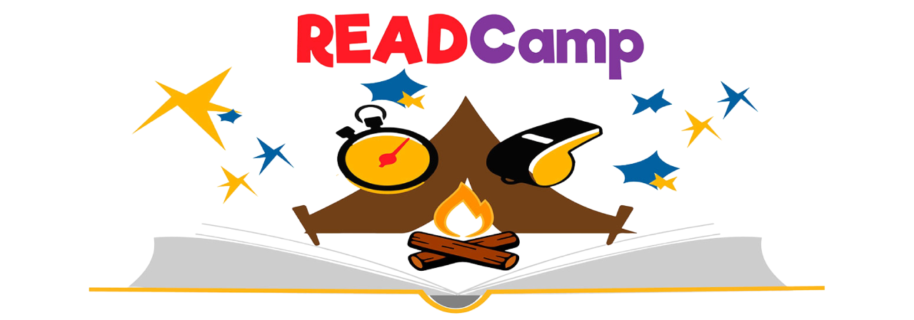
Place Username & Password Here!

2025-2026 Academic Year

Training
Begins Monday, May 25th
All books are to be read and recorded online at https://www.readwithmalcolm.com/readcamp/

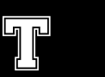

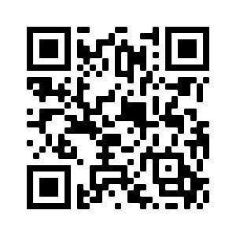
Note: This is ALL online!
The attached paper copy is ONLY for students that do not have internet access.

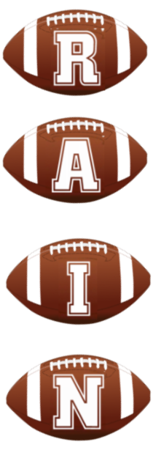

Read & Earn

Become a READ Camp Champion
Read 8 books & record online
Earn *fill in school incentive of choice here*

About the Books
Book 1: Reading Conditioning: Select a book at your current reading level.
Book 2: Reading Speed: Select a book that you can read quickly and comprehend.
Book 3: Reading Strength: Select a book that makes you a stronger reader.
Book 4: Special Teams Reading Drills: Select a book that is special to you.
Book 5: Superpower Reading: Select a book about your favorite superhero.
Book 6: Inspirational Reading: Select a book about someone who inspires you.
Book 7: Team Reading Activity: Select a book to read and discuss with a friend or your family.
Book 8: Finish READCamp Strong: Select any book! (Try to keep it going and earn MVP status… see below!)

@ReadWithMalcolm #READCamp
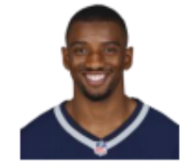

Introducing your Head Coach!

NFL Superbowl Champion & Author,
Malcolm Mitchell

Next Level Reading
READ Camp MVP Challenge

Read 12 books & record online
Write a paragraph Book Review of your favorite book read this summer to recommend to a friend, classmate, teacher, or family member. Explain and describe why others should read this book!

EARN *fill in school incentive of choice*
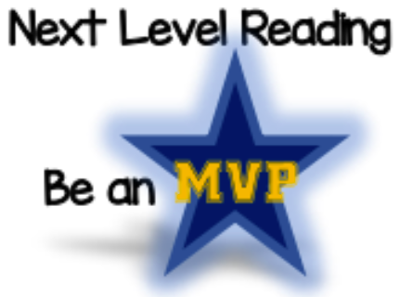

Name: __________________________

Teacher: ________________________

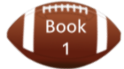

Title: _____________________________________________________________
Author: __________________________________________________________
Favorite part of the book: ___________________________________________________________
____________________________________________________________________________________________
____________________________________________________________________________________________________________________________________________________________________________________________________________________________________________________________________________________

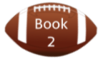

Title: _____________________________________________________________
Author: __________________________________________________________
Favorite part of the book: ___________________________________________________________
____________________________________________________________________________________________
____________________________________________________________________________________________________________________________________________________________________________________________________________________________________________________________________________________

Title: _____________________________________________________________
Author: __________________________________________________________
Favorite part of the book: ___________________________________________________________
____________________________________________________________________________________________
____________________________________________________________________________________________________________________________________________________________________________________________________________________________________________________________________________________

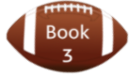

Title: _____________________________________________________________
Author: __________________________________________________________
Favorite part of the book: ___________________________________________________________
____________________________________________________________________________________________
____________________________________________________________________________________________________________________________________________________________________________________________________________________________________________________________________________________

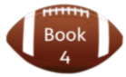

Name: __________________________

Teacher: ________________________
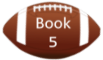

Title: _____________________________________________________________
Author: __________________________________________________________
Favorite part of the book: ___________________________________________________________
____________________________________________________________________________________________
____________________________________________________________________________________________________________________________________________________________________________________________________________________________________________________________________________________

Title: _____________________________________________________________
Author: __________________________________________________________
Favorite part of the book: ___________________________________________________________
____________________________________________________________________________________________
____________________________________________________________________________________________________________________________________________________________________________________________________________________________________________________________________________________
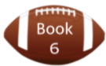

Title: _____________________________________________________________
Author: __________________________________________________________
Favorite part of the book: ___________________________________________________________
____________________________________________________________________________________________
____________________________________________________________________________________________________________________________________________________________________________________________________________________________________________________________________________________
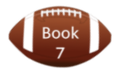

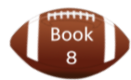

Title: _____________________________________________________________
Author: __________________________________________________________
Favorite part of the book: ___________________________________________________________
____________________________________________________________________________________________
____________________________________________________________________________________________________________________________________________________________________________________________________________________________________________________________________________________

