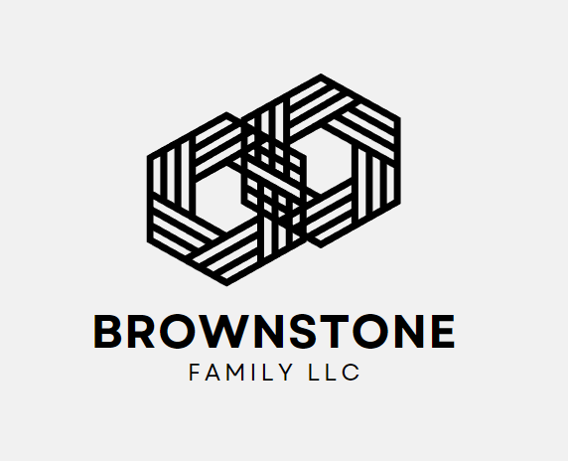
Application for Employment
Brownstone Family LLC provides quality community services to meet the unique needs of individuals with mental and physical disabilities.

Name: ____________________________________________________ Date: _____________________
Phone Number: ______________________________ Cell Phone: _______________________________
Position Applied For: ____________________________________________________________________

How Did you hear about employment opportunity?
Friend/Family Indeed Linked-In Facebook Website Other: ______

Brownstone Family LLC participates in E-Verify- Federal Law requires all employers to verify the identity and employment eligibility to all persons hired to work in the United States.
Legal Name as it appears on Social Security Card:

__________________________________________________________________________________

Address: __________________________________________________________________________
(Street & Number) (City) (State) (Zip Code)

Social Security Number: _____-____-_______
Date of Birth: __________________________

Can you, upon employment, provide genuine documentation establishing your identity and eligibility to be legally employed in the United States? Yes or No
Are you Under 18 Years of Age? Yes or No
Position requires valid Driver's License and Basic Computer skills
Do you possess a valid Driver's License? Yes or No
Do you have basic computer knowledge? Yes or No
Have you lived in North Carolina continuously for the past 5 years? Yes or No
If not, please include the city and states: _____________________________________________

Convictions
Have you ever been convicted of a felony? Yes or No
If yes, please give date and details: ____________________________________________________________________________________________________________________________________________________________________________________________________________________________________________________________________________________________________________________________________________________

Schedule availability
All direct support employees may work schedules that include weekend and holiday hours specify days and hours available.
Circle all that apply: Part-time Full-time Substitute/Seasonal
1st Shift 2nd Shift 3rd Shift Flexible
Education
Do you have a high school diploma or GED? Yes or No
 | Name and Location | Graduate? Degree? | Major/Course of Study
High School

College or University

Other Education

School of Nursing if applicable (circle): CNA LPN RN Other: __________________
Describe specialized training, skills, and activities if applicable (Ex. CPR, First Aid):
_______________________________________________________________________________________________________________________________________________________________________________________________________________________________________________________________
Other training or education including military: _______________________________________________________________________________________________________________________________________________________________________________________________________________________________________________________________

Licensure
To be completed by registered professional and certified technical applicants only. For the purpose of this section, references to the term “licensed” also apply to the term’s “registration” and “certification”.
Medical Specialty: _______________________________________ State(s): ______________
Expiration Date: __________________________ Certification Number_____________________
Serial Number: _________________________________

Work History: Please list in order of most recent:
Company Name: ________________________________ Phone: _________________________
Address: ______________________________________________________________________
Street City State Zip Code
Position Held: __________________________________________________________________
Supervisor Name and Title: _____________________________ Ending Salary: ______________
Hours per week: ____________ (Circle) Full-time Part-time Seasonal
Job Duties: _______________________________________________________________________________________________________________________________________________________________________________________________________________________________________________________________
Reason for Leaving: _____________________________________________________________________________________

Company Name: ________________________________ Phone: _________________________
Address: ______________________________________________________________________
Street City State Zip Code
Position Held: __________________________________________________________________
Supervisor Name and Title: _____________________________ Ending Salary: ______________
Hours per week: ____________ (Circle) Full-time Part-time Seasonal
Job Duties: _______________________________________________________________________________________________________________________________________________________________________________________________________________________________________________________________
Reason for Leaving: _____________________________________________________________________________________

Company Name: ________________________________ Phone: _________________________
Address: ______________________________________________________________________
Street City State Zip Code
Position Held: __________________________________________________________________
Supervisor Name and Title: _____________________________ Ending Salary: ______________
Hours per week: ____________ (Circle) Full-time Part-time Seasonal
Job Duties: _______________________________________________________________________________________________________________________________________________________________________________________________________________________________________________________________
Reason for Leaving: _____________________________________________________________________________________

References: Please give at least three references (2) business and (1) personal NOT related
Name | Occupation | Phone Number | Years known

Read Carefully Before Signing
I certify that the facts set forth in my application are true, complete, and correct. I understand that if employed, false statements on this application shall be considered sufficient cause for involuntary termination.
I understand that if I am hired, the rules and regulations of this employer and any personnel procedures do not constitute a contract of employment.
I understand that all employees of Brownstone Family LLC are employed at will and employment and compensation can be terminated, with or without cause, with or without notice, at any time, at the discretion of Brownstone Family LLC.
I understand that if hired, I must undergo a drug screen and background check. No supervisor or representative of Brownstone Family LLC other than the Chief Executive Office or designee has the authority to enter an offer of employment.

Signature of Applicant: __________________________________ Date: ___________________

This application will be considered active for 60 days. If you wish to be considered for employment after that time, you must reapply.

Background Check Authorization

I, _________________________, understand and acknowledge that my signature on this form will give Brownstone Family LLC full consent to conduct a background check to confirm my identity, current address, and previous employment. I understand that such reports may contain public record information concerning my driving record, North Carolina Health Care Registry, criminal records, etc. from the federal, state, and other agencies which maintain such records.
I also understand that this is necessary if I wish to meet all the criteria for the position in which I seek that is associated with Brownstone Family LLC. Furthermore, I am aware that a successful background check does not guarantee employment.
I agree that Brownstone Family LLC may contact my references, previous employers, and any third party applicable to confirm all the details that have been included in my application.

____________________________________________ __________________
Signature Date

Drug Test Consent
I am aware that Brownstone Family LLC is committed to providing a drug-free workplace which promotes the health, safety and welfare of individuals and employees. I understand that all applicants offered employment with Brownstone Family LLC must pass a drug test. I also understand that if I am employed by Brownstone Family LLC then I am subject to the Drug and Alcohol-Free Workplace Policy. This policy includes random drug and alcohol testing for cause and post-accident. Employees who refuse to comply with any request for a test will be subject to termination. As an applicant, I will consent to providing a urine specimen for the purpose of having a drug test and release Brownstone Family LLC from any liability arising from the test. I understand that a confirmed and/or unexplained positive test will result in denial of employment. With the offer of employment, I understand that failure to report for a drug screen as scheduled will result in denial of employment unless otherwise stated and explained based on the discretion of the agency.
____________________________________________ __________________
Signature Date

