**Important Test Dates and Links for Registration**

ACT Dates (2019-2020):

<http://www.act.org/content/act/en/register.html>

(2019) (2020)

July 13th February 8th

September 14th April 4th

October 26th June 13th

December 14th July 18th *(Not in NYS)

Redesigned SAT Dates (2019-2020):

<https://collegereadiness.collegeboard.org/sat/register>

(2019) (2020)

August 24th March 14th

October 5th May 2nd

November 2nd June 6th

December 7th

TACHS (2019-2020):

<http://www.tachsinfo.com>

November 8th

HSPT (2019-2020):

<http://www.regis.org>

TBD

ISEE (2019-2020):

<https://www.erblearn.org/parents/admissions-testing-isee>

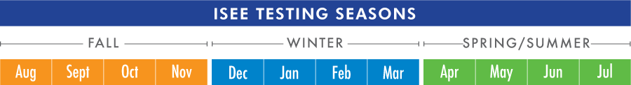

Students may register to take the ISEE one time in any or all of three testing seasons. The ISEE testing seasons are defined as Fall (August–November), Winter (December–March), and Spring/Summer (April–July). ISEE does not encourage multiple testing, but we do offer students and families that option.

SSAT (2019-2020):

<http://www.ssat.org>