**Important Test Dates and Links for Registration**

ACT Dates (2020-2021):

<http://www.act.org/content/act/en/register.html>

(2020) (2021)

October 10th February 6th

October 17th April 17th

October 24th June 12th

October 25th July 17th *(Not in NY)

December 12th

Redesigned SAT Dates (2020-2021):

<https://collegereadiness.collegeboard.org/sat/register>

(2020) (2021)

September 26th March 13th

October 3rd May 8th

November 7th June 5th

December 5th

TACHS (2020-2021):

<http://www.tachsinfo.com>

November 6th (Virtual)

HSPT (2020-2021):

<http://www.regis.org>

November 7th & 8th (Virtual)

ISEE (2020-2021):

<https://www.erblearn.org/parents/admissions-testing-isee>

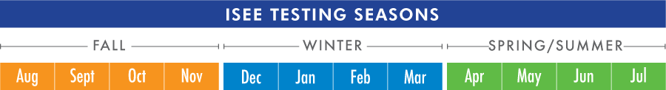

Students may register to take the ISEE one time in any or all of three testing seasons. The ISEE testing seasons are defined as Fall (August–November), Winter (December–March), and Spring/Summer (April–July). ISEE does not encourage multiple testing, but we do offer students and families that option.

SSAT (2020-2021):

<http://www.ssat.org>