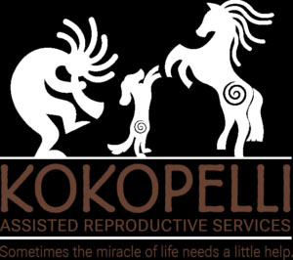
Join Us
November 26th, 2022
For a free seminar with
Dr. Alyssa Shelby, DVM

Dr. Shelby, DVM will be discussing, progesterone, what to know, and how it is used in understanding when to breed and so much more.

The Seminar is free to all exhibitors and their guests of the Delta ASF Trot Off The Turkey Show and will be held indoors at the Stanislaus County Fairgrounds after the 2nd show or at 5:00 pm. We will let you know what building at the show.
Please join us for a pot-luck after the seminar.
About Our Speaker:
Dr. Shelby was born and raised in central Missouri in a rural community. She earned her B.S. in Animal Sciences in May of 2013 from the University of Missouri. While there, she was a member of Sigma Alpha professional Agricultural Sorority, president of Pre-Vet Club, as well as competed on the National Livestock Judging Team her junior/senior year. She attended the College of Veterinary Medicine at the University of Missouri and graduated in May 2017 with her DVM. She was very active in veterinary school, serving as Class President, President, and co-founder, of the Theriogenology Club (study of reproductive medicine), fundraising chair for the Missouri Mule Team, served as the National American Association of Bovine Practitioners representative for her college, and was involved in American Association of Equine Practitioners club.
Dr. Shelby’s passion is comparative reproductive medicine (large and small animals). In her free time, she likes to ride horses, work with cattle, workout, read, and explore her new home state of California. She currently lives with her husband, who is an MD, and their pets (tortoiseshell cat, Pembroke Welsh Corgi, and Basset Hound). She is studying via the alternate training route to obtain her board certification in Theriogenology.

Kokopelli is a veterinarian run practice that houses the only small animal boarded theriogenologists (Dr Christensen) in the Northern California region. We focus on reproduction in all species, with a current primary focus on canine and equine reproductive medicine. We are in the process of building a general practice facility to help better serve all of our clients veterinary needs. We have advanced reproductive technology as well as a vast knowledge of reproductive medicine in animals which helps us provide top of the line care to all of our clients. Our goal is to help everyone achieve reproductive success.

