

**2024 Dart Team Roster**

Email, Text or Call in your roster to

[jomama@mendotavalley.com](mailto:jomama@mendotavalley.com) 612-202-1941

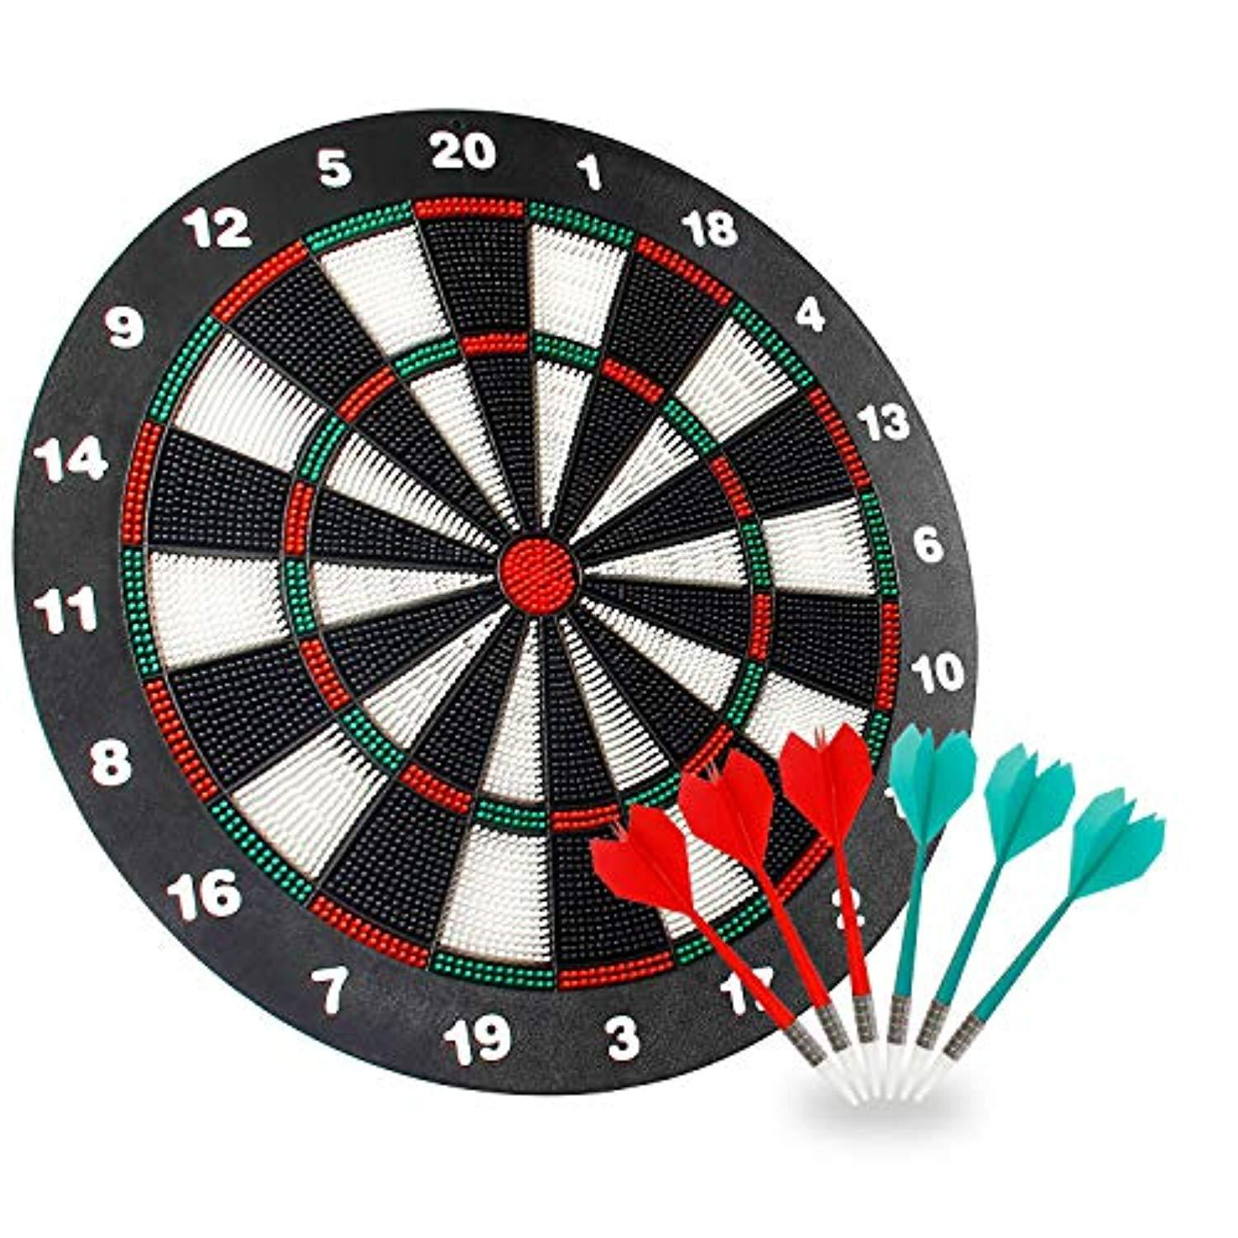

***Start Dates Vary by Area***

Night of Play________________________

Home Location _____________________________

Team Name _________________________________

**CAPTAIN:** _______________________ Email ___________________________

Address __________________________ City ________________ Zip _________

Cell ( _____ ) _______ - ___________ Alt ( _____ ) _______ - ___________

Player: ___________________________ Email ___________________________

Cell ( _____ ) _______ - ___________ Alt ( _____ ) _______ - ___________

Player: ___________________________ Email ___________________________

Cell ( _____ ) _______ - ___________ Alt ( _____ ) _______ - ___________

Player: ___________________________ Email ___________________________

Cell ( _____ ) _______ - ___________ Alt ( _____ ) _______ - ___________

Player: ___________________________ Email ___________________________

Cell ( _____ ) _______ - ___________ Alt ( _____ ) _______ - ___________

Player: ___________________________ Email ___________________________

Cell ( _____ ) _______ - ___________ Alt ( _____ ) _______ - ___________

Player: ___________________________ Email ___________________________

Cell ( _____ ) _______ - ___________ Alt ( _____ ) _______ - ___________

Player: ___________________________ Email ___________________________

Cell ( _____ ) _______ - ___________ Alt ( _____ ) _______ - ___________