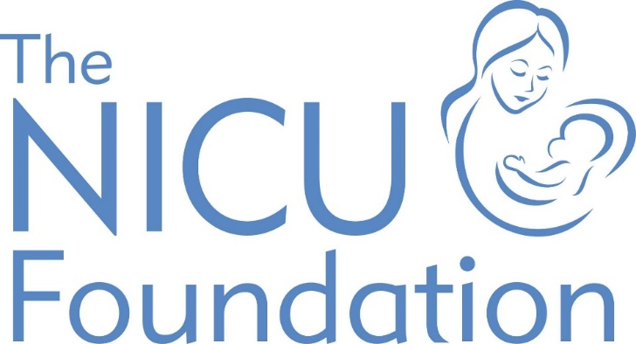
Sponsorship
Form

We need your support

Please read the information below to help us benefit even more from Gift Aid. If you require more fields on your form you could photocopy it, or alternatively download another copy from www.nicufoundation.co.uk.

How your money can help…

£5
Could support the unit in providing each family with a diary to track their babies progress and development.

£50
Could fund a professional to attend a regional study day on baby massage

£100
Could fund a teaching and education package for parents around various aspects of care they may encounter in the neonatal unit

£500
Could support a unit in offering massage and other holistic therapies to families in the neonatal unit

£1,000
Could fund a nurse to complete their Neonatal Specialist Course, providing them with vital training and education on the care of neonatal babies

Multiple or large donations
Could help us purchase essential equipment and refurbish family rooms to support the comfort and well-being of babies and their parents staying on the unit.

Guide to Gift Aid

Write your full name
To claim Gift Aid, the form must
be clearly completed in the sponsor’s handwriting.

Fill in your home address
Please do not include your work address as HMRC need to know where you live to claim Gift Aid.

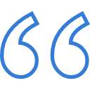
Avoid ditto marks
Unfortunately, we can’t claim Gift Aid on your donation if ditto marks (“) are used.

Write down your donation
The most important bit – how much would you like to sponsor someone for their event?

@NicuFoundation
@thenicufoundation
Tick the Gift Aid box
If you’ve read the declaration and are happy to include Gift Aid, please tick the box.

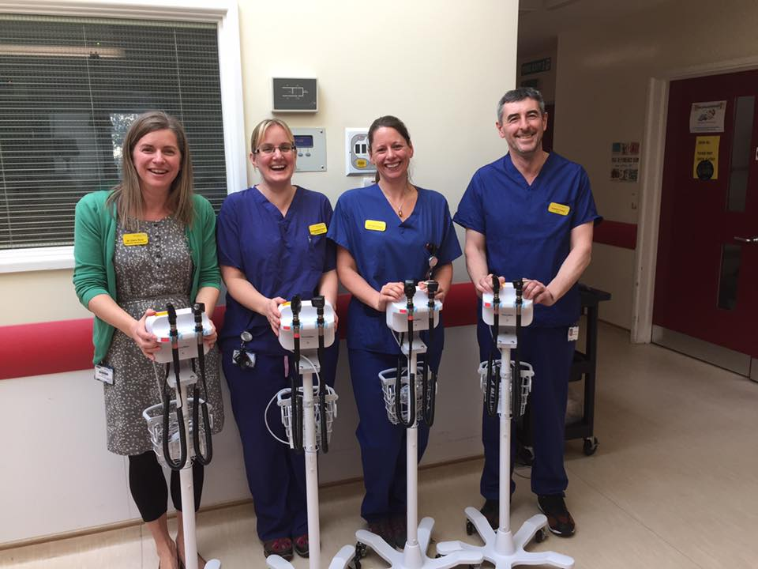
Please make sure you fill in all of these details.
Name Address
Postcode Email Phone Event name

Make your gift work harder

Do you pay tax? If so, by simply completing this form you can boost the value of your gift by 25p for every £1 without costing you a penny.
If I have ticked the box headed ‘Gift Aid’, I confirm that I am a UK Income or Capital Gains taxpayer. I have read this statement and want The NICU Foundation to reclaim tax on the donation detailed below, given on the date shown. I understand that if I pay less Income Tax / or Capital Gains tax in the current tax year than the amount of Gift Aid claimed on all of my donations it is my responsibility to pay any difference. I understand the charity will reclaim 25p of tax on every £1 that I have given.

Title | Initials | Surname | House name or number | Postcode | Date paid | Your donation | Gift Aid  (please tick)
(Please fill in your name and home address in your own writing – otherwise we can’t claim Gift Aid.)
Total
Date paid to charity

