**32nd AFIS Internet Users Conference**

2018 Reston, Virginia

August 26-29, 2018



Hosting Agencies Department of Forensic Science and Virginia State Police

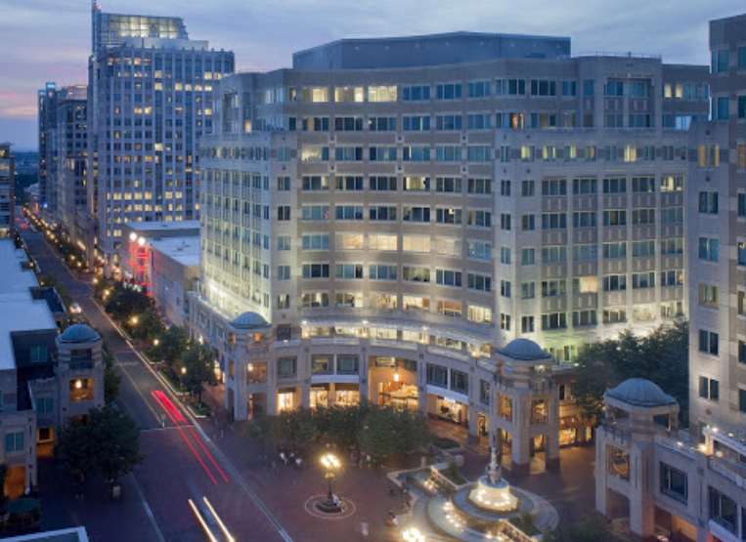

Hyatt Regency Reston

1800 Presidents Street

*Reston, Virginia*

*Room Rate: $169*

*Hotel Booking Link:* [*https://aws.passkey.com/go/AFISInternetConference*](https://aws.passkey.com/go/AFISInternetConference)

*Hotel Website: https://reston.regency.hyatt.com/en/hotel/home.html*