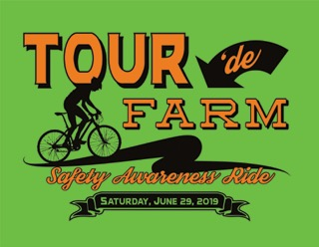
Join us for a 35 mile Farm Safety Awareness Bike Ride on June 29th, 2019. There will be safety demonstrations, dairy snacks and beverages at each farm. The ride will begin and conclude at the Pines Ballroom.

All funds donated will be used to promote farm safety awareness and to support the Ram & Jeremy Seibel Scholarship fund.

Schedule of Events

7:30 – 8:00 Registration at Pines Ballroom
8:30 – Depart Pines Ballroom
9:15 – 9:45 Demonstration at Woodmohr Jerseys (John & Wendy Schmidt)
11:00 – 11:30 Demonstration at CR Vineyards (Cathy & Randy Feuling)
12:15 – 12:45 Demonstration at Klinger's Farm Market
2:00 – 2:30 Demonstration at Mayer Lane Holsteins (Don & Liz Mayer)
3:00 Arrive at Pines Ballroom
4:00 - charcoal chicken dinner

Non-rider Registration

Name: __________________________________
Address: ________________________________
Email: __________________________________
Phone Number: __________________________

Chicken Dinner
_____ Adult ($10)
_____ Child 10 years old and under ($5)

T-Shirt ($10 each)

Adult: S M L XL 2XL 3X

Youth: XS S M L XL

Total Enclosed: ________
Make checks payable to “Ram & Jeremy Seibel Memorial Scholarship Fund”

Complete and return the registration form by June 10, 2019 to:
Ann Seibel 8977 170th Ave. Bloomer, WI 54724

