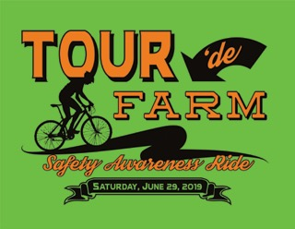
Join us for a 35 mile Farm Safety Awareness Bike Ride on June 29th, 2019. There will be safety demonstrations, dairy snacks and beverages at each farm. The ride will begin and conclude at the Pines Ballroom.

All funds donated will be used to promote farm safety awareness and to support the Ram & Jeremy Seibel Scholarship fund.
Schedule of Events
Friday June 28, 2019
6:00-7:00 Pre-registration at Pines Ballroom
Saturday June 29, 2019
7:30 – 8:00 Registration at Pines Ballroom
8:30 – Depart Pines Ballroom
9:15 – 9:45 Demonstration at Woodmohr Jerseys (John & Wendy Schmidt)
11:00 – 11:30 Demonstration at CR Vineyards (Cathy & Randy Feuling)
12:15 – 12:45 Demonstration at Klinger's Farm Market
2:00 – 2:30 Demonstration at Mayer Lane Holsteins (Don & Liz Mayer)
3:00 Arrive at Pines Ballroom 4:00 - charcoal chicken dinner
Rider Registration
Registration price - $50 *deadline to register June 10
(includes T-shirt and Charcoaled Chicken Dinner)

Name: __________________________________
Address: ________________________________
Email: __________________________________
Phone Number: __________________________
T – shirt Size:
S M L XL XXL 3X

Complete and return the registration form by June 10, 2019 to:
Ann Seibel 8977 170th Ave. Bloomer, WI 54724
Make checks payable to “Ram & Jeremy Seibel Memorial Scholarship Fund”

** All riders must be 18 years of age and must wear a helmet**

