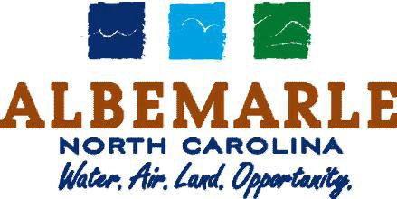

City of Albemarle, North Carolina

Community Overview
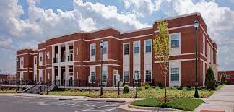

Albemarle City Hall
144 N. 2nd Street, PO Box 990, Albemarle, NC 28002
Phone: 704.984.9000 | Email: info@albemarlenc.gov | web: ww.albemarlenc.gov

GPS Coordinates of City Hall  Latitude/Longitude [35.35250/ -80.19818] | Link To Stanly County, NC Online GIS  http://www.stanlygis.net/

Table of Contents

- Introduction
  - Statement of Intent
  - City’s Role in the Redevelopment
  - Location of Property

- City of Albemarle Narrative & Reuse Goals
  - Downtown Albemarle: Redevelopment Opportunities
  - The Next Growth Area In The Charlotte Region
  - Planning & Progress
  - The Pfeiffer Effect
  - Close To Charlotte, But Right At Home
  - Proud of Our Past…Looking Forward To Our Future
  - Transportation

- Site Description

  - General Information
  - Albemarle Downtown Development Corporation (ADDC)
  - Retail Strategies: 2022 Albemarle Downtown Strategic Plan
  - Downtown Albemarle Grants & Assistance
  - Adaptive Reuse of Property
  - Former Police Department HQ Building & Property Information
  - Current & Past Use
  - Parking Availability
  - Nearby Uses
  - Appraisal
  - Stanly County & City of Albemarle Building Codes

- Community Description, Profile, Community Demographics & Data
  - Demographic & Livability Data
  - Downtown Marketing

- Submission Process
  - Timeline
  - Development Team Experience and Background
  - Reuse Proposal

- Review & Selection Process
  - Review Process
  - Evaluation Criteria

- Other Terms, Conditions and Source Materials

Location

The City of Albemarle is located in Stanly County. North Carolina and serves as the County Seat. Albemarle has a population of just over 16,000 residents and is in the Charlotte Metropolitan Statistical Area (MSA). The City is located in Central North Carolina approximately 45 minutes from metropolitan Charlotte, NC to the east; the City of Greensboro, NC one hour to the northwest; and 1.5 hours from the state capitol of Raleigh two hours to the northeast. The links below provide mapping and GIS information for the City as well as a link to City of Albemarle data and facts.

City Hall Address: 144 N. 2nd St., Albemarle, NC 28002

GPS Coordinates. Latitude 35.35014, Longitude: 80.20006

Web Link: Google Earth – City of Albemarle

Web Link: Stanly County Online GIS

Web Link: City Data for City of Albemarle

Web Link: US Census Bureau Data for City of Albemarle
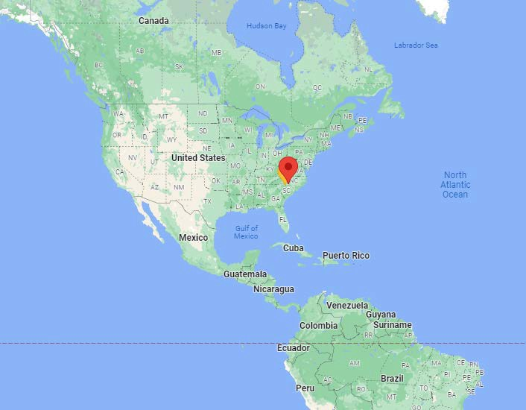

City of Albemarle
N O R T H C A R O L I N A
North America Location Map

MINNESOTA
o,
MinneOa:polis

WISCONSIN

MICHIGAN
-'NEW•

Toronto
0

·' Ottawa
. •® . Mo,f'ntreal "'
/ VERMO,:IT
!

MAINE \
['BRU

IOWA
NEW YORK : HAMPi_HIRE
Chicago JASSAC.liOSHJS
NeW·York

!,,

·!-y••···

Q. -

ILLINOIS INOIANA OHIO ,':
Cincinnati Coluplius
₀ 0 !!
Indianapolis
•, :-o. '

Philadelphia ·.·
•M�.irti.AN�(o NJ
·
·0
PENNSYLVANIA
,o
: CT
'RI

.... ....,
St. Loufs .
MISSOURI I),.

•·.

... ·'
' 'WEST
VIRGINIA
KENTUCKY
:06
Washington..
VIRGINIA

.-········· ··············· ,:: ......Nashville I

A :'
}

IS
.'....,.
..
l,.•MISSISSIPP
TENN⁰ESSEE
'!'
'Atlanta
0
ORTH
�Ch.. ar,lotteROLINA
SOUTH ••
•
CAROLINA

...1 ALABAMA ,' GEORGIA City of Albemarle

rlouston
0
LOUISIANA .Jack•'sonville
Orlando oTam0 pa FLORIDA
0
Miami
0

NORTH CAROLINA
Eastern U.S. Map

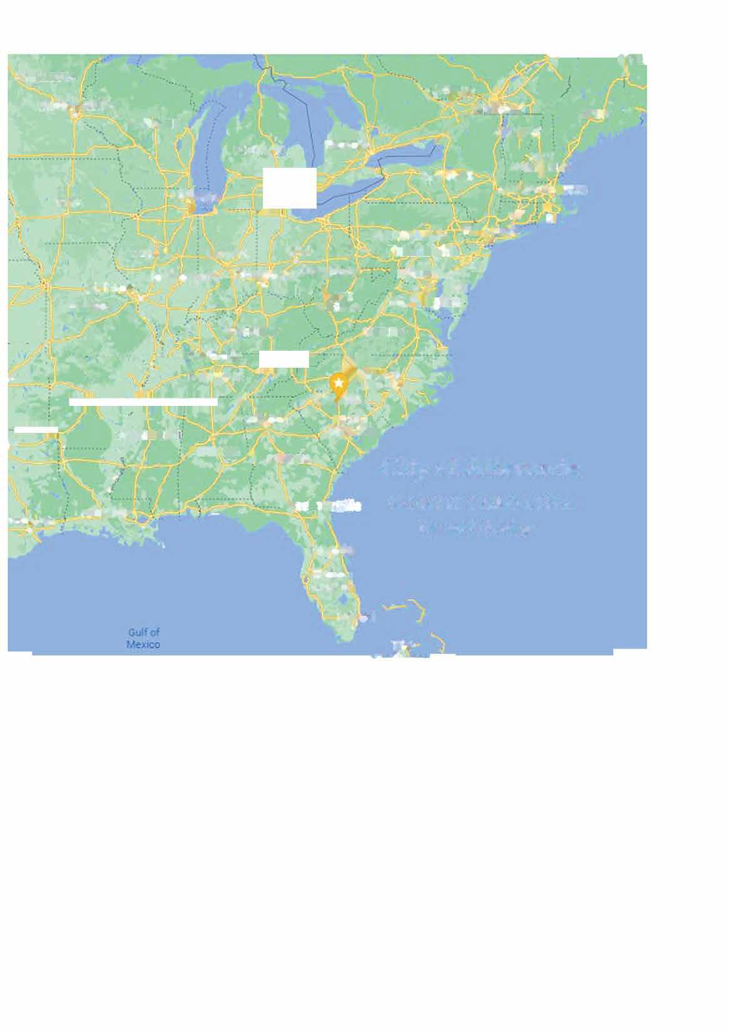

6
City of Albemarle Overview
Albemarle Economic Development: Keith Tunnell, Director
144 N. 2nd St. | PO Box 190, Albemarle, NC 28002-0190 | Phone: 704.984.9419 | Email: ktunnell@albemarlenc.gov

LoafkCe aNtaowrroban diMooresville ver
�•
,f
<?:o&� Co1nelius

@ Ch1na Gro�e Landis
Enochville
lL
l{annapolis
Granije Q_uarry
@)
Rockwell

Gold Hill
High Rock ®
0
©

,vesville
-'.; Il::aldwell
Hu'\!:'.sville

Concord

Mt Pleasant
Ricnt,eld
New London

Badin
Eldor;
u

Harrisburg
er FSnyaer 'nway
6 River H.aven

Holly

IV
� Charlotte
j Newell
Rocky River

Mint Hi\l

Locust Red Cross Midland Stanf1ekl Oakboro

A_quadale
®
(§J Pee De,

Norwood Mt

ylie

Matthews
Pi�eville Indian Tcail
Fairview §
§)
Unionville

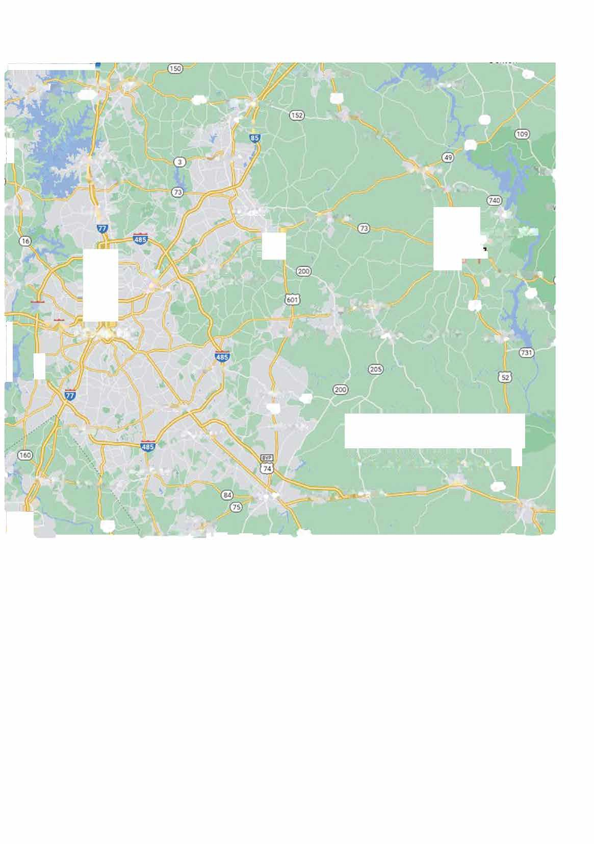
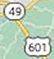
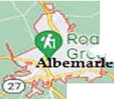
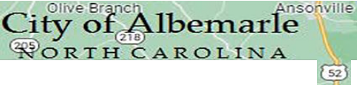
- Cay Weddington 16-CoWlty Charlotte Region
Fort Mill Indian hnd Monroe Wingate Marshville Polkton @)
Wadesboro
Mineral
(§)
-------w.vh,w-,Spring,, s,__,__•.__r..;i, , __.

7
City of Albemarle Overview
Albemarle Economic Development: Keith Tunnell, Director
144 N. 2nd St. | PO Box 190, Albemarle, NC 28002-0190 | Phone: 704.984.9419 | Email: ktunnell@albemarlenc.gov

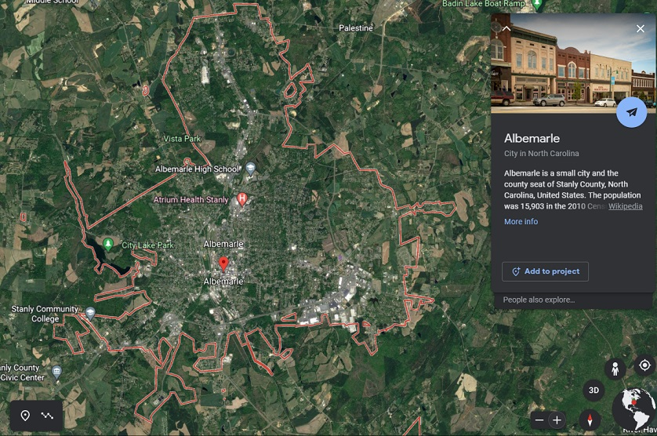
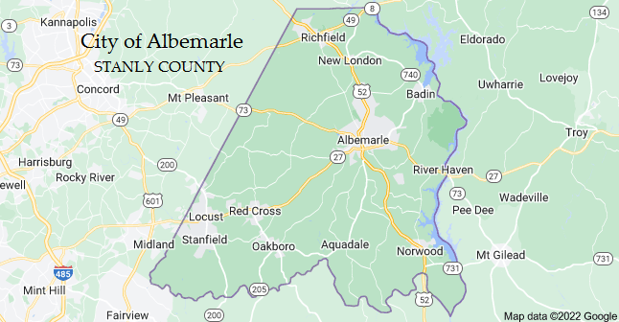

8
City of Albemarle Overview
Albemarle Economic Development: Keith Tunnell, Director
144 N. 2nd St. | PO Box 190, Albemarle, NC 28002-0190 | Phone: 704.984.9419 | Email: ktunnell@albemarlenc.gov

8
City of Albemarle Overview
Albemarle Economic Development: Keith Tunnell, Director
144 N. 2nd St. | PO Box 190, Albemarle, NC 28002-0190 | Phone: 704.984.9419 | Email: ktunnell@albemarlenc.gov

Downtown Albemarle: Redevelopment Opportunities

The City has established the following goals for the adaptive reuse of the property:

    - New retail or office opportunities that address identified market leakage downtown with a plan to fill gaps and/or develop a mixed use of retail, commercial and/or housing.
|
    - The Retail Strategies: Albemarle Marketing Report (2021) provides updated market, leakage, and other retail data. The City of Albemarle has contracted with Retail Strategies the past 8 years with great success in attracting new regional and national retail businesses.

    - Retail Strategies has also provided Downtown Albemarle 1-Mile Radius Demographic & Market Data which is useful to those interested in opening a business in the downtown core.

    - New downtown housing opportunities utilizing historic preservation programs including federal historic tax credit funded rehabilitations and any State of North Carolina credits.

    - This building is located in the Albemarle Downtown Historic District. Click here to view archival documents as well as view and download a copy of the Historic Downtown Albemarle Guide.
    - Additional downtown pedestrian traffic and additional downtown business customers.
    - Downtown revitalization through increased investment, tax revenue, and job creation.
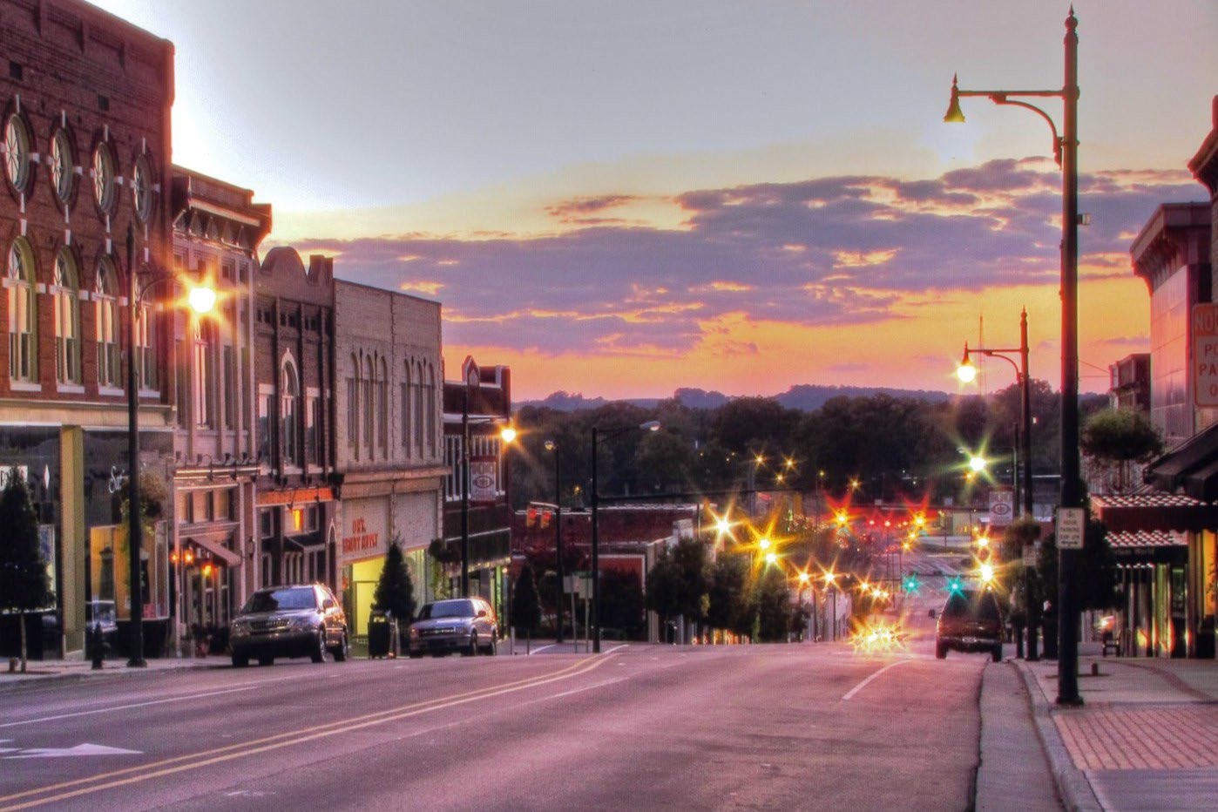

The Next Growth Area In The Charlotte Region

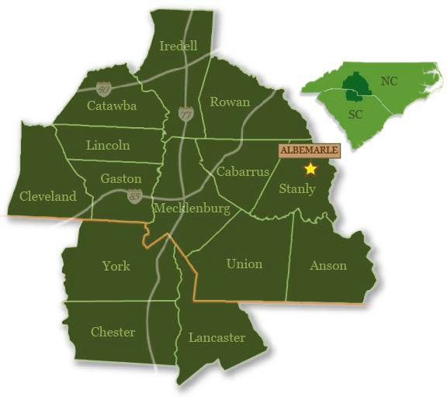
All one has to do is follow the growth of Charlotte over the past 25 years to see why Stanly County and the City of Albemarle are destined for growth and development in the coming decade. The City has a good highway network, available land, millions of gallons of excess capacities of water and sewer, reliable and affordable power, and a strong labor force.

Albemarle is already seeing strong growth in the housing, retail, and small business sectors. With the new 282-acre Albemarle Business Center (ABC) industrial park under construction, it’s only a matter of time before thousands of high paying jobs return to the City in the industrial, distribution, and manufacturing sectors.

The Charlotte Region has been one of the fastest growing regions in the U.S. over the past 25 years. Most of the region's largely undeveloped property is to the east and Stanly County and the City of Albemarle are ideally positioned to capitalize on this growth. Albemarle is positioned to catch the wave of industry looking to locate in the Charlotte Region. The City of Albemarle owns the water, sewer and electric utilities that serves the new industrial park giving the City an even greater edge when negotiating to bring industry home. Add in outstanding workforce training delivered by Stanly Community College and all the pieces are in place to see Albemarle experience success in attracting good paying, high quality manufacturing jobs.
Web Link: Charlotte Regional Visitors Authority
Web Link: Visit Stanly
Web Link: Albemarle Downtown Development Corporation (ADDC)
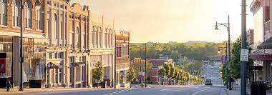

Planning & Progress

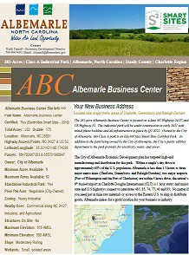
Albemarle’s past, present, and future were all analyzed in 2017 as part of the City’s economic development strategic plan. Many of the 2017 plan’s goals and objectives have been met. In late 2021, the City embarked on a new strategic planning process for all City departments that will be completed by the end of 2022.

One of the top goals of the 2017 Strategic Plan was to build a new industrial park to attract high-paying manufacturing jobs. That goal has been realized as the design and permitting of the Albemarle Business Center (ABC) industrial park was completed in 2021. An ElectriCities SmartSite Certified Park, construction on the 282-acre Class A park infrastructure got underway in February of 2022 and the City’s economic development team is already marketing the park to prospects. At full buildout the park has the potential to generate more than
$1.2 billion in new investment, create more than 2,500 jobs and substantially increase annual revenues for the City’s utilities that serve the park.

On the retail front, Albemarle has seen a decade of strong growth and progress. More than a dozen regional and national retailers have invested in Albemarle, most along the NC 24/27 corridor. Partnering with Retail Strategies of Birmingham, AL the City has been able to utilize the company’s strong ties and hard work to lure many national retailers. More than $17 million in new investment and hundreds of retail jobs have been created during the time the City and Retail Strategies have worked together.

In the fall of 2021, the City contracted with Retail Strategies to work with its Retail Strategies Downtown division to work with the Albemarle Downtown Development Corporation (ADDC), the City’s Economic Development Department, downtown business owners, property owners and other stakeholders to assess and create a strategic plan for downtown development.

This year-long initiative will assess downtown properties and develop marketing plans to entice new investors into the downtown. The program will also leverage the opinions and ideas of the business community to review both the City’s economic development and the ADDC’s programs of work, providing input to strengthen the plan and strategies to grow downtown. The downtown strategic plan is expected to be completed by the end of 2022.

The impact of Pfeiffer University's Health Science Center on downtown’s rebirth, the successful partnership with Retail Strategies, and the soon to be realized success of the downtown plan will make Albemarle an ideal location in which to invest, start a business and live.

Click Here ForThe ABC Park Flyer
NC Economic Development Partnership (NCEDP www.edpnc.com
www.stanlyedc.com

www.electricities.com

www.albemarledowntown.com

Click here to view the most recent Retail Strategies Retail Marketing Report for Albemarle. Learn more at www.retailstrategies.com

The Pfeiffer Effect

The Pfeiffer Health Sciences Center (HSC) opened in 2019 in the Five Points area of Downtown Albemarle. Pfeiffer currently has over 150 students enrolled at the HSC in its Occupational Health and Physician Assistant programs. A third program of study is to be added soon with more than 270 students expected to be in the facility earning their degrees within the next two years. The City of Albemarle, alumni, local benefactors, Stanly County and host of stakeholders and supporters raised more than $7 million to make the facility a reality.

The opening of the HSC had an immediate impact on the downtown Albemarle economy. The addition of graduate-level students has led to several housing projects constructed or on the way in the downtown. The same can be said for retail and restaurants with several new businesses opening in the downtown. While the number of available housing units in the downtown will be over 75 in the coming months, there remains ample opportunity in the downtown for additional growth in housing and retail.

Pfeiffer isn’t the only educational institution that calls Albemarle home. The main campus of Stanly Community College (SCC) is in Albemarle. With an enrollment of more than 4,000 students, for over 50 years SCC has played a pivotal role in workforce and professional training for area youths and adults. SCC also supports local business and industry through the SCC Small Business Center located in downtown Albemarle.

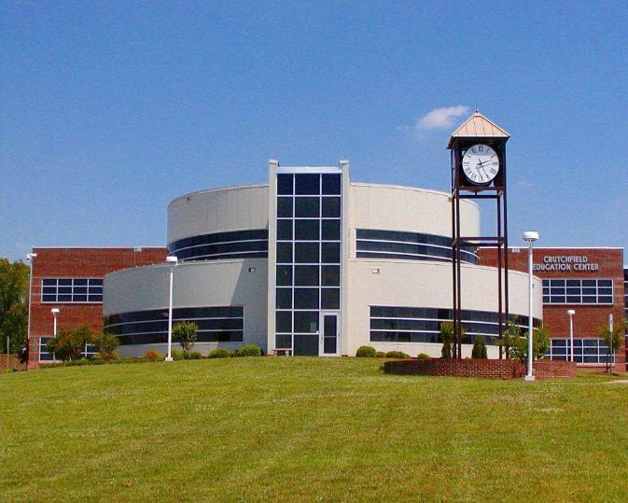
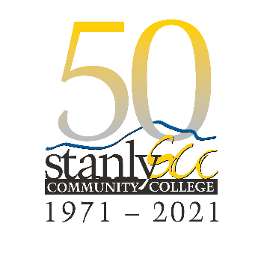
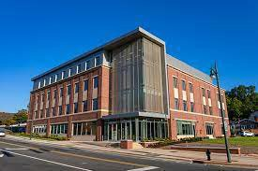
Combined, Pfeiffer and SCC provide a unique advantage for Albemarle business, industry, and residents. Both offer quality educational and career opportunities not seen in every community. The leadership, staff, and students at each institution are keys to our educational and economic success. As each grow, Albemarle will grow with them into a great college town full of retail, restaurants, entertainment, and cultural activities.

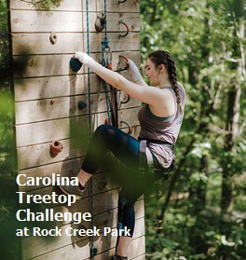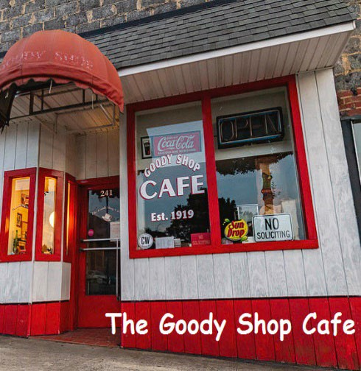

Click Photo To Visit The Challenge!
Cick Photo To Find Your Clown Cookie!
Click Photo For Hands Down Best Burger In Town

Close To Charlotte, Right At Home

The advantage of being just an hour due east of Charlotte, with access to one of the most culturally diverse cities in America, is just one of the great things about living in Albemarle. While Charlotte and all it has to offer is pretty great, there’s something about living in a City that’s just a short drive away from the grandeur and beauty of the Uwharrie Mountains & Lakes Region of North Carolina.

Along with all that Mother Nature has blessed us with, Albemarle residents are fortunate to live in such a historic and charming city. Albemarle was named for George Monck, the Duke of Albemarle, one of eight Lord Proprietors granted the lands of the Carolinas by King Charles II of England back in 1663. Today, none of the Lord Proprietors own any part of Albemarle but the City of Albemarle honors its former landowner by naming the City after him and utilizing the Duke’s Coat of Arms as its City seal.

It's easy to fall in love with Albemarle. Just walking the downtown you’ll see turn of the century buildings, architectural features seen few other places and small parks and public places that give it so much of its charm. Beautiful Churches on almost every block with most having served as houses of worship for decades and unique shops like The Albemarle Sweet Shop and its famous Clown Cookie, or The Goody Shoppe Cafe which is small on space but big on great hamburgers, hot dogs, and other tasty foods made right in front of you on the grill – all while the staff treats you like a member of the family – and have done so for over 100 years. The Churches, public buildings, and the unique architecture of many of the buildings led to downtown Albemarle being declared a historic district by the National Register of Historic Places.

Albemarle has a history where fortunes were made by some, but most were mill workers or farmers who worked hard and made life better for them and their families. Textiles and farming dominated the local economy for over 100 years until the textile mills began to close and totally go away by the 1990s.

Many of the textile “shotgun” style homes remain, outliving the mills that have since been torn down or in disrepair. Those who made their fortunes in farming, milling, or textiles built stately homes just a few blocks from downtown. More than 80 of these homes remain and make up the Pee Dee Avenue Historic District. Comprising more than 80 homes, they were built between about 1891 and 1947 and include notable

Sunrise at Morrow Mountain State Park
Lake Tillery and the Uwharrie Mountains

examples of Queen Anne, Colonial Revival, and Bungalow/Craftsman style residential architecture. Other communities within the City include more modern single family and multi-family developments, apartments in the downtown historic district, and just outside the City you can live in just about any size house you please on Lake Tillery, Badin Lake, or in the beautiful countryside of Stanly County.

Many find the City’s size, with a population of just 16,000 residents, just right. Just right for walking the historic downtown visiting shops, eating at local restaurants with a variety of dishes, and ending the evening at one of the beautiful downtown parks. Or perhaps you’d like to take a shot at throwing an axe at The Tomahawk Throwing Range on 2nd Street or just sipping on a craft beer at Badin Brews or at the soon to be open Uwharrie Brewing at the former City of Albemarle Fire Station #1 off 3rd Street.

As the county seat for Stanly County, the County Courthouse and other Stanly County Government offices are in the downtown as is Albemarle City Hall. The downtown is home to professional services, retail, restaurants, non-profits, Churches of almost every denomination, educational institutions, and government.

But the charm and uniqueness of Albemarle is enhanced by the beauty of the Uwharrie Mountains, Lake Tillery and Badin Lake. A nature enthusiasts dream, just about any outdoor activity on the water or in the woods is just minutes away. The Uwharrie National Forest and Morrow Mountain State Park showcase this pristine part of the Tarheel State with plenty of opportunities for hiking, camping, biking, bird watching, or just walking to one of the many overlooks and enjoying a sunset or sunrise. If you like to get wet, Lake Tillery and Badin Lake offer fishing, and a host of watersports in one of the most peaceful settings you’ll find anywhere. We even have one of the top ropes courses in the nation at the Carolina Treetop Challenge at Rock Creek Park.

But it’s the people of Albemarle who make it even more special. You’ll find our citizens to be proud of their heritage and welcoming to people of all cultures and ethnicities. There’s a large contingent of Vietnamese, White, Latino, and African-American residents here and all proud to call Albemarle home. Quiet, safe communities, and good, decent, hard-working people are what make up this great little City.

We know once you’ve made the decision to live or invest in Albemarle, it won’t be long until you’ll feel right at home too!

Housing

Albemarle and all of Stanly County is seeing rapid growth in single family home construction as well as a number of multi-family and senior living developments that have been completed or that have been approved and soon to be under construction.

The City has seen a resurgence in apartments and housing in the downtown area. Due in part to the impact of Pfeiffer University locating it's Health Science Center in downtown at Five Points, the former Albemarle Hotel is being redeveloped into 27 apartments with retail space on the ground floor; 27 units are now complete and there are other developments in the planning or permitting stage.

Outside of downtown along the NC 24/27 corridor behind Walmart, the DR Harrell Company has been approved and will begin construction on 350 apartments later this summer. The development will include first-class amenities and along with the apartments the company will construct 400 townhomes in blocks of 50 over the next 5 years. This development will provide much needed Class A apartments for residents and newcomers.

Along with downtown housing and apartments and townhome development, the City has seen a number of national tract builders entering the marketplace. TrueHomes, DR Horton, Meritage Homes and Smith Douglas Homes have one or more communities completed with available homes or lots. Other national builders are in the marketplace seeking property.

The City of Albemarle Public Housing Department offers apartment living to low- and moderate-income families. Rents are based on 30% of occupant family’s adjusted annual income or a flat rate based on apartment’s number of bedrooms. Applicants must pass criminal-background and other background verifications and owe no debts to any public housing agency. The City manages two HUD low income housing communities:

- Elizabeth Heights
- Amherst Gardens located near business highway 24-27 bypass, is a multi-family home site.

Sample Of Single Family Housing Developments In The City of Albemarle
Not Inclusive Of All Single Family Communities & Builders In The Community
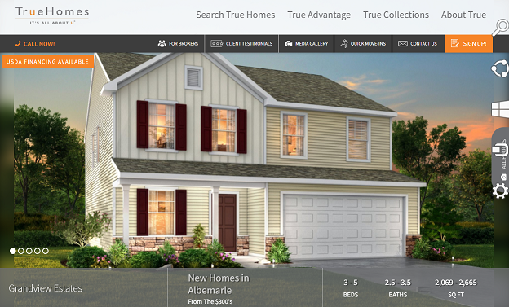TrueHomes Grandview & Grandview Estates Click Here To Visit Grandview Website  Click Here To Visit Grandview Estates Website | 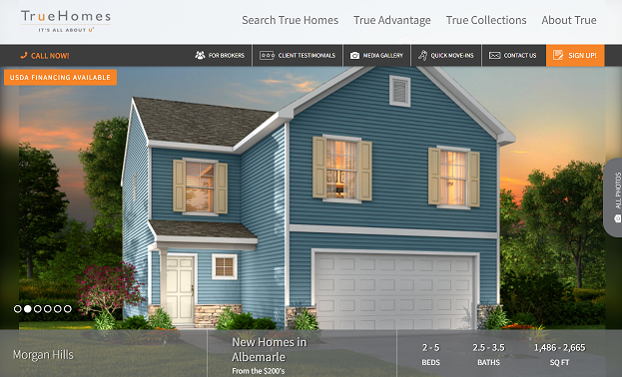  TrueHomes Morgan Hills Albemarle  Click Here To Visit Website
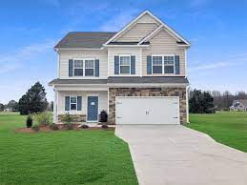  Smith Douglas Homes – Parkwest Albemarle  Click Here To Visit Website | 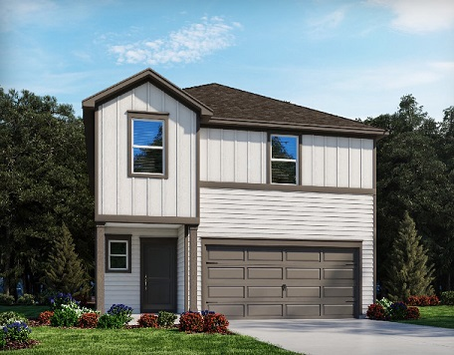  Meritage Homes – Morgan Hills Albemarle  Click Here To Visit Website
For Additional Information Or For A Complete Listing Of Single Family Home Communities On File With The City Contact
City of Albemarle Economic Development
Phone: 704.984.9419 | Email: ktunnell@albemarlenc.gov | Web: www.albemarlenc.gov

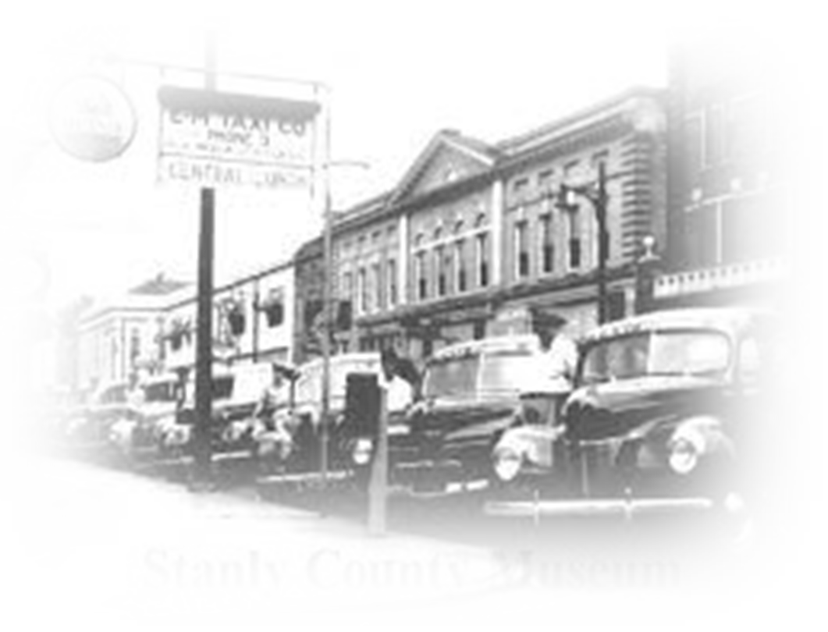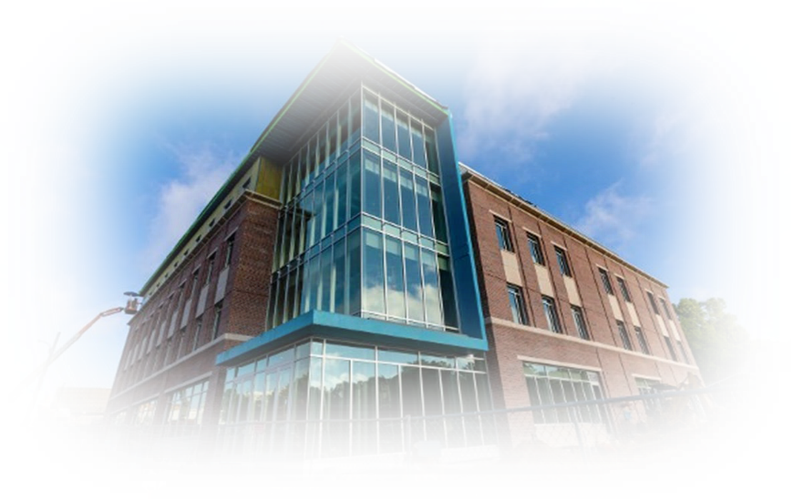

Proud of Our Past...Looking Forward To Our Future

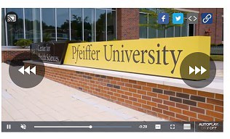
Since 2019, the Albemarle City Council, City Management, and staff have embarked on an ongoing initiative to improve the City by first listening to citizens and our business community and then building a successful plan for Albemarle’s future growth and prosperity.

As part of its mission and visioning plan, Council engaged residents by sending out a Citizen Survey in 2020 that allowed residents to provide feedback on a variety of important issues facing the City and it also allowed individuals to write-in concerns or suggestions not listed on the survey. More than 3,000 residents and business owners participated in the survey with the results made

WRAL Communications video reporting on the growth of Downtown Albemarle.

public in early 2021. It came as no surprise that the economy, creation of jobs, and development of the downtown were at the top of the priority list.

With citizen comment and priorities in hand, the City completed its vision and mission statement in 2021 and has now embarked on a strategic planning process to replace the one created in 2017. Each city department has completed a process to identify key goals and objectives for the first year of the plan with additional long- range goals set and to be completed over a five-year span. The new strategic plan is set to be completed by June and utilized as part of the FY 2022-23 City budget process. Many of the priorities to be set by Council and staff for their respective strategic plans came out of or wee formulated due to priorities, comments, or suggestions made by citizens participating in the Citizen Survey.

  - City of Albemarle Strategic Plan (2017)
  - City of Albemarle Citizen Survey Overview (2021)

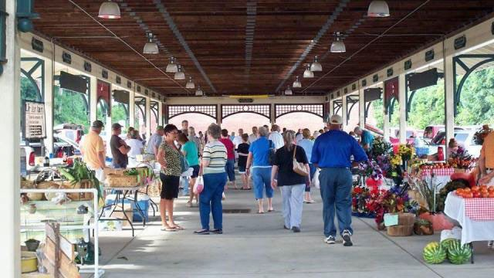
The City of Albemarle Farmer's Market located at Market Station in Downtown Albemarle,

New Projects Slated For Downtown Albemarle Bring New Potential To Stanly County
Article courtesy of WRAL Communications, Raleigh, NC (June 2021)

Nestled in the center of Stanly County and just under an hour away from Charlotte, the City of Albemarle and its historic downtown are in the midst of a transformation.

As recent growth in the metro area has increased the population in Stanly County, officials in Albemarle are intentionally planning for that growth and making changes that will allow downtown Albemarle to become a pedestrian-friendly tourist and business destination.

"The physical changes that are happening now are very exciting. The four-story addition of the Pfeiffer University satellite campus is obviously the most noticeable, but also it has spurred the redevelopment of existing buildings that have been vacant for quite some time," said Joy Almond, main street manager for the City of Albemarle. "The Albemarle Hotel is one of the buildings that is being rehabilitated into apartments, and that's going to be a game-changer because we haven't had residents actually living in the heart of downtown for a very long time.
Having those eyes and ears on our downtown district 24/7 is going to be huge for the businesses there."

With the new 282-acre Albemarle Business Center industrial park helping to lead the charge for further growth alongside additions like the Pfeiffer satellite campus, Albemarle is well positioned for significant growth.

While the streets of downtown Albemarle were quiet for the past few years, this isn't the first time the historic district has been a popular destination. In fact, the town used to be quite the hot spot just under a century ago.

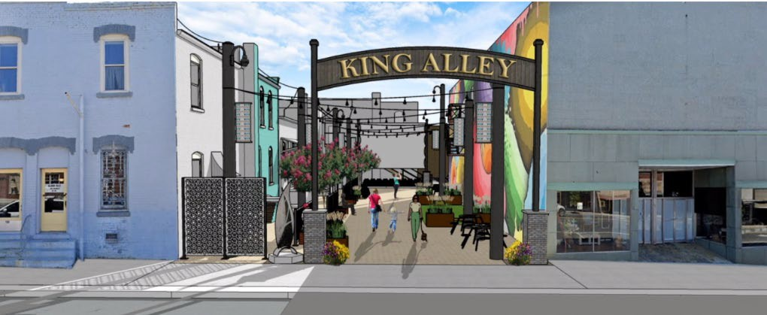
Rendering of the King Alleyway in downtown Albemarle. Albemarle City Council will invest more than $1 million in converting the alleyway into a pedestrian friendly area that will be utilized for special events and available for use by the businesses connected to the alley. The project is expected to be completed by the end of 2022.

"Some of the missing pieces to return Albemarle to the vibrant downtown that it once was at its peak are currently in the works. Back in the 1930s and 1940s, the town had three movie theaters — so it must have been a happening place," said Keith Tunnell, economic development director for the City of Albemarle. "We just want to return it to that former glory, when people came to Albemarle to shop, dine, and to be entertained."

The renovation of the Albemarle Hotel and the former Lowder Hardware building will bring additional residential and retail to downtown, and as the Pfeiffer campus begins to increase offerings, both Almond and Tunnell anticipate a larger student and young professional population in the area — a demographic which downtown Albemarle hasn't seen much of before.

With that new demographic also comes new, unique opportunities to attract them, and the city is taking care to plan proactively for ways to keep them engaged.

"The Pfeiffer University Health Science Center will bring in at least 270 students within the next 24 months, and those are master's degree level students who will likely be looking for housing near the Center," said Tunnell. "We already have a large contingent of students in the downtown from Stanly Community College so this makes us an opportunity to grow into an even larger college town. We have a new brewery that will be opening by early summer 2022 along with other businesses that students and locals will enjoy. We already have some entertainment venues, such as an axe throwing business. There are a few other businesses missing from downtown that we hope to add in the coming months, one of those being a boutique hotel that could allow visitors to stay in downtown where they would be accessible to all of the shopping, entertainment, restaurants, and the beauty of our downtown."

Added Almond: "We have new property managers on several properties on one downtown commercial strip, so there have been some changes in business owners. It's an opportunity for new businesses to come in with fresh ideas, and it's an exciting time for the city."

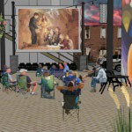
Additional renderings of the King Alleyway project in Downtown Albemarle.

For those new businesses looking for a home in downtown Albemarle, the community offers several resources to aid in getting your business started. The Stanly Community College Small Business Center offers counseling, seminars and workshops that can help small business owners in everything from creating a business plan to understanding OSHA regulations. In her position, Almond also encourages business owners to come to her or other city officials for help with the local processes.

As downtown Albemarle continues to grow, the city is strategically implementing ways to make the area more pedestrian and business-friendly including the City funding a wayfinding program that will begin placement of City signage in 2022.

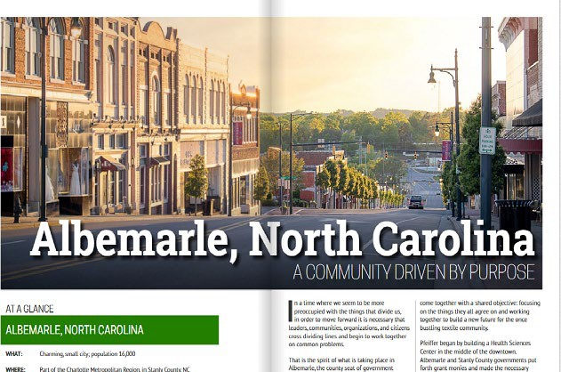
"One way that the city has been proactive is by continuing to implement the streetscape plan. They're implementing more elements of that as far as creating some inviting outdoor space for the public to enjoy that will also help bring foot traffic to the businesses," said Almond. "One project we're very excited about is an alleyway project. It's currently in the works to be converted into a pedestrian-only alleyway that will have lighting, seating, public art, and other spaces. I'm very excited to see how that's going to attract additional patrons to these businesses."

Albemarle Feature In BusinessView Magazine June 2021

Click on image to view, download, and read complete feature.

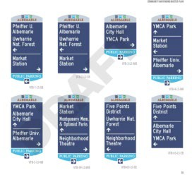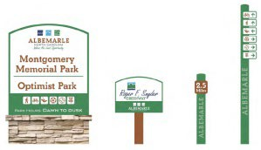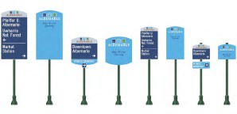

The Albemarle City Council adopted the design and color scheme for the City's wayfinding signage initiative in June of 2021. Examples of the signage is seen here along with a design for branding the City's parks and tourism locations (right). To be completed in phases, the first phase will focus on Downtown Albemarle with signage to be installed in 2022.

Wayfinding Initiative – Part of the City of Albemarle Streetscape Plan
Wayfinding Signage

In 2019, the Albemarle City Council approved the adoption of a wayfinding plan that would better help travelers to navigate the city, especially its downtown area, as the City continues to grow. The wayfinding initiative is part of an overall branding and marketing plan being implemented by the City to attract locals and visitors to the downtown, City parks, and other points of interest.

The City contracted with Greenville, South Carolina-based Arnett Muldrow & Associates, a creative planning firm, to develop the overall wayfinding plan. The city has a history with the company as it helped design Albemarle’s downtown plan in 2001. Arnett Muldrow has helped roughly 550 communities in 40 states with wayfinding plans.

Wayfinding refers to information systems — like city signs — that guide people through a physical environment and enhance their understanding of the space. The wayfinding system is part of a streetscape master plan that the City Council adopted in 2016.

The design of the different types of signage has been completed as has the list of venues that will be placed on the signage. Installation of the signage will be done in stages with the central business district having signage positioned first starting in mid-2022. Future phases will see signage placed at key intersections and will eventually reach out to major thoroughfares such as NC Highway 24/27 and US Highway 52.

Both highway NC 24/27 and US 52 have the highest traffic counts of any highway leading into the City of Albemarle. NC 24/27 is the major route connecting the City to Charlotte and is the gateway to the Uwharrie Mountains, Morrow Mountain State Park, Lake Tillery and Badin Lake. It is those tourists the City hopes to reach with the signage, enticing them and locals to visit the downtown business district.

  - Stanly News & Press Article: “Council Adopts Wayfinding Plan” by Chris Miller, March 26, 2021

Our No. 1 Incentive: Our Citizens

The one constant is our work ethic. An ability to learn, adapt, and come back stronger than ever.

The number one incentive we have to offer new business and industry is our people. The ability to hire quality workers and train them to meet and exceed the needs of industry sets us apart. The successful programs at Stanly Community College and the ability to create new programs for new industry will help us attract new high-tech manufacturing jobs and investment.

There is an abundant labor supply within a 45-minute drive time of Albemarle. Many of our City residents out- commute as much as an hour or more each day for work. Development of the ABC industrial park and recruitment of high-tech manufacturing to the park will allow many of those residents the opportunity to stay closer to home for work and spend more time with family.

New business and industry will generate additional revenue for the City that will allow the City’s leadership to fund improved programs and services for all our residents. Stanly County and the local school district will also benefit from these revenues with each adding their own additional programs and services to move Stanly County and the City of Albemarle forward together.

The City of Albemarle is committed to fostering a pro-business environment where we continue as partners with our business and industry for decades to come. We don’t just say it, we mean it. It is our mission to build a community where there is balance, opportunity and diversity. Where everyone has opportunity to prosper and thrive and where we commit to training a workforce that delivers each day for your business.

For over 100 years, the people of Albemarle and Stanly County proved themselves to be among the most hard- working, loyal, and prosperous workforces in the nation as literally thousands went to work each day in textile mills. That drive, determination, loyalty, and commitment to hard work is still there – ready to go to work for you and your business and industry.

We welcome you to the City of Albemarle whether a new resident, new business owner, or visitor to our idyllic part of the world. If you have questions or need assistance please contact anyone at City Hall and they will be happy to help connect you to the appropriate department and staff member.

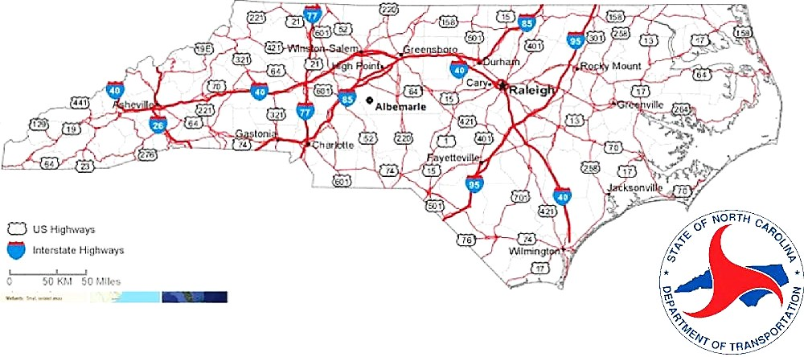

Website Links

NCDOT District 1 Stanly & Cabarrus Counties

NC Department of Transportation

Transportation Access

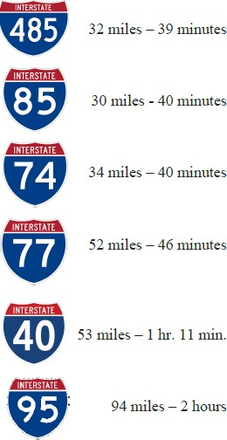
While true Albemarle doesn’t have direct access to an interstate highway, the City’s transportation infrastructure is among the best anywhere No less than six interstate highways are an hour or less drive from downtown; the City is within an hour of one of the world’s busiest airports; and residents are less than 3 hours away from the Blue Ridge Mountains or the communities and beaches along the Atlantic Coast.

Highway Network

NC Highway 24/27 is the major artery connecting Albemarle to Charlotte and beyond. NC 24/27 is a 4-lane divided highway that runs east-west from Interstate 485 in Charlotte to Albemarle and connecting to Interstate 74 less than an hour away. US 52, one of the primary trade routes in the U.S. prior to the interstate highway system being constructed, traverses through Albemarle from north-south connecting with I-95, 1.5 hours away near Darlington, SC and less than 30 minutes north to Interstate 85 near Concord, NC. Albemarle is within an hour drive or less to interstates 485, 77, 74, 73, 85, and 40.

Seaports

Two of the busiest seaports on the east coast of the U.S. are within a three-hour drive of Albemarle. The Port of Charleston (SC) is just under a four-hour drive from Albemarle via US 52 South, connecting to I-95 south in Darlington, SC connecting with I-26 to the port.

The largest port in North Carolina, the Port of Wilmington is just under 3 hours from Albemarle via US 52 South to NC 74 east to the port.

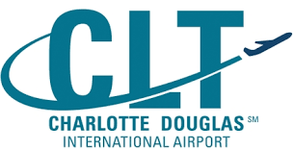  Charlotte Douglas International Airport  Charlotte Douglas is among the Top 10 busiest airports in the world. A hub facility for American Airlines there are more than 175 outbound flights daily to destinations around the world. More than 50 million passengers pass through CLT each year. The airport is currently undergoing over $1 billion in improvements. CLT is approximately 1 hour from Albemarle via NC 24/27 and I-485.  https://www.cltairport.com/ | Piedmont Triad International Airport, located in Greensboro, is 64 miles and approximately a one hour and 15-minute drive from Albemarle via NC 109 and Interstate 73. PTI offers 16 direct flights to major US cities and more than 180 daily domestic one stop flights across the US. PTI is served by five airlines including Delta, American, Allegiant, Spirit and United.  https://flyfrompti.com/ | Stanly County Airport (KVUJ) is a county-owned, joint civil-military, public-use airport four miles from Albemarle. The airport provides a full-range of services and is one of the few general aviation airports in the US with its own tower due to the Air National Guard wing which is based here. A modern terminal with all amenities including computerized weather and flight info, lounges, meeting rooms, and a full-time staff are ready to assist.  www.stanlycountyairport.com/

International Airports & General Aviation

Charlotte Douglas International (CLT) is accessible from Albemarle via NC 24/27 and Interstate 485 and is about a one-hour drive. CLT is a hub facility for American Airlines and serves all major US airlines. There are more than 600 flights daily including direct flights to all major US cities and more than a dozen foreign destinations. Last year, more than 50 million passengers flew through CLT ranking it among the Top 10 busiest airports in the world.

Piedmont Triad International Airport is just over an hour from Albemarle via NC 9 and Interstate 73. Located just outside Greensboro, PTI offers over 180 flights daily, including 16 direct flights to US cities and is served by 5 major airlines.

Stanly County and the City of Albemarle have access to one of the top general aviation airports in the United States. A shared facility with the Air National Guard, Stanly County Airport is equipped with a 24-hour manned tower and state-of-the-art technology. The 12,000 square foot terminal was built in 2010 and has both pilot and passenger lounges, computerized mapping and flight information, conference rooms, and a full-time staff.

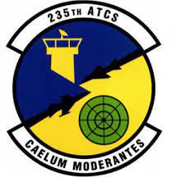
The New London Air National Guard Base, which shares the airport with Stanly County, performs Air Support Operations missions, which involves providing critical meteorological services for planning, requesting, coordination and controlling air support to ground operations. More than 2,000 airmen train at the Stanly County ANG Base each year and hundreds more train at the adjacent fire academy. New London is home to: :

  - 283rd Combat Communications Squadron
  - 235th Air Traffic Squadron
  - 118th Air Support Operations Squadron
  - 15th Weather Flight

Historic Downtown Albemarle Redevelopment

General Information

The downtown area of Albemarle is the center and focal point of Stanly County, serving as the County seat and home to a diverse number of businesses including those for local and state government, professional services, retail, restaurants, non-profits, educational institutions, and entertainment. The historic downtown commercial district contains a diverse range of commercial uses and a growing resurgence in demand for downtown residential dwellings and retail. Recent downtown projects include:

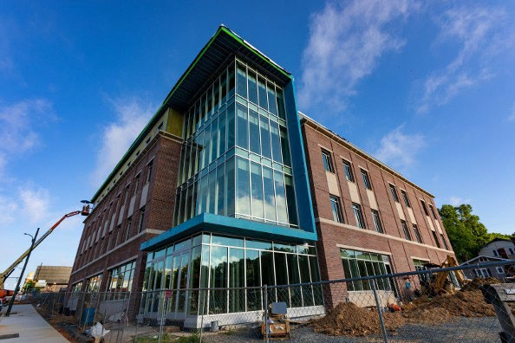
- The more than $11 million invested in the Pfeiffer University Health Science Center (HSC) which opened in 2020 in the Five Points area of downtown. The HSC currently has more than 150 students in master’s degree level Physician Assistant and Occupational Health programs. 275 students are expected by 2023.

- Developer Anchor & Pillar began redevelopment of the former Albemarle Hotel in June of 2021. Renamed The Residences at the Albemarle Hotel, the property will

feature 29 apartments and retail space. The $8 million project was financed in part through crowdfunding led by Vicinity Capital with the remainder financed by Uwharrie Bank, one of the nation’s top regional banks headquartered right here in Albemarle.

- The City of Albemarle also invests in downtown. The City has expanded City Hall, and in 2019 renovated a closed bank building to house the headquarters for the Albemarle Police Department. Total investment of more than $6 million.

- Stanly County History Center on 2nd St. and opening of the
Albemarle Neighborhood Theater on N 3rd St.

- Redevelopment of the former Station 1 Fire Department building on 3rd St. into Albemarle’s first craft brewery. Total investment of over $1 million with 17 jobs.

- The opening of The Tomahawk Throwing Range & Blade Shop at 130 S. 2nd St.; and Badin Brews on 1st St., are just two of several new businesses that have located in downtown Albemarle.
Pfeiffer University Health Science Center (HSC),
downtown Albemarle. The HSC has helped spur growth in Downtown Albemarle.
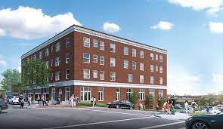
Rendering of The Residences at the Albemarle Hotel. Developer Anchor & Pillar are investing more than
$8 million to restore the former hotel into 29 luxury apartments and retail space.
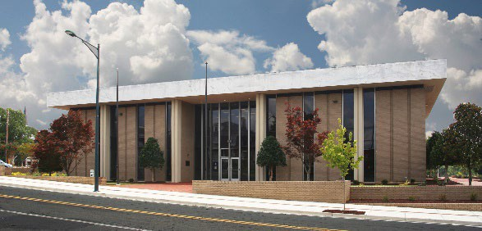
Once a former Savings & Loan, the City of Albemarle invested more than $6 million to make the building the City's new Police Department Headquarters.

The Albemarle Downtown Development Corporation (ADDC)
The ADDC works with the City and downtown businesses and stakeholders to support the downtown business community. The ADDC, a 501(c)(3) non-profit, takes an active role in the planning and promotion of a
number of events and festivals each year. The ADDC also provides grants and other assistance to downtown businesses and raises private sector funds to recruit new business to downtown and support existing businesses. The ADDC also owns and provides upkeep to three parks in the downtown area and is part of the National Main Street Program and the North Carolina Main Street Program.
  - Albemarle Downtown Development Corporation (ADDC)
  - North Carolina Main Street Program

City of Albemarle & Downtown Strategies Strategic Plan

In late 2021, the City of Albemarle Council contracted with Retail Strategies of
Birmingham, AL to work with City staff, the ADDC, downtown business owners, property owners, and stakeholders to develop a 5-year strategic plan for the downtown.

The year-long program of work had its kickoff meeting in early November 2021. Staff have already started the process of communicating with and engaging the business community, stakeholders, and citizens. Several initiatives to improve the downtown have already been identified including:

  - Providing free wi-fi downtown and free wi-fi to the City’s public housing communities
  - Research and discussion to create a Women & Minority Business Program.
  - Creation of the Catalyst Grant Program to assist downtown businesses and property owners

The overall scope of work in the coming months will include:

- Creation of a strategic plan that will include an assessment of all available property downtown
- Identifying grant programs or other assistance to help property owners improve and maintain their properties
- An improved marketing and promotions plan that encompasses the entire region.
- A review of all policies, procedures, programs, and assistance offered to downtown businesses
- A plan to identify gaps in the downtown retail needs and recruit new businesses and housing downtown.
Once finalized and approved by the Albemarle City Council, the plan will be implemented by the City of Albemarle Economic Development Department and the ADDC staff. This will be our road map to create an even greater downtown Albemarle that will bring in new business, more available housing, and support the existing businesses in our charming Downtown.
  - Retail Strategies: Downtown Strategies Strategic Planning
  - Retail Strategies: City of Albemarle Marketing Plan 2020

D. Downtown Albemarle Grants & Assistance

The City of Albemarle and the Albemarle Downtown Development Corporation (ADDC), 501C(3) non-profit, both provide grant assistance to qualifying businesses.

The City of Albemarle supports the ADDC non-profit through a public-private partnership. City economic development staff work closely with the ADDC Board of Directors and assists the ADDC with its annual program of work and day-to-day management of the non-profit.

ADDC grants and assistance include:
- Landscape Grants
- Façade Grants
- Sign Grant

The Albemarle Downtown Revitalization Area Policy (ADAR)

The City of Albemarle provides a 100% tax break for five years for qualifying economic development projects that invest in City industrial and/or retail buildings. The improved value of the building is eligible to receive a 100% tax break for 5 years. The incentive is discretionary and must be approved by the Albemarle City Council. Contact the City of Albemarle Economic Development Department for more information or to apply for this incentive.

The Downtown Albemarle Catalyst Grant Program

In early 2022, the City of Albemarle Council approved a new grant program that provides up to $50,000 in grant funds for businesses in the downtown Municipal Service District (MSD). The MSD, made up largely of the entire downtown area, is assessed a special tax with proceeds from the tax supporting grant, marketing, and promotion of the downtown businesses, festivals, and events. Businesses that apply for and are approved can utilize the funds for building improvements or to refurbish or purchase new furniture, fixtures, and equipment. Initial funding for Year 1 of the Catalyst Grant is $90,000.

To learn more about this or other grants or incentives for downtown businesses, contact the City of Albemarle Economic Development Department.
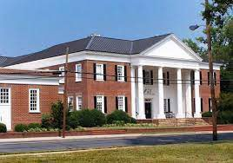
- City of Albemarle Government
- Albemarle Downtown Development Corporation

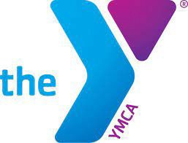
Albemarle residents have access to one of the top YMCA facilities and staffs in the region. Click here for more info about our fabulous YMCA!

Historic Tax Credits

Historic Downtown Albemarle has received historic district accreditation by the federal government and the State of North Carolina. This designation protects the downtown through redevelopment guidelines and also affords developers and investors an opportunity to obtain a number of tax credits.

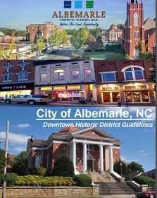
Local City of Albemarle Historic Designations, Tax Credits & Guidelines

The City of Albemarle places oversight and decision-making authority on historic districts with the Historic Resource Commission (HRC). Appointed by the City Council, the HRC members are charged with Administering Certificates of Appropriateness (COA) along with other responsibilities. Above all, the HRC helps preserve historic sites that have important architectural, cultural, social, economic, political, or archaeological history for the enrichment of the community. The HRC must also keep an inventory of historic resources, review National Register nominations, and it may designate local landmarks and districts.

The Downtown Albemarle Historic District boundary includes over 160 properties encompassing the historic downtown core generally from Market

Click Here to download the Downtown Albemarle Historic District Guide.

Station to the West, Five Points to the East, South Street to the South, and North Street to the North. It includes industrial, educational, institutional, commercial, and residential that developed in the late- nineteenth and early twentieth centuries.

  - City of Albemarle Downtown Historic District Guide

State of North Carolina Historic Rehabilitation Tax Credits are Income tax incentives for the rehabilitation of historic structures are important tools for historic preservation and economic development in North Carolina. A federal income tax credit for the rehabilitation of historic structures first appeared in 1976 and today consists of a 20% credit for the qualifying rehabilitation of income-producing historic properties. Since 1976, over 3,100 completed "certified rehabilitation" projects have been reviewed by the N.C. State Historic Preservation Office, representing almost two billion dollars of investment in historic properties.

  - NC Historic Rehabilitation Tax Credits Website
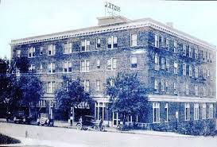
Anchor & Pillar Development is completing renovations to the former Albemarle Hotel in the Downtown Historic District. When completed in 2022, The Residences at the Albemarle Hotel will feature 29 luxury apartments and retail space.
More info at: www.anchorandpillar.com

Federal Historic Tax Credits

The Federal Historic Preservation Tax Incentives program encourages private sector investment in the rehabilitation and re-use of historic buildings. It creates jobs and is one of the nation's most successful and cost-effective community revitalization programs. It has leveraged over $102.64 billion in private investment to preserve 45,383 historic properties since 1976. For more information on how to develop property in the Historic District and how to qualify for the National Register Historic Tax Credit program click here.

20% Tax Credit
Federal Historic Tax Credits Summary

A 20% income tax credit is available for the rehabilitation of historic, income-producing buildings that are determined by the Secretary of the Interior, through the National Park Service, to be “certified historic structures.” The State Historic Preservation Offices and the National Park Service review the rehabilitation work to ensure that it complies with
the Secretary’s Standards for Rehabilitation. The Internal Revenue Service defines qualified rehabilitation expenses on which the credit may be taken. Owner-occupied residential properties do not qualify for the federal rehabilitation tax credit. Learn more about this
credit before you apply.
Each year, Technical Preservation Services approves approximately 1200 projects, leveraging nearly $6 billion annually in private investment in the rehabilitation of historic buildings across the country. Learn more about this credit in Historic Preservation Tax Incentives.

10% Tax Credit
PLEASE NOTE that Public Law No: 115-97 (December 22, 2017) repealed the 10% tax credit.
The 10% tax credit is available for the rehabilitation of non-historic buildings placed in service before 1936. The building must be rehabilitated for non-residential use. In order to qualify for the tax credit, the rehabilitation must meet three criteria: at least 50% of the existing external walls must remain in place as external walls, at least 75% of the existing external walls must remain in place as either external or internal walls, and at least 75% of the internal structural framework must remain in place. There is no formal review process for rehabilitations of non-historic buildings.

Tax Benefits for Historic Preservation Easements
A historic preservation easement is a voluntary legal agreement, typically in the form of a deed, that permanently protects an historic property. Through the easement, a property owner places restrictions on the development of or changes to the historic property, then transfers these restrictions to a preservation or conservation organization. A historic property owner who donates an easement may be eligible for tax benefits, such as a Federal income tax deduction. Easement rules are complex, so property owners interested in the potential tax benefits of an easement donation should consult with their accountant or tax attorney. Learn more about easements in Easements to Protect Historic Properties: A Useful Historic Preservation Tool with Potential Tax Benefits.

Community Data, Statistics & Information
  - Demographic & Livability Data

According to the 2020 US Census, the City of Albemarle had a population of 16,432 and trade area of over 60,000. Albemarle is the county seat of Stanly County as well as the County’s major center of employment. The following links are reliable data sources for demographics, retail trade, community and livability data, and official local, regional, and state websites.

Demographic & Community Data: City of Albemarle, NC
Click Logo or Map To View  US Census Bureau City of Albemarle Dashboard | 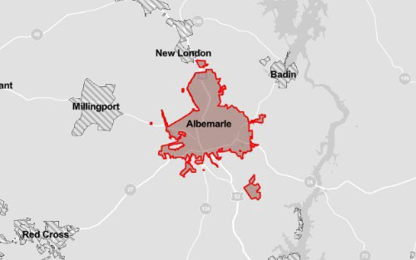
Click Logo or Map To View  N.C. Office of State Budget And Management  State & Community Statistical Information | 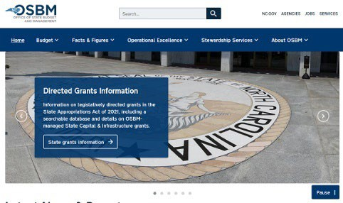
Click Logo or Profile For  City Data Profile: City of Albemarle, NC | 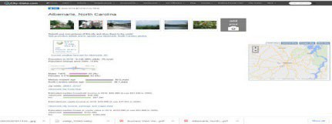
Click on the DATAUSA logo or website home page image for  Community & Demographic Information For The City of Albemarle | 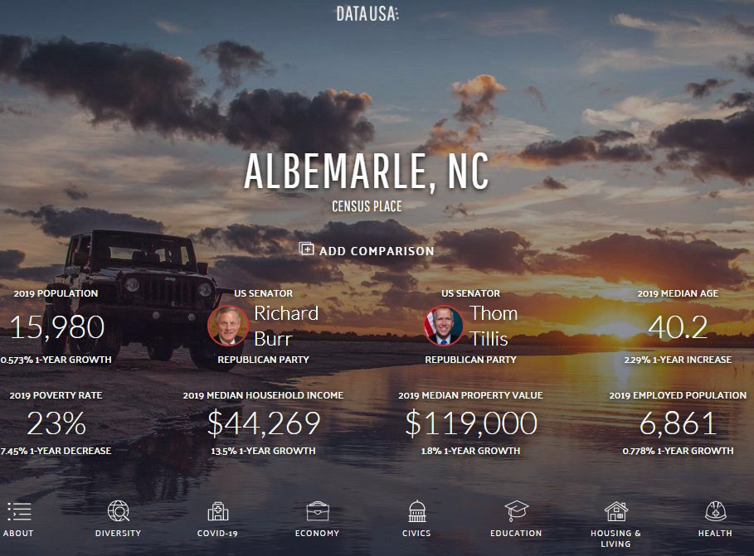

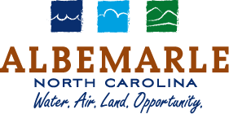  Click Logo or Image website image for the official website of  The City of Albemarle Government | 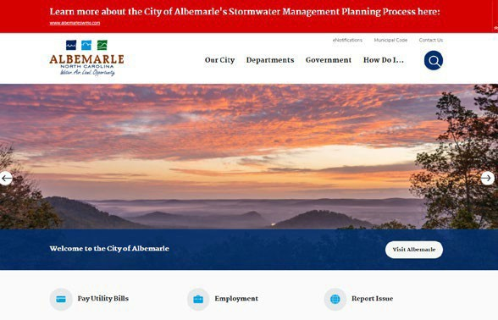
Click Logo or website home page for  Stanly County Economic Development | 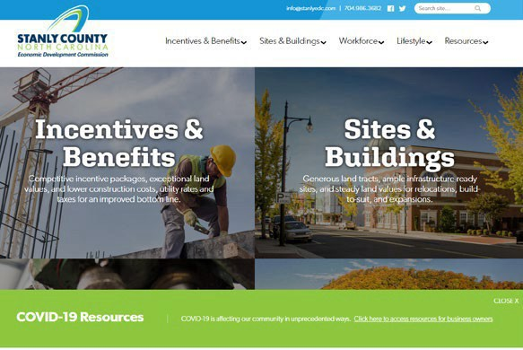
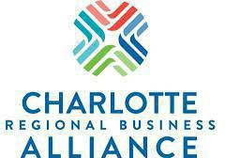  Click logo or web page image to visit the website for the  Charlotte Regional Alliance | 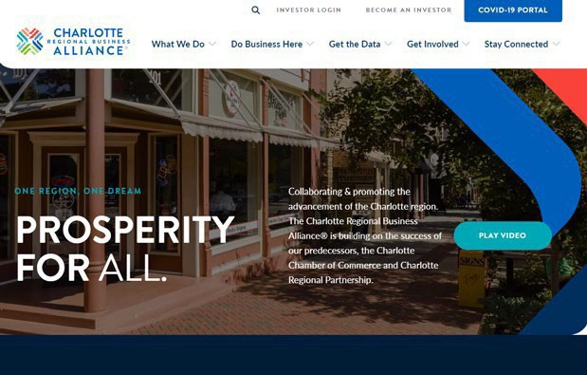
Click logo or website home page for the  North Carolina Economic Development Partnership | 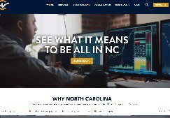
Click Logo or Profile For Retail Strategies  City of Albemarle 2021 Retail Market Profile | 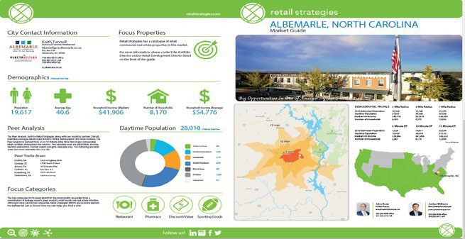

Click on logo or website home page image to visit the
Stanly Community College website & Stanly CC Small Business Center
Click logo or Document Cover For  The Albemarle Downtown Development Corporation (ADDC) | 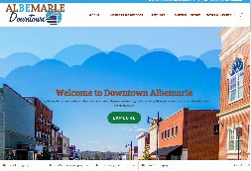
Click Logo or Image To Visit
Stanly County Convention & Visitors Bureau VisitStanly.com
Click on the Logo or Image To Visit  Stanly County Chamber of Commerce | 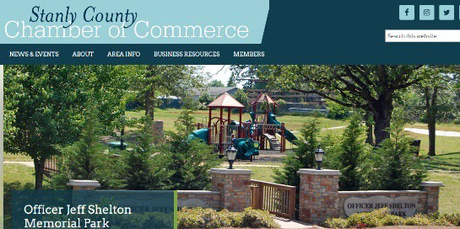

Click Logo or Document Image For Downtown Albemarle Historic District Development Guidelines & Documents | 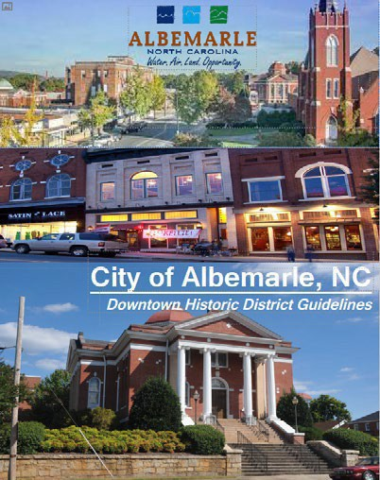
Click Logo or Document Cover For  City of Albemarle Land Use Plan | 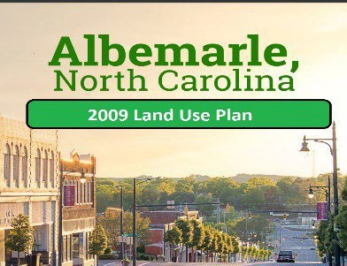
Click Logo or Document Image For  Albemarle Business Center Industrial Park Marketing Flyer | 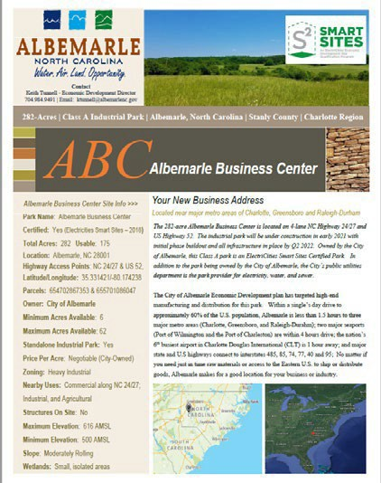
Click logo or web page image to visit the  NC State Climate Office Website.  The site has historical climate and weather data for all of NC. CLICK HERE to NC State Weather Monitoring Station in NewLondon, NC which is only a few miles from the City of Albemarle. | 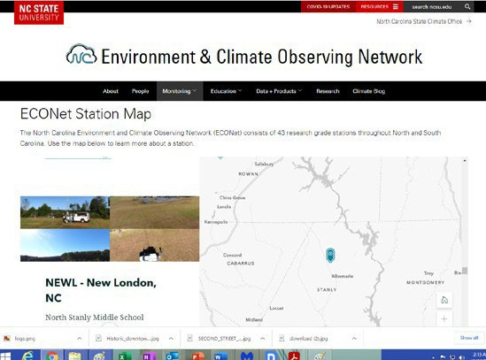
2022 Downtown Albemarle  1-Mile Radius Demographic & Market Data | 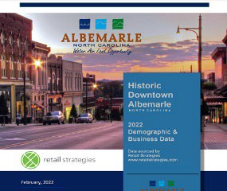

Downtown Marketing

NC 24/27 & US 52 Retail Corridors

There is a strong demand for housing, retail, services, and restaurants in the downtown Albemarle market. Retail Strategies of Birmingham worked with the City of Albemarle the past eight years to assist with recruitment of regional and national retailers to the Albemarle market. Largely focused on the NC 24/27 and US 52 retail corridors where most regional and national chains would locate due in large part to the traffic counts on both highways, Retail Strategies has been successful in bringing more than $17 million in new investment and creation of more than 600 retail jobs to the City of Albemarle.

Downtown Strategies – Downtown Albemarle Strategic Plan

Due to the success over the past 10 years partnering with Retail Strategies on the regional and national retail recruitment program for the NC 24/27 and US 52 corridors, City leadership signed a contract to work with Retail Strategies’ downtown development division.

Retail Strategies’ downtown planning and marketing division works with small downtowns across the country to assist them with identifying key assets, assessing all building and property assets, identifies retail and other business gaps; develops strategies to attract new business with an emphasis on gaps, to help staff and stakeholders who are heavily engaged develop a full downtown marketing plan The goal is to have input from all business owners, residents, and stakeholders to create a detailed marketing strategy and plan of work to attract key smaller businesses into the Albemarle downtown.

The City’s economic development and ADDC staff have worked closely with the Retail Strategies Downtown team. The year-long program of work to create a strategic plan for Downtown Albemarle got off to a great start in early November 2021 when more than 40 downtown business owners, property owners, and stakeholders attended the Downtown Strategies Kick-Off event at City Hall.

Key components of the strategic plan that will be developed with input from business owners, property owners, stakeholders and citizens in the coming year will likely include:

Existing Property Assessment, Cataloging & Marketing
An assessment of all available buildings in the downtown with a rating of those that are:
  - in a suitable condition to lease
  - in a condition to lease with minor improvements and repairs
  - in a condition to lease with major improvements or repairs
  - those properties that are blighted and must undergo substantial repairs and renovations or possible demolition

These properties will have marketing flyers created that can be put into the City’s new economic development database to be marketed to interested parties.

Events & Festivals
An assessment of existing events and festivals to determine the success of each and how best to grow, market, and promote each event to maximize participation and attract locals and tourists from the nearby major population centers of Charlotte and Greensboro. Meetings will be held with stakeholders throughout 2022 with their assistance and guidance to complete the plan.

ADDC / City Economic Development Review
A review of the program of work and success of both the City of Albemarle Economic Development Office and the Albemarle Downtown Development Corporation (ADDC).

Committees Reviews & Reports
Retail Strategies staff will create committees made up of like businesses in the downtown. Each committee will be responsible for analyzing and reviewing the current programs, policies and procedures utilized by the ADDC and the City to promote downtown businesses, attract new business and otherwise provide input as to how we can work together to make Downtown Albemarle an even better location for business, housing, and visitors. The recommended list of committees may include:
  - Restaurants
  - Retailers
  - Professional Services
  - Governmental
  - Property Owners, Real Estate Professionals & Banking
  - Housing
  - Churches
  - Non-Profit Agencies
  - Tourism & Entertainment
  - Citizens
  - Youth
  - Education (K-12/Stanly CC/Pfeiffer)
  - Minority Populations To Promote & Support Diversity
  - Farmers
  - Others
Each group will meet and identify strengths, weaknesses, opportunities and threats (SWOT) pertaining to their respective business sector. Each group will be asked to report back to the leadership team their concerns, solutions, and recommendations to improve the downtown business district. Each of these sub-set reports will be included in the final strategic plan with major goals, objectives, tasks, and recommendations included in the final plan for review by City Council. If approved by City Council, the goal is to have each sub-set group continue to meet twice annually with ADDC and City staff to ensure the plan is implemented and to make any recommendations for additions or changes to the plan. The overall goal is to create and implement a plan that the business owners and key stakeholders create and help implement successfully.

Business Attraction, Marketing and Promotion
The plan will also identify gaps in the downtown retail market and create a marketing plan to attract those businesses to the downtown.

The plan will also analyze and review current marketing and promotion plans and practices for both traditional and digital marketing. The evaluation and assessment will determine if improvements can be implemented to increase the number of visitors to the City for day trips or longer visits, attendance at events, festivals, etc. and to identify sub-set markets to create customized marketing plans that might include:

  - Tourists going to the Uwharries & Lakes Region
  - Upcoming events at City parks or the City Theatre
  - Area HIstoric Sites
  - Vineyards
  - Drive-In Theater
  - The Air National Guard Training Programs & Fire Training Program At Stanly County Airport
  - National Outdoor Sports & Recreational Events & Competitions
  - Local & Regional Wineries, Brew Houses, and Breweries
  - Ag & Art Events & Festivals
  - Storytelling Festivals
  - Car Shows
  - Our Unique, Nostalgic & Famous Products & Businesses (Sweet Shop, Drive-In, Donut Dinette, Goody Shoppe Café, The Tomahawk Throwing Range, Carolina Treetop Challenge, etc.)
  - Cultural Events & Festivals To Highlight & Honor The City’s Diversity
  - Day & Weekend Trip Planners & Marketing to Charlotte and Greensboro markets
    - Families with Children Trip Planners
    - Older Active Adults Trip Planners
    - College Aged Singles Activities & Events
    - Young Active Married Couples
    - Singles
    - Nature & Outdoor Enthusiasts
    - Foodies

  - FY 2021-2022 Albemarle Economic Development Budget
  - FY 2021-2022 Albemarle Downtown Budget
  - FY 2021-2022 Albemarle Downtown Development Corporation Budget
  - 2017 City of Albemarle Strategic Plan
  - Retail Strategies City of Albemarle 2021 Retail Market Study
  - Retail Strategies Website
  - 2022 Downtown Albemarle 1-Mile Radius Demographic & Market Data

City of Albemarle Economic Development Staff

Mr. Keith Tunnell, Director
City of Albemarle Economic Development Department 144
N. 2nd St. | PO Box 190 Albemarle, NC 28001 Phone: 704.984.9419 Cell: 803.487.4531
Email: ktunnell@albemarlenc.gov

Primary Responsibilties: Mr. Tunnell supervises and directs all City economic development programs and services. Along with planning and implementing the city's economic development program of work, Mr. Tunnell is the lead on all industrial, office, and major retail projects involving the City. He is also the lead marketer in attracting new business and industry to the new Albemarle Business Center industrial park and he is the primary project manager for all City retail, industrial, and commercial projects including those in the downtown municipal service district (MSD). He serves on the Board of the Albemarle Downtown Development Corporation and oversees and manages two staff members whose primary responsibilities are to market and support the ADDC and downtown development.

Mr. Tunnell has over 25 years of economic development experience and marketing. He served as Public Information Officer and assisted with economic development for the City of Sevierville; was Project Director with the South Carolina Department of Commerce from 1999-2002; Assistant Economic Development Director and Public Information Officer for Lancaster County (SC) from 2002-2003. Tunnell served as President of the Lancaster County Economic Development Corporation (LCEDC) from 2003-2015. During his tenure, the LCEDC's membership grew from under 30 members to over 140 and membership dues increased from just over $30,000 annually to more than $225,000 in 2015. Under his leadership, the LCEDC was also successful in obtaining more than $4 million in grants.

Decimated by textile industry offshoring, Lancaster County lost more than 23,000 jobs in the textiles and more than 30% of the County's tax base from 1990-2007. Tunnell and the County leadership created and funded an economic development plan to recruit new and varied companies to the community and improve workforce training. Tunnell worked with private sector developers and investors to create new industrial and office parks as part of the County's overall plan to improve economy. The LCEDC and County's efforts proved successful as the LCEDC created more than 10,000 jobs from 2005-2015 and increased per capita incomes from $19,000 in 2005 to more than $52,000 today.

The LCEDC and County's development plan was centered on diversifying the County's employment away from a single industry as had been the case for over 100 years with Springs Industries textile operations. Tunnell and his team successfully recruited high tech manufacturing, back office, mining, distribution; and national and regional headquarters for Fortune 1000 companies. His team's marketing and recruitment efforts led Red Ventures to locate its headquarters campus in Indian Land, SC that employs more than 3,000 in internet sales and marketing with a total investment in the County by the company of more than $300 million. During his tenure, Lancaster County averaged $150 million annually in new investment and lowered the County's unemployment rate from a high of 18.9% in the midst of the Great Recession to less than 3% when his career with the LCEDC came to a close in 2015.

Joy Almond, Director
Main Street Program & ADDC Liaison
City of Albemarle Economic Development
144 N. 2nd Street | PO Box 990 Albemarle, NC 280021

Phone: 704-984-9420
Email: jalmond@ci.albemarle.nc.us Web: www.albemarledowntown.com

Primary Responsibilities: City Liaison with the Albemarle Downtown Development Corporation; Main Street Coordinator; Downtown Redevelopment; Downtown Events and Festivals; Downtown Business Contact for ADDC & City of Albemarle
Monica Chang Marketing Assistant City of Albemarle Economic Development
144 N. 2nd St.| PO Box 990
Albemarle, NC 28002

Phone: 704.984.9417
Email: mchang@albemarlenc.gov
Web: www.albemarlenc.gov

Primary Responsibilities: Works with ADDC Liaison and Main Street Manager to promote and market events; Economic Development administrative duties; creation and implementation of marketing and promotion plans for all City and ADDC events and festivals.

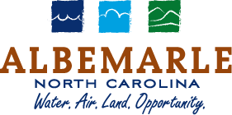
54
RFP: Redevelopment Of The Former Albemarle Police Department & U.S. Post Office Building City of Albemarle Economic Development: Keith Tunnell, Director
144 N. 2nd St. | PO Box 190, Albemarle, NC 28002-0190 | Phone: 704.984.9419 | Email: ktunnell@albemarlenc.gov

For Additional Information Contact

Mr. Keith Tunnell, Director
City of Albemarle Economic Development Department 144 N. 2nd St. | PO Box 190 Albemarle, NC 28002
Phone: 704.984.9419
Email: ktunnell@albemarlenc.gov
Web: www.albemarlenc.gov

