Number
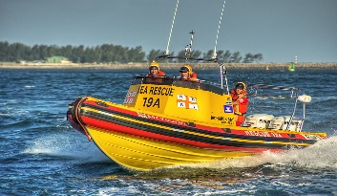
Registration Form
Silver Lake Howard Benedict Memorial Boat Parade
Tuesday, July 4, 2023 @ 2:00 PM Sharp
Directions: Please complete the information below and return it to the Parade Coordinator, Sally Capurso, via email: 13caps@rochester.rr.com before July 4 (preferred) OR via a hard copy at 1:30 PM on 07/04 at the parade to the Silver Lake Boat near the Marina dock. You will then be given a number to place in a visible location on your boat facing the shoreline. Please return this number at the end of the parade to the SLA boat OR to 4199 Private Drive 3, if you forget!
Winners will be announced at the SLA Annual Meeting on Saturday, August 12. (You will be contacted.) Participants arriving after 1:55PM may possibly be ineligible for prizes.
Last name_________________________First name ____________________
Email address______________________phone #_______________________
*******************************OR*********************************
Group Name_____________________Track Name________________________
Boat Category: (Circle one)
Sport Boat Pontoon Boat Row Boat Other_________________
Brief Description of your Boat _______________________________________
________________________________________________________________

Category You Want Judged: (Circle one)

Patriotic OR Most Creative OR Funniest OR Under the Sea (Lake) Theme
ALL are entered for the Presidential Award.
Revised 06/2023 Questions: email Sally @ 13caps@rochester.rr.com

