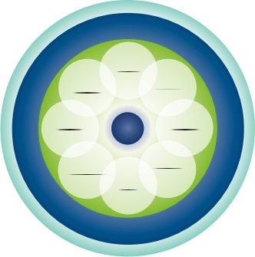

**t**

**r**

**1**

**Miserable**

**2**

**3**

**4**

**5**

**Great**

**1**

**Miserable**

**2**

**Mental/Emotional Well-Being**

**3**

**4**

**5**

**Great**

**1**

**Miserable**

**2**

**Life: How is it to live your day-to-day life?**

**3**

**4**

**5**

**Great**

**Personal Health Inventory**

**Use this circle to help you think about your whole health.**

● All areas are important and connected.

● The body and mind have strong healing abilities. ● Improving one area can help other areas.

● The inner ring represents your mission, aspirations, or purpose. Your care focuses on you as a unique person.

● Mindful awareness is being tuned in and present. ● Your self-care and everyday choices make up the

green circle.

● The next ring is professional care (tests, medications, supplements, surgeries, examinations, treatments, and counseling). This section includes complementary approaches like acupuncture and yoga.

**Power of**

**the Mind**

1. elaxing & Healing
2. **pirit & Soul**

Growing& Connecting

**Family, Friends**

**& Coworkers**

Relationships

**Moving**

**the Body**

Energy& Flexibility

**Me**

1. **echarge**
2. leep & Refresh

**Surroundings**

Physical & Emotional

**Personal**

**Development**

Personal Life

& WorkLife

**Food & Drink**

Nourishing& Fueling

● The outer ring includes the people and groups who

make up your community.

**Me**

**Rate where you feel you are on the scales below from 1-5, with 1 being miserable and 5 being great.**

**Physical Well-Being**

**What is your mission, aspiration, or purpose? What do you live for? What matters most to you?** Write a few words to capture your thoughts: