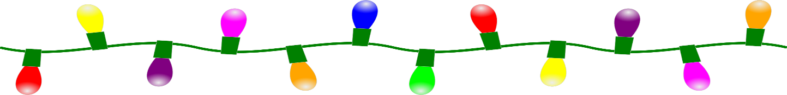
Edwardsville Hometown Committee
Annual Christmas Light’s Project
@ Main & Hillside

Cost:
RETURNING sponsor’s-$50.00
FIRST TIME sponsor-$100.00

This fee helps to cover:
1.The cost of the lighting and replacement of lights & electrical equipment and decorations yearly.
2. A holiday sign with your personal message placed in the display area.
3. Remaining proceeds go to Edwardsville Hometown Committee projects fund

Name_____________________________________Email_____________________________
(print)

Message for my sign: (please print)

Amount paid______________ via: check___ Money order___(payable to Edwardsville Hometown Committee)
Sponsor’s are encouraged to be a part of the decorating process, bring your family & friends! Many hands make light work! Please mark below what you can assist with.

I will be participating in the decorating_________ (please bring work gloves, step ladder, light hanging pole if you have )

I am unable to participate in the decorating________

I will help monitor the display during through December and January_____

I will assist with un-decorating & Packup after the holilday________

Please drop off form and payment in a sealed envelope in the Committee drop box
at the Edwardsville Borough building before November 1st
**Forms and payment can also be mailed to: P.O.Box 1224 Kingston Pa.18704

**Offical Display Lighting with a visit from Santa!
Friday Nov 28th 6pm to 7pm
Light Refreshments

