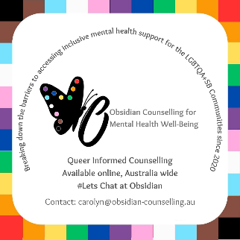

**New Client Registration Form Counselling - Adult**

*Please note Obsidian Counselling only provides counselling support for mild to moderate mental health wellbeing concerns, working exclusively with the Gender Sexuality Diverse Communities & those questioning or concealing their authentic Self. Clients must live at a valid Australian residence and provide proof upon request. For further TC&Ps see the Obsidian website https://obsidian-counselling.com.au/*

Date: Click or tap here to enter text.

***Section 1: Personal Details **required***

Name you would like us to use: Click or tap here to enter text.**

Legal Surname: Click or tap here to enter text.**

Legal First Name or Initial: Click or tap here to enter text.**

Date of Birth: Click or tap here to enter text.**

Country of Birth: Click or tap here to enter text.

Gender: Click or tap here to enter text. Pronouns: Enter text.

Contact Number**: Click or tap here to enter text. Okay to text? Y  N

Address**: Click or tap here to enter text.

Town/Suburb** Click or tap here to enter text. State** Click or tap here to enter text. Postcode Click or tap here to enter text.

E-mail**: Click or tap here to enter text. Okay to email? Y  N

Please our primary method of contact is via email.

Cultural Identity: Click or tap here to enter text.

***Section 2: Emergency Contact*** (In case of an emergency, who do we contact?)

Name**: Click or tap here to enter text.

Contact Number**: Click or tap here to enter text.

Relationship to you: Click or tap here to enter text.

***Section 3: General Information***

* Is there any information you feel is relevant you would like to share prior to your first session?

Click or tap here to enter text.

* My preferred day for Counselling Saturday  or Monday
* I have access to stable internet or phone connection yes  or No
* I acknowledge that Obsidian Counselling is fee-for-service, and that no Medicare or health fund rebates are available or applicable. Further if no payment is made prior to session, that the session will be automatically cancelled Yes
* How did you hear about Obsidian Counselling for Mental Health Well-Being?

Click or tap here to enter text.

***Section 4: Signature***

Typing your signature is acceptable for this form

Client Signature: Click or tap here to enter text.

Date: Click or tap here to enter text.

Please see the Obsidian website for further TC&Ps of booking

https://obsidian-counselling.com.au/terms-conditions-policies

---------------------------------------------------------------------------------------------------------------------

Client Reference: (office use only)

If you need to talk with someone urgently please phone

Lifeline on 13 11 14

If life is in immediate danger phone 000 (triple zero)

Thank-you for completing.