Local roots farm 2021 csa membership agreement

2021 csa membership agreement
We, Local Roots Farm, pledge to provide our Members with fresh, NOFA certified organic, local seasonal food. You, the Member, will receive a portion of our harvest. This agreement outlines our shared commitments to that relationship. By purchasing a membership share, you agreed to the terms and conditions outlined herein. Please retain a copy of this agreement for your own personal records.

Becoming a member of Local Roots Farm:

CSA Stands for community supported agriculture, which is basically a subscription for vegetables. Members pay up front to secure their share. We farmers then use the money to purchase seeds and equipment to get food growing. Then, each week, beginning in mid June 2021 to mid/late October 2021 , we provide fresh, local vegetables to our farm members.

Growing practices
- We believe in providing fresh, seasonal, certified organic veggies from our farm to your home. We believe that people should have a relationship with their food, one that gives back to both members and back to the land. We believe in transparent farming practices. Our farm records will be available to all members upon request. We welcome any inquiries about our standards or about our growing practices.

SHARED RISK
- Members of our CSA get the opportunity to share in the abundance of a local Western New York farm. With that opportunity there are risks associated with our growing season. We are committed to minimizing those risks, yet risks will always remain. We promise to do our best to provide you with a bountiful share each week. By joining our CSA, you are agreeing to share the risk of crop failure with us and all of our members.

Should this happen, members will be contacted directly, as soon as possible, to discuss options for remediation. However; it is unlikely that we would be able to refund membership fees or even partial membership fees, as the money is used to fund the seasons expenses. Please take this into consideration when joining our CSA.

SHARED REWARD
- There is an opportunity for developing connections and relationships between the farmer, the land and other fellow CSA members through the farm newsletters, on-farm events, volunteering on the farm, potential hands on classes regarding cooking and growing & community group discussions. These types of learning activities and community events would take place both at Local Roots Farm and pick up places location; Singer Farms Naturals.
- A sense of “we’re all in this together”. When our harvests are abundant and overflowing, your shares will be as well. We the farmers pledge to you to give our very best and do everything within our power, while remaining within our sustainable practices, to provide you as a Member with the absolute best available produce every week.

PICK UP Process & pick Up location
- Members are responsible for picking up shares each week from the pick up location. Pick up location will at Local Roots Farm 5328 West Lake rd. Burt N.Y. Please look for signs to direct you to specific locations and be sure to read emails that list these locations specifically at the site.
- Pick up time will be between 4:00-6:30PM on Wednesdays; please ensure to pick up your share with in the timeframe stated above. Although we deliver high-quality produce to the site, it will decline quickly if not picked up on time.
- We request that members are respectful of the pick up location host’s property. Follow any additional rules posted at the pick up location site
- If you cannot pick up your share, you must arrange for someone else to pick it up for you. You are responsible for explaining the pick up procedure to your substitute
- If unforeseen circumstances arise, please contact Local Roots Farm as soon as possible, as we try to accommodate for emergencies. Shares that are not retrieved within the designated pick up time will be forfeited for that week.
- You will be receiving the freshest produce available short of growing it yourself. That being said, shares will be packaged and at times may be unwashed. Please take the time to properly wash and store all produce once each week’s share is received.

MEMBERSHIP FEES

- By selling membership in advance of the growing season, CSA reduces the burden of upfront cost for the farmer. Your membership fees provide us with funds necessary to purchase seeds and equipment before the season starts, and we appreciate your commitment. Below are the payment plans offered for the 2021 season:
- Option #1: pAy in full

Pay yearly membership fee of $570.00 up front to be paid in full due by April 1, 2021 to secure yearly membership
- Option #2: pay half now/ pay half later

Split payment fee with two payments to secure your yearly membership:
- Payment One of $285.00 due by April 1st 2021.
- Payment Two of $285.00 due by June 1st 2021.

COMMUNICATING WITH US
- The best way to communicate on with us is via email, phone or Face Book. You can contact us by email at Localrootsfarmrt18@gmail.com or by phone at 716-946-3198. We will do our best to respond as soon as possible. Our Facebook page can be found at https://www.facebook.com/LocalRootsRT18/
- We will communicate with you via email. When you sign up, you will be added to our mailing list. Please check your emails from us. We depend on being able to communicate important information such as necessary changes to your distribution schedule or to our farm events. Periodically, we will email a newsletter giving you information about the crops available, recipe ideas, and any other farm related activities or news.

By purchasing a membership share, you agree to the terms and conditions outlined herein. Please retain a copy of this contract agreement for your records. We thank you in advance for your faith in our farm. We look forward to growing for you!

By signing below I, _________________________________________________, agree to the Terms and Conditions listed in the above contract and agreement regarding the 2021 Local Roots Farm CSA membership agreement. By signing I agree and commit to uphold payment responsibilities and will ensure to have $570 paid no later than June 1st 2021 as to ensure membership share for the 2021 season.

Member information
Name _____________________________________________________ Phone #(______)_____________
Email ______________________________________Additional Contact____________________________
Address ______________________________________________________________________________________
Additional Member Names__________________________________________________________________

All payments will be accepted via mail by check or money order only.
Arrangements to meet can be made for cash payments.
Please print contract and send to:
Local Roots Farm
5328 W. Lake Rd.
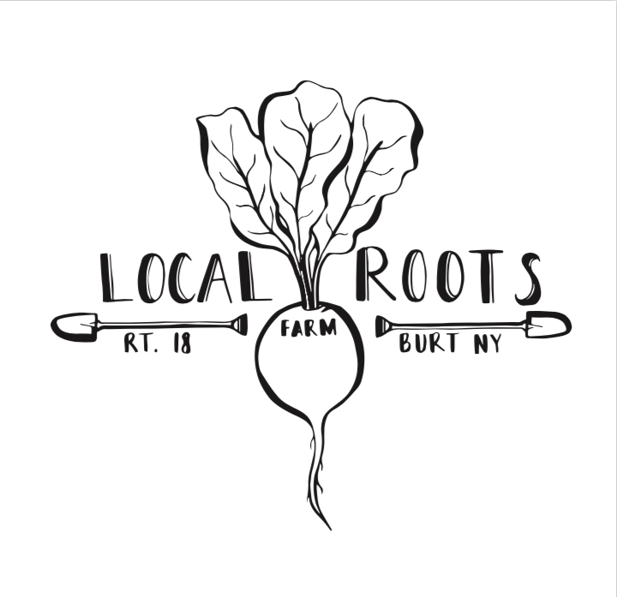
Burt NY 14028

