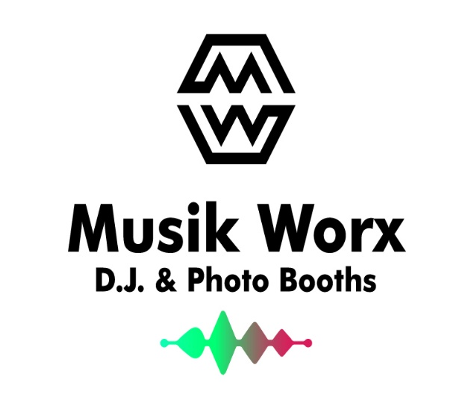
Musik Worx DJ & Photo Booths
Serving North Dakota.
526 6th Street N.E. Minot, ND 58703
(701)720-8532
www.musikworxdjphotobooths.com
Requirements/Terms and Conditions
- Non refundable retainer is Required to secure date that will be applied towards the balance.
- Wedding Reception work sheet with attached additional songs (30 to 40) must be submitted 14 calendar days prior to event date. (Including any changes)
- Client will arrange power for the DJ and Photo Booth to operate. This includes power at any outdoor location for a Ceremony or Reception. (Two 110v 10 amp 3 prong outlets within thirty feet of the set up area from a reliable power source)
- Client shall provide crowd control if warranted, furnish Musik Worx DJ & Photo Booths with directions to the event and wi-fi password at the event location.
Event Requirements: (Please check each line.)
- Access to facility at least 90 minutes prior to event for set up. (This does not affect scheduled hours.)
- The client is to provide a safe working grounded outlet.
- The client is to provide reasonable shelter from the elements. We reserve the right to deny or break down set up if location is not or becomes unsafe or may cause damage to us or our equipment.
- Music for your event must be finalized and submitted to Musik Worx DJ & Photo Booths at least 14 days prior to the event.
- Client is to provide access to a strong Wi-fi signal to ensure we have the ability to play requests throughout the time of the event.
- Client acknowledges that they are responsible for any damage or loss of our equipment for the full replacement value caused by clients or their guests, or any theft or disaster, (including but not limited to fire or flood.)
Event Terms and Conditions:
- Payment of balance will be required in full at least one week (Seven Calendar Days) before contracted event date.
- A non-refundable retainer of _________________will be required to reserve the scheduled date.
- Travel fees will apply to locations more than 30 miles from Minot.
- Client will indemnify Musik Worx DJ & Photo Booths against any and all liability related to event during or after. Client will indemnify Musik Worx DJ & Photo Booths against any and all liability associated with the use of pictures taken in the photo booth.
- Musik Worx DJ & Photo Booths is not responsible for the actions of any guests or clients. We do not condone underage drinking, drugs or allowing guests to drive under the influence.
- Once the event starts there will be no refunds.
- Client is responsible for FULL payment should cancellation occur within 72 hours of event for any reason.
- Any returned checks a charge of $50 dollars applies.
- Any unpaid balances will be assessed Late fees and interest and Client will be responsible for any and all legal fees incurred.

Service Contract:

The following contract and it’s terms will set forth an agreement between Musik Worx DJ & Photo Booths

(Provider) and______________________________________ the parties, for DJ and/or Photo Booth services for

an event taking place on (Date) ________________________. This written contract sets forth the full, written intentions of both parties and supersedes all other written and/ or oral agreements between the parties.

Service Period:

The Service period will be as follows:

Time from and to: __________________________________

Date: ______________________________________________
Provider agrees to have a Photo Booth operational for a minimum of 80% during the agreed upon period for the Photo Booth. Occasionally, operations may need to be interrupted for maintenance of the photo booth or printer.

Contact Information:
Name:
Address:
Type Of Event:
Phone Number:
E-Mail Address:

Wedding Colors:
Name And Location of Venue:
Venue Contact and Phone Number:

Package Options:

Item: | Cost: | Total:
Silver Four Hour: | $1050.00
Gold Six Hour: | $1250.00
Platinum DJ & Photo Booth Combo: | $1850.00
Ceremony: | $250.00
Up-Lighting: | $200.00 (Or $30.00 per Up-Light)
Layout Design | $25.00
Zip Drive of Event Pictures: | $20.00
Additional Hours: | $150.00
Standard Photo Booth | $850.00
Magic Mirror Photo Booth | $350.00 (Per Hour) 3 Hour Minimum.
New Platinum Plus DJ & Magic Mirror Photo Booth: $2250.00

I have read all requirements, terms, and conditions and fully understand and comply:

Name: ______________________________________________

Date: _______________________________________________

Deposit Paid: __________ Amount: ______________________

Client Signature: ______________________________________

Musik Worx Signature: _________________________________

