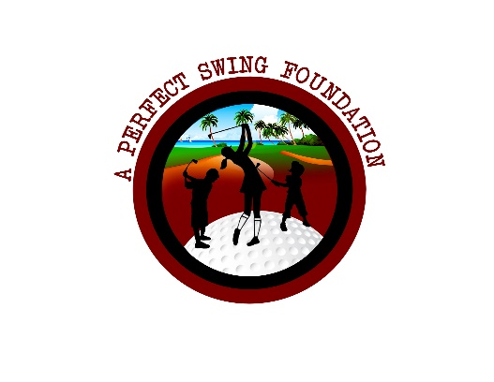
Rules/Regulations
- Dates: Mondays April 15, 2024 – June 3, 2024
- $50 to participate
(Donation to the A Perfect Swing Foundation)
- Play will take place at Sunset Hills Golf Course – short course
- All holes are PAR 4s
- You will post one score per two-week cycle to be utilized towards your point total.
- Thirteen minutes max time to play each hole. Slow play will be penalized one point.
- Stroke play (Ready Golf) is the play format
- All out of bounds and lost balls will be a one stroke penalty. You can hit from the spot of your initial shot or from where your ball crosses into the penalty (wooded) area.
- There will be a Closest to the Pin competition and prize every session

Highest Point Total at the end awarded a Bushnell GPS.
5 points received each time you play in league play
2 points received each time you make a PAR
4 points received each time you make a BIRDIE (par – 1)
8 points received each time you make an EAGLE (par – 2)
16 points can be earned once you card a 36 for the 9 holes, but in doing so you must move back a tee box for all remaining play sessions.

Name | Initial Score |  | April 15 or April 22 | April 29 or May 6 | May 13 or May 20 | May 27 or June 3 | Final  Score | Differential Score

