
September 2017

Commit Yourself to the Redeemer
Gary Smith

The last year and a half has been a challenging time for the Church of the Redeemer. Father Peter retired and we have had a series of guest priests. This allows us to continue functioning as a church in proclaiming the Gospel and having the Sacraments duly administered. This left us without the leadership of a priest to provide the guidance and vision only a priest can provide. In the interim, we have had excellent lay leadership that has continued our outreach to the needy and has provided religious education programs. No church can function without committed lay leadership and participation, and as a church we have done more than survive, we have stayed in mission.

Equally important to the time commitment of the laity is the financial strength and stability of the church. Historically, the periods between permanent rectors has been a time when the church builds up cash reserves that see us through the times when the rector’s salary and expenses often brings us to a negative cash flow situation. The selling of the rectory and a previous building fund campaign, gave the church the money to make some sorely needed restorations and improvements to the church. These actions leave the building in good shape for the time being, but any 200-year-old building will always need more TLC than newer construction.

For the time being our financial operating position is in good shape, but it is essential that we remain faithful and generous in our giving so that as a church we can do more than survive. It will soon be time to consider making a pledge for 2018. Now is the time to begin prayerfully considering what your response to this year’s stewardship campaign will be.

Not only does The Church of the Redeemer, need money to operate, it needs YOU, your time, your talent, and your prayers. As you fill out your pledge card in the near future, seriously commit yourself to give time to get involved in the ministry and outreach of the church, in an existing ministry or in starting a new one.

Pray About It

MIXING GOOD AND EVIL
(Excerpt from The Reason for My Hope by Billy Graham)
Submitted by Ron Obenauf

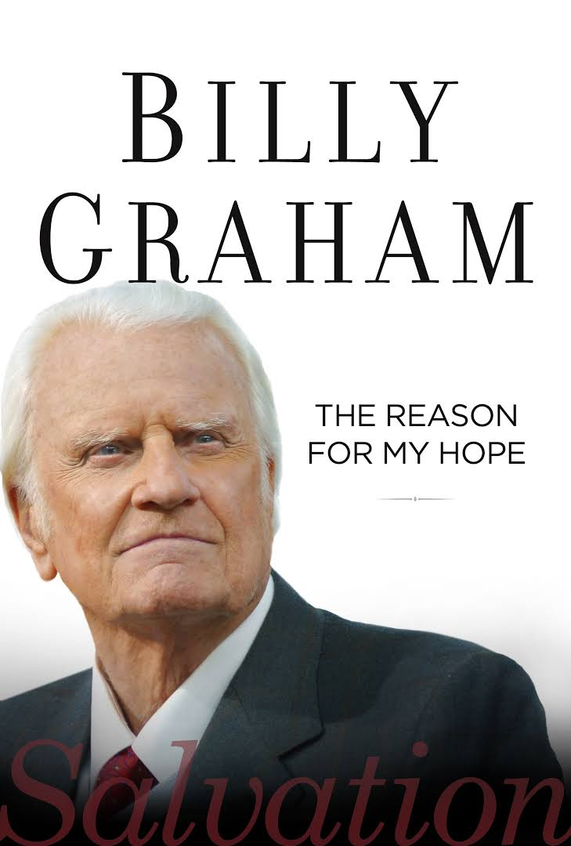
The story is told of teenage siblings who asked their father for money to go see a movie with their friends. Knowing the content of the movie was inappropriate, the father told them they couldn’t go.

The son and daughter debated their position by telling their father that there were only a few curse words and one minor immoral scene, but the rest of the movie was a wonderful love story with high adventure. The father still refused to let them go.

Sulking, they retreated to their rooms until they were called for supper. When it came time for dessert, their mother set a pan of freshly baked brownies smothered with creamy icing on the table. The father cut large squares for his children and said, “Your mother has made your favorite dessert, but there is one thing you should know before you eat it. I had her mix some manure into the batter.”

The teenagers shoved the plates back and tilted away from the table. “How could you?” they moaned. “Oh, it’s just a little bit,” the father answered. “Enjoy!”
That lesson, both of them would say later in life, served as a reminder that it takes only a trifle to corrupt. Needless to say, the entire pan of brownies was thrown out.

Sinful man thinks he is good, but he bears the seed of sin. It is God who is good and gracious to forgive the sinner and then plants the seed of holiness within his heart. The Bible says, “No one who is born of God will continue to sin, because God’s seed remains in them; they cannot go on sinning” (1 John 3:9 NIV). When God looks at the transformed man, He sees the redemptive work of His Son, who turns men and women from darkness into His marvelous light.
* * * *
Let’s not mix manure in the batter of our life. Amen.

GOOD SAMARITAN
By Ardeth Obenauf

For over 30 years, Good Samaritan has been helping needy residents of Bedford County. Good Samaritan gives monetary aid for rent and electric bills, plus food and clothing as needed. A long-time member of Church of the Redeemer, Cecil Nelson, was also a long-time volunteer and supporter of Good Samaritan. Today Gary Ashley and Laurita Parker keep up the connection between the charity and our church. Volunteers at Good Samaritan tend to stay with it for the long haul, some into their 90s, as they see day to day how important the work they are doing is to the community.
Good Samaritan is currently located at 201 East Highland Street, a few blocks down the street that runs alongside New Covenant Christian Bookstore. The location has changed several times over the years, but has been in the current building for a good while. The front portion of the building houses the front desk and the food pantry, while the clothing store is located in the back.
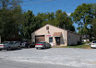
Income from the clothing store goes to pay the rent on the building plus buy food for the food pantry. The remainder of the charity’s funds comes from a variety of sources. Many of Bedford County’s churches contribute as do more fortunate individuals. Significant funding comes from United Way of Bedford County as well as the Emergency Food and Shelter National Board Program. Shelbyville Power contributes money collected from its customers that add something when the pay their bill. Additional food comes from Second Harvest, as well as local grocery stores such as Kroger and Food Lion.
Nearly all the goods and donations coming into Good Samaritan are from within Bedford County and it all goes to benefit Bedford County residents. All the workers, led by the Director, Cathy Miller, are volunteers.
Anyone interested in volunteering or donating to Good Samaritan can visit the location on Highland Street, or call 931 648 1189.

Holy Cross Day

A major feast observed on Sept. 14th in honor of Christ's self-offering on the cross for our salvation. The collect for Holy Cross Day recalls that Christ "was lifted high upon the cross that he might draw the whole world unto himself," and prays that "we, who glory in the mystery of our redemption, may have grace to take up our cross and follow him" (BCP, p. 192). The themes of Holy Cross Day are powerfully expressed by the hymn "Lift high the cross" (Hymn 473).
This feast is known as "The Exaltation of the Holy Cross" in the eastern church and in missals and sacramentaries of the western church, and it is known as "The Triumph of the Cross" in the Roman Catholic Church. It was one of the 12 great feasts in the Byzantine liturgy. The 1979 BCP is the first American Prayer Book to include Holy Cross Day.

Historically, the feast has been associated with the dedication on Sept. 14, 335, of a complex of buildings built by the Emperor Constantine (c. 285-337) in Jerusalem on the sites of the crucifixion and Christ's tomb. This shrine included a large basilica and a circular church. Constantine's mother, Helena (c. 255- c. 330), supervised the construction of the shrine, and a relic believed to be the cross was discovered during the work of excavation. Claims by the Church of Jerusalem to have the cross date from the mid-fourth century, and the pilgrim Egeria mentions a feast commemorating the discovery of the cross in Jerusalem in the late-fourth-century. Although the authenticity of alleged relics of the cross may be questionable, Holy Cross Day provides an opportunity for a joyous celebration of Christ's redeeming death on a cross.

Feast of St. Matthew,

September 21th

During September and October, the Gospel readings will continue to be from the Gospel of Matthew. St. Matthew is known to us principally as an Evangelist, with his Gospel being the first in the New Testament. His Gospel was written in Aramaic, the language that our Lord Himself spoke and was written to convince the Jews that their anticipated Messiah had come in the person of Jesus.

At the time that Jesus summoned him to follow Him, Matthew was a publican, that is, a tax-collector for the Romans. His profession was hateful to the Jews because it reminded them of their subjection; the publican, also, was regarded by the pharisees as the typical sinner. Not much else is known about Matthew. According to tradition, he preached in Egypt and Ethiopia and further places East. Some legends say he lived until his nineties, dying a peaceful death, others say he died a martyr's death.

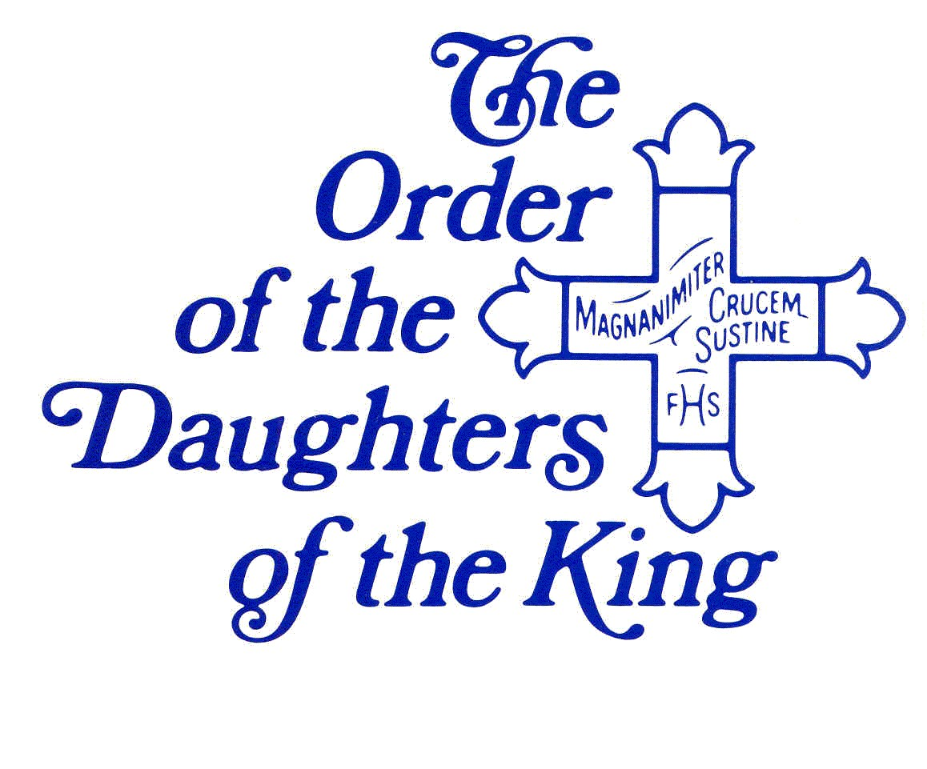
News of the Redeemer chapter of the Daughters of the King.
On August 13th, we admitted two daughters into the chapter; Alice Johnson and Mary Carol Palmer. We had a fun time at the reception following the 10am service. We had welcome gifts for them. Michelle Daley made prayer shawls for them. Father Jess blessed the shawls. Photos are on the website, www.churchofredeemer.org. We will continue to have monthly meetings the second Sunday at 11:30.

Sue Morphis attended the Province IV summer retreat at Kanuga in North Carolina, Friday to Sunday. It was a wonderful, rewarding experience. There were workshop sessions on creating sacred spaces, the Labyrinth, temple scarves, and praying the offices. There was also a study of the historical tabernacle with scale models. It was very informative, reminding us that through Jesus Christ we have direct contact to God.

There was a bus load of junior Daughters from south Florida as well as Daughters from all areas of Province IV. It was great to see so many Daughters together.
We joined with our sisters from East Tennessee for a picture of the Tennessee contingent.

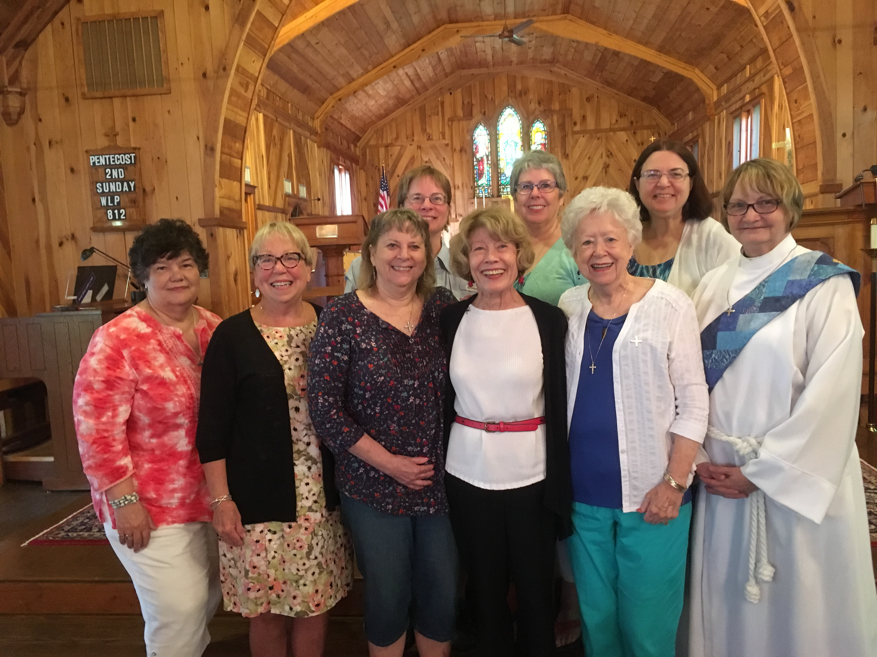

This picture was taken in the chapel. The conference center is on a lake and is something to
behold, a quality facility. If you have an opportunity it is well worth the 6 hour drive to attend a
conference.
The Fall Assembly for our Diocese will be held at St. Paul's in Murfreesboro on September 23.
Canon Snare will be the speaker. It will be a good time to bid her farewell since she will be
retiring. We will miss her.


The Redeemer community exists to share the power of the Lord Jesus Christ through worship in the Anglican Tradition and through the demonstration of His love in our daily lives.
Church Office Hours

Office Hours: Thursday 10-12 noon
Church: 684-5506

The Church Office is located in the parish hall, next to the patio doors.

VESTRY MEMBERS
Senior Warden: Jamie Williams
Junior Warden: Cliff Hirst
Clerk: Rick Francis
Treasurer: Garrett Gordon
Stewardship: Gary Smith
Asst Junior Warden: George Krause
Music: Billie Crowell
Inreach: Babs Chicoine
Outreach: Ron Obenauf
Inreach: Mary Darwin

Sextons: David & Michelle Daley

Prayer List

Members of the Congregation:
Karen and Phil Phillips Linda Moore
Hortense Cooper Nancy Pigg
Michelle Daley Joe Hardison

Angie Davidson
Brittany Atnip
Jim Jobe
Bill Yancy
Linda Brodie – Peter’s friend
Jerry Jones – Friend of Scott and Alice
Bob Stringfellow – Friend of Jill Bell
Karen – Friend of Mary Darwin
Ryan Helton – Friend of Renee Gordon
Ingle Family – Terry’s family
Mitch – Friend of Mary Darwin
The Very Rev.Tracey Lind (Dean of Trinity Cathedral, Cleveland, OH)- Marsha Sharp
David Bearden – Relative of Joe Hardison
Jayson Ashley – Nephew of Gary Ashley
Laurita Jordon – Daughter of Laurita Parker
Deb Lenning - Friend of Mary Darwin
Jennifer Franklin – Ardeth’s cousin
Judy Hankins – Friend of Cliff
Nancy Wagner – Rene’ Francis’ mother
Lee Young – Friend of Cliff Hirst
Vickie Waggoner- Ella Cauble’s God child
Ryan, Ashley, Miles, and Kay Wagner – Relatives of Ron Obenauf
Linda Lindsey – Friend of Cheryl Richardson
Sue Thetford – Friend of Cheryl Richardson
David Yow – Laurita Parker’s Brother in Law
Phyllis Brown – Cliff Hirst’s Aunt
James McAdams – Michelle Daley’s relative
Bob Garrett – Relative of Billie Crowell
Mary Jane Godwin – Sister of Billie Crowell
Harvey and Doris Obenauf – Ron and Wanda’s parents
Rhonda Gray – Gary Ashley’s sister
Janice Raines – Friend of Marsha Sharp
Walter Bobo – Friend of Marsha Sharp

Good Samaritan
Women of Grace
Ministers of Jesus Organization
Cross Shelter
Come Unity Ministry
Participants in the AA Groups that meet here at the Redeemer

Justin Welby - The Archbishop of Canterbury

Michael Curry – Presiding Bishop
John C. Bauerschmidt – Bishop of Tennessee

Diocesan Cycle of Prayer
September 3, 2017
Church of St. Mary Magdalene, Fayetteville
September 10, 2017
St. Joseph of Arimathea, Hendersonville
September 17, 2017
Church of the Holy Cross, Murfreesboro
September 24, 2017
St. Luke’s Community House, Nashville

A Word from the Retired Rector
(circa 2012)

THIS IS MY PARISH
It is composed of people like me.
We make it what it is.
It will be friendly, if I am.
Its pews will be filled, if I help to fill them.
It will make generous gifts to many causes
if I am a generous giver.
It will bring other people to worship and
fellowship if I bring them.
It will be a church of loyalty and love,
of fearlessness and faith,
and a church with a noble spirit
if I, who make it what it is,
am filled with these qualities.
Therfore, with the help of God
I shall dedicate myself to the task of being
all things that I want my parish to be.

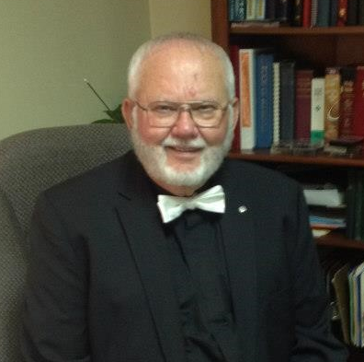
Dear Parish Family
This little locution expresses how “we” become who we are as a parish family. It takes all of us together to be good, better or best. It is a realization of how important you are to the rest of us.
How would you feel if one of your body parts: hand, foot, ear, eye wasn’t part of you to be there and function? Well, you know how we feel when you are missing.
It is a joy to see each other as we raise our voices in hymns of praise and share the gift of ourselves with each other.

With love,
Fr. Peter

Server Schedule

Date | Chalice Bearer | Acolyte | Reader 1 | Reader 2 | Usher | Altar Guild
Sep. 03 | Claudia Smith | Teri Smith | Laura Williams | Sue Morphis | Cliff Hirst | Sue Morphis
Sep. 10 | Jamie Williams | Isaac Williams | Ardeth Obenauf | Charles Whitaker | David Daley | Renee Gordon
Sep. 17 | Garrett Gordon | Teri Smith | Tamra Smith | Ron Obenauf | Gary Ashley | Rene Francis
Sep. 24 | Claudia Smith | Isaac Williams | Billie Crowell | Laura Williams | Laura Williams | Gary Ashley
Oct. 01 | Jamie Williams | Teri Smith | Sue Morphis | Tamra Smith | Cliff Hirst | Teri Smith
Oct. 08 | Garrett Gordon | Isaac Williams | Ron Obenauf | Ardeth Obenauf | David Daley | Sue Morphis
Oct. 15 | Claudia Smith | Teri Smith | Laura Williams | Sue Morphis | Gary Ashley | Renee Gordon
Oct. 22 | Jamie Williams | Isaac Williams | Ardeth Obenauf | Charles Whitaker | Laura Williams | Rene Francis
Oct. 29 | Garrett Gordon | Teri Smith | Tamra Smith | Ron Obenauf | Cliff Hirst | Gary Ashley


We need Acolytes, Chalice Bearers, Lay Readers, Ushers, and Altar Guild. No experience necessary! Pay is low, but the rewards are great! Volunteer now to be an active participant in the 8 or 10 am service. Contact Sue, Rick, or Jamie if you are willing to volunteer. The Redeemer counts on laity participation.

Monthly Events for September 2017
*** you can CTRL+click on the underlined titles to get the readings of the day

September 2017
Sunday | Monday | Tuesday | Wednesday | Thursday | Friday | Saturday
 |  |  |  |  | 1 | 2
3  Thirteenth Sunday after Pentecost  Proper 17  Morning Prayer  8:00 am  10:00 am | 4  Labor Day | 5 | 6  Noonday Prayer  12:12 pm | 7 | 8 | 9  ECW Annual Meeting @ Grace Church Spring Hill
10  Fourteenth Sunday after Pentecost  Proper 18  Holy Eucharist  8:00 am  10:00 am | 11 | 12 | 13  Noonday Prayer  12:12 pm | 14  Holy Cross Day | 15 | 16
17  Fifteenth Sunday after Pentecost  Proper 19  Holy Eucharist  8:00 am  10:00 am | 18 | 19 | 20  Healing Service  Eucharist/Lunch  12:12 pm | 21  St Matthew, Evangelist | 22 | 23  DOK Fall Assembly  @ St. Paul's, Murfreesboro
24  Sixteenth Sunday after Pentecost  Proper 20  Holy Eucharist  8:00 am  10:00 am | 25 | 26 | 27  Healing Service  Eucharist/Lunch  12:12 pm | 28 | 29  St Michael and All Angels | 30

Monthly Events for October 2017
*** you can CTRL+click on the underlined titles to get the readings of the day

October 2017
Sunday | Monday | Tuesday | Wednesday | Thursday | Friday | Saturday
1  Seventeenth Sunday after Pentecost  Proper 21  Holy Eucharist  8:00 am  10:00 am | 2 | 3 | 4  Healing Service  Eucharist/Lunch  12:12 pm | 5 | 6 | 7
8  Eighteenth Sunday after Pentecost  Proper 22  Holy Eucharist  8:00 am  10:00 am | 9 | 10 | 11  Healing Service  Eucharist/Lunch  12:12 pm | 12 | 13 | 14
15  Nineteenth Sunday after Pentecost  Proper 23  Holy Eucharist  8:00 am  10:00 am | 16 | 17 | 18  St Luke, Evangelist  Healing Service  Eucharist/Lunch  12:12 pm | 19 | 20 | 21
22  Twentieth Sunday after Pentecost  Proper 24  Holy Eucharist  8:00 am  10:00 am | 23  St James of Jerusalem | 24 | 25  Healing Service  Eucharist/Lunch  12:12 pm | 26 | 27 | 28  St Simon & St Jude, Apostles
29  Twenty First Sunday after Pentecost  Proper 25  Holy Eucharist  8:00 am  10:00 am | 30 | 31  Vigil of All Saints  (White for vigil)



Social Media

The Redeemer now has a website! Please check it out and subscribe for updates.

www.churchofredeemer.org


The Church of the Redeemer is on Facebook!
https://www.facebook.com/ChurchOfRedeemer/
Please like and share with your friends!

September 2017

“Sharing the power of Christ
through Worship and Love”
Newsletter 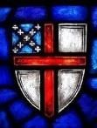
Newsletter
The Episcopal
Church of the
Redeemer
203 East Lane Street
Shelbyville, TN 37160

