

**November 2017**

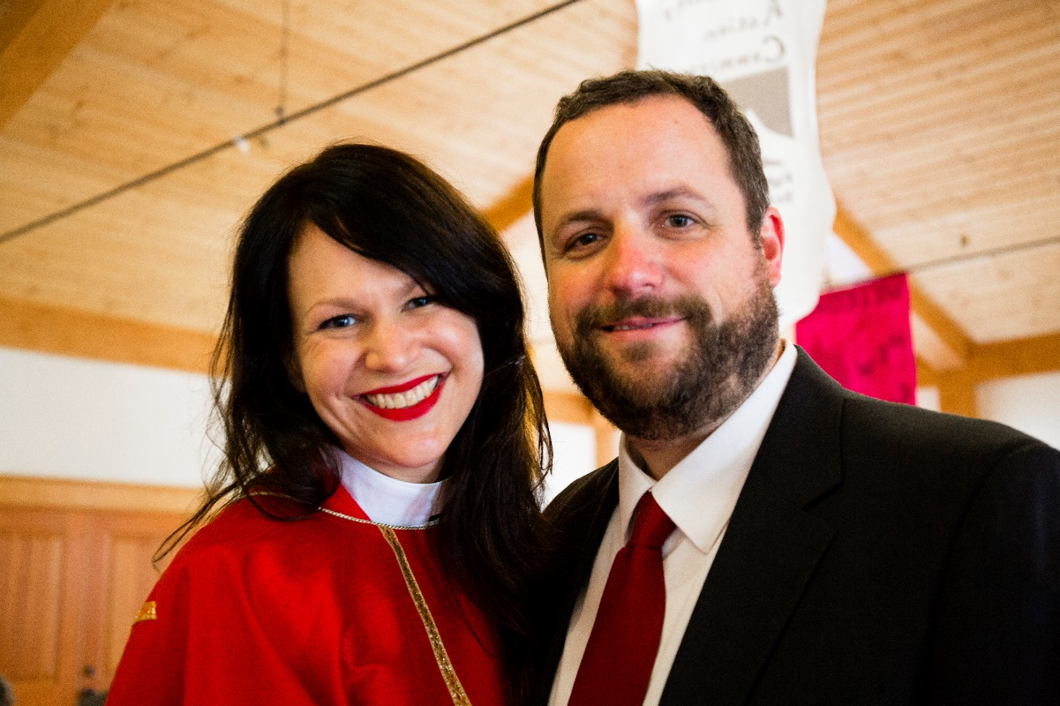

The Rev. Regan and Paul Schutz

Meet our New   
Priest-In-Charge

**First Sunday, December 3rd, Advent I**

The Rev. Regan Schutz is honored and delighted to be appointed Priest-in-Charge of the Episcopal Church of the Redeemer effective December 1, 2017!

A sixth generation Oregonian, Mtr. Regan has fallen in love with Middle Tennessee. For the past four years she and her family have made their home in Sewanee, where her husband Paul serves as Director of Marketing & Communications for the School of Theology’s [Beecken Center](http://theology.sewanee.edu/academics/programs-center). Their daughter Cecilia is an eighth grader at St. Andrew’s-Sewanee, and their daughter Genevieve is a first grader at Sewanee Elementary School.

Mtr. Regan attended [Jesuit High School](http://www.jesuitportland.org/) in Portland and then received a BA in Psychology from the [University of Colorado](http://www.colorado.edu/) at Boulder. After time in New York City where she met Paul, a New York University graduate, Mtr. Regan returned to Oregon with Paul in 2001. They fell in love, got married, and had two incredible children☺ The Schutzes were actively involved at [Trinity Episcopal Cathedral](http://www.trinity-episcopal.org/) in Portland, and as Mtr. Regan’s call to ordained ministry became deafening, the Schutz family made preparations to head to seminary.

During seminary, Mtr. Regan served internships as a chaplain at [Hamilton Medical Center](https://www.hamiltonhealth.com/) in Dalton, Georgia and at [St. Augustine’s Chapel](http://www.staugustineschapel.org/) on the Vanderbilt campus in Nashville. In May 2017 Mtr. Regan received her Master of Divinity from the University of the South’s [School of Theology](http://theology.sewanee.edu/), and she was ordained to the priesthood in October 2017. It was a great honor to have so many Redeemer parishioners present for that great celebration!

In addition to parochial ministry, Mtr. Regan continues in her decade-long [Godly Play](http://www.godlyplayfoundation.org/) ministry. Godly Play is a Montessori-based formation curriculum fostering experiences of God and modeling the Christian language for children of all ages. Believing that Godly Play will change the world, Mtr. Regan joined the Godly Play Foundation in 2010 and is currently the Director of US Godly Play Training and the Director of Communications & Development.

Mtr. Regan comes to Redeemer from [Otey Memorial Parish](http://www.oteyparish.org/) in Sewanee where she has spent the past year serving at the altar and the pulpit, piloting a Godly Play preschool morning, and leading a [Living Compass](https://www.livingcompass.org/) series. She is eager and excited to bring her energy and enthusiasm to the loving community at Redeemer—and to be blessed and to grow through ministry together! Thanks be to God for this incredible opportunity to undertake the work of the Body of Christ together!

Advent Sunday Study



<https://www.churchpublishing.org/adventpresence>

Advent reminds us who God is and who we are meant to be. Join us at 9 am all four weeks of Advent to explore in community this time of preparation—of patience—of remembering what grounds and sustains us.

We will be reading Bud Holland’s *Advent Presence*, which may be purchased from Church Publishing or Amazon. Get your copy today and come ready to slow down and savor the time given to us to prepare for the coming of Christ!

**Our Historic Church Building  
 is 200 Years Young**

The Church of the Redeemer was started at Shelbyville, Tennessee, in 1853 and in May, 1867, the Parish was admitted into union with the Convention of the Diocese of Tennessee. The original church building, a small brick structure of English architecture was Consecrated by the Right Rev. C. T. Quintard, Bishop of Tennessee, on August 1, 1868. This building was located near Belmont Avenue.

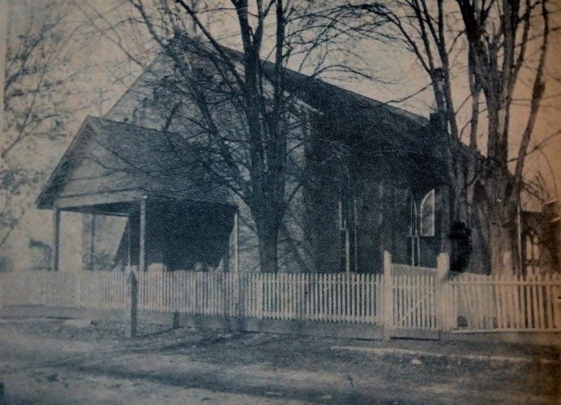

In the early nineteen twenties, the Church was dissolved and the property was sold with the proceeds from the sale of the property invested by the Diocese for future use in case the Shelbyville Church should ever be revived. The church was reorganized as a Mission in 1935 and received once more into union with the Convention of the Diocese in Nashville, January 1936.

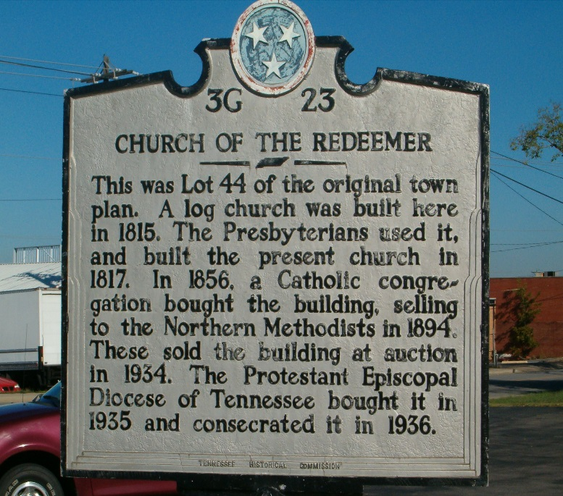

A building was secured just a few blocks from the Courthouse square. This building was built in 1817 by the Presbyterians and has been used by several dominations through the years.

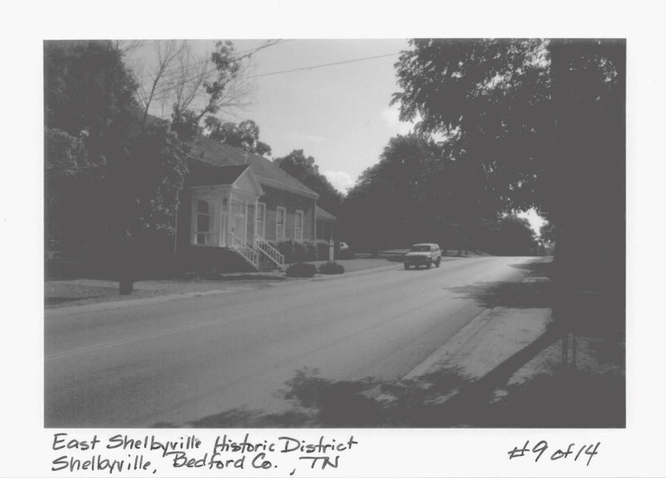

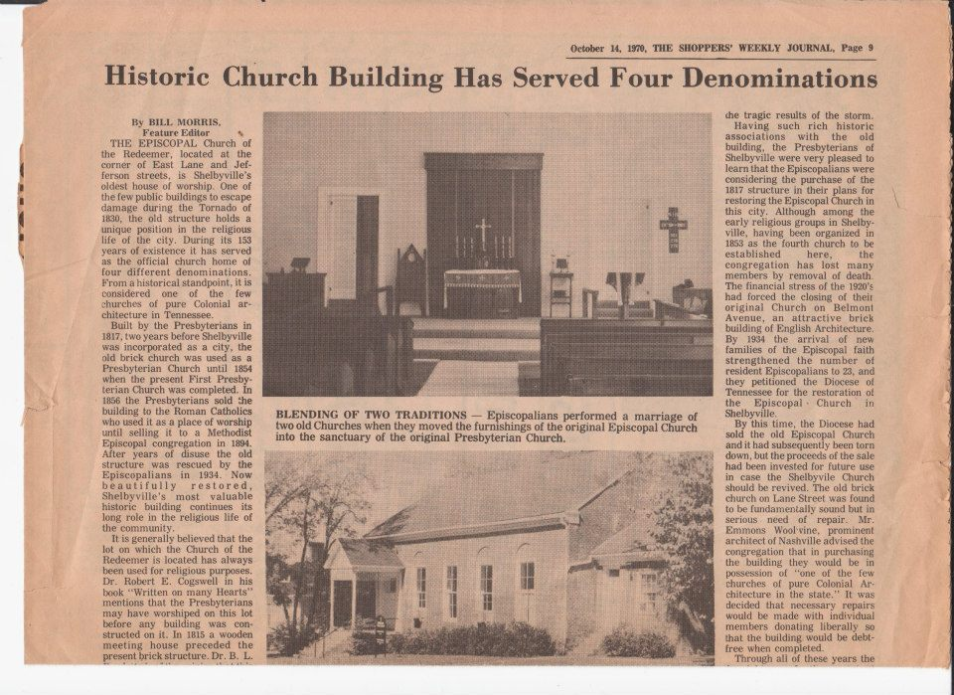

The furniture from the original Redeemer had been preserved and was moved to its new home. The Gailor Family, manifesting an interest in the newly organized Church, the last one officially authorized by Bishop Gailor, gave the Altar and serving pieces in his private chapel at Sewanee, to the Redeemer. On May 5, 1936, the Church was Consecrated by the Right Rev. James M. Maxon, Bishop of Tennessee.

The building located in the East Shelbyville Historic District, was added to the National Register of Historic Places on April 23, 1990. 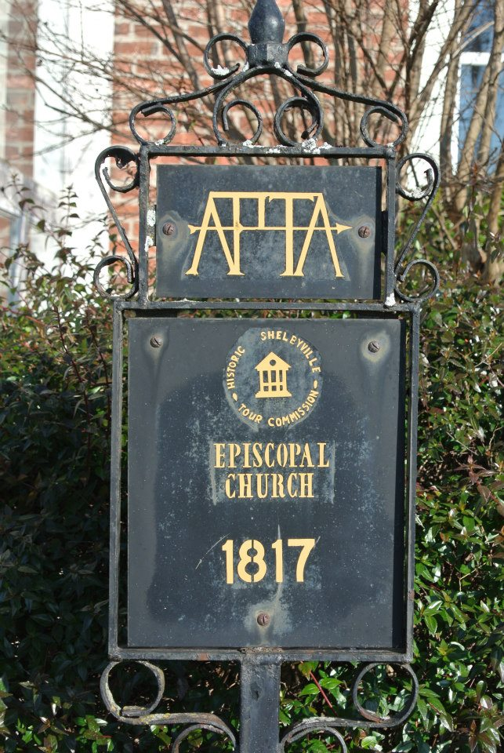

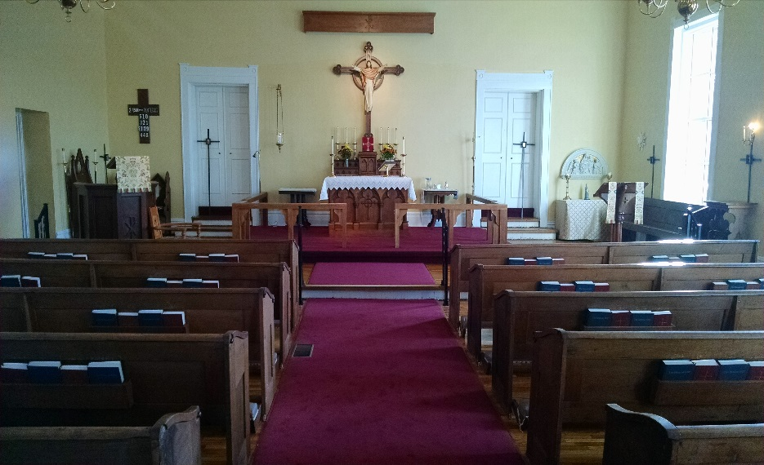

In 2016, the Church underwent a complete renovation, but retaining the original furniture and its Colonial architecture.

THE EPISCOPAL

CHURCH OF THE REDEEMER

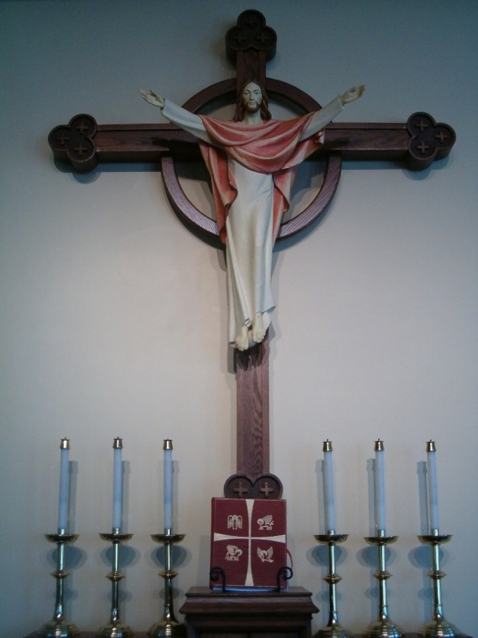

REQUESTS YOUR PRESENCE AT A

CELEBRATION COMMEMORATING

THE 200th ANNIVERSARY

OF OUR CHURCH CONSTRUCTION,

THE OLDEST BUILDING IN SHELBYVILLE

SUNDAY, NOVEMBER 19, 2017

AT YOUR CONVENIENCE

BETWEEN 2 AND 4 PM

**BEYOND THIS LIFE**

*(excerpts from The Law of Rewards by Randy Alcorn)*

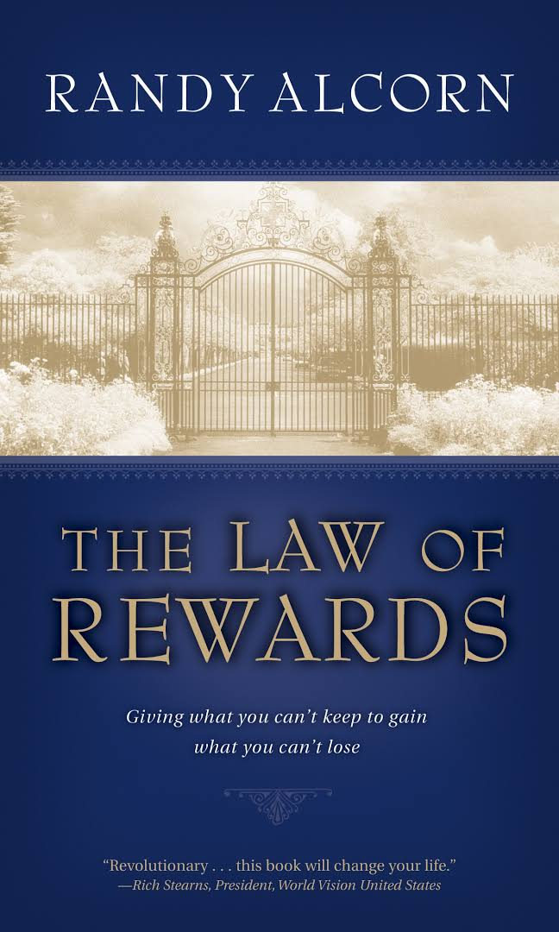

*Submitted by Ron Obenauf*

An ancient story goes like this: A slave travels with his master to Baghdad. Early one morning, while milling through the marketplace, the slave sees death in human form. Death gives him a threatening look. The slave recoils in terror, convinced that Death intends to take him that day.

The slave runs to his master and says, “Help me. I have seen Death, and the look in his eyes tells me he intends to take my life this very day. Please, master, let me leave now and flee on camel so that by tonight I can reach Samara, where Death will not find me.” His master agrees, and the terrified servant rides like the wind for the fifteen-hour journey to Samara.

A few hours later, the master sees Death among the throngs in Baghdad. He boldly approaches Death and asks him, “Why did you give my servant a threatening look?”

“That was not a threatening look,” Death replies. “That was a look of surprise. You see, I was amazed to see your servant today in Baghdad, for I have an appointment with him tonight in Samara.”

The time of our death is unknown. The way of our death is unpredictable. But the fact of our death is inescapable. The statistics are unwavering: 100% of those who are born die. If life’s greatest certainty is death, wouldn’t it be foolish not to prepare for what lies beyond this life?

What we do in this life is of eternal importance. You and I will never have another chance to move the hand of God through prayer to heal a hurting soul, share Christ with one who can be saved from hell, care for the sick, serve a meal to the starving, comfort the dying, rescue the unborn, translate the Scriptures, bring the gospel to an unreached people group, further God’s kingdom, open our homes, or share our clothes and food with the poor and needy. This life is our opportunity to “store up for ourselves treasures in Heaven” (Matthew 6:20). “There’s nothing in this life that we’ll keep, only what we give away will remain.” (Mart Green)

May we live with heaven on our minds. Amen.

**ARROWHEAD RANCH**

*Offering Hope and Direction*

*Submitted by Ardeth Obenauf*

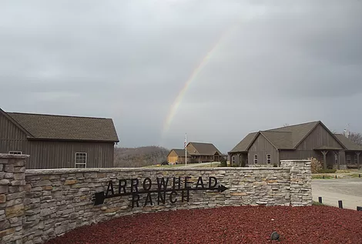

Just south of Shelbyville in the community of Normandy is Arrowhead Ranch, a “long-term residential care facility for level one boys ages 10-18 years old.” Level one means that they are facing a hardship such as loss of parents or abandonment. They are not mentally or psychologically challenged. Young men in need of direction learn the importance of hard work and team building in a Christian family setting. Six boys live in a home with a married Christian couple serving as house parents, providing a balanced family life during adolescence.



Arrowhead Ranch was founded by Preston Sweeney in 2008 on 179 acres bordered on 3 sides by the Duck River. While attending school, the boys also have responsibilities on the ranch. Skills they acquire include horsemanship, herd management, ranch care and maintenance, and home maintenance. Free time has them enjoying fishing, canoeing, camping, baseball, volleyball and softball.

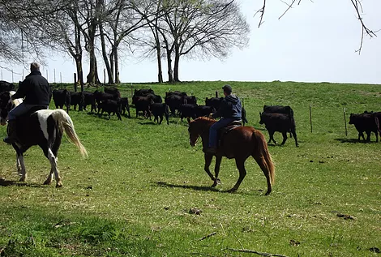

A relationship with Christ is encouraged through the example of the staff, a loving relationship with house parents, daily devotionals and regular interaction with local churches,

Arrowhead Ranch holds several fundraisers including a fish fry, golf tournament, and annual barbecue dinner. The boys’ families pay the fees as they are able; Arrowhead Ranch has a goal that no boy not be admitted due to lack of ability to pay.

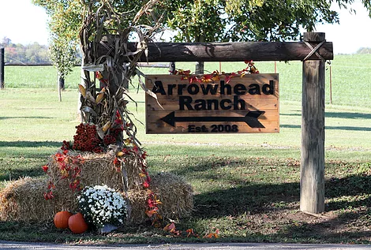

Arrowhead Ranch is a 501 (c) (3) non-profit and donations are tax-deductible. To learn more about the ranch, find them on Facebook or go to [www.arrowheadranchtn.net/](http://www.arrowheadranchtn.net/).

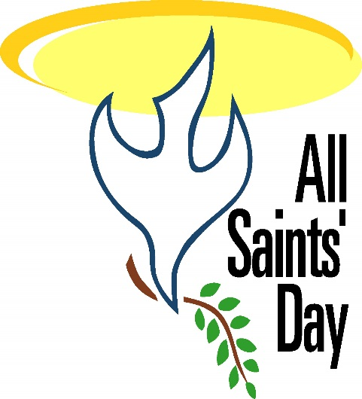

All Saints’ Day is celebrated on November 1st as a commemoration day for all Christian saints.

**Traditions of All Saints' Day**

The origin of All Saints' Day may date back to a Greek Christian tradition from the 4th century, when a festival was held to honor saints and martyrs on the Sunday following Pentecost.

The first recorded All Saints’ Day occurred on 13 May 609 CE when Pope Boniface IV accepted the Pantheon in Rome as a gift from the Emperor Phocas. The Pope dedicated the day as a holiday to honor the Blessed Virgin and all the martyrs.

In 835 CE, during the reign of Pope Gregory III, the festival was moved to November 1st and was expanded to include the honoring of all saints. It is likely that November 1st was intentionally chosen to replace the pagan feast of the dead, Samhain. The night before Samhain was a time when evil spirits roamed the land looking for humans. To confuse the spirits, people would dress up as creatures. This tradition carried on after November 1st became a Christian festival, hence the name of Halloween - which is a shortened version of *All Hallows' Eve*.

The day survived the Reformation, though the Protestants combined it with All Souls’ Day, which was on November 2nd.

The day was abolished as a church festival in 1770, but may be celebrated by many churches on the first Sunday in November.

In Roman Catholicism, All Saints' Day is a Holy Day of Obligation. This means Catholics must go to Mass on the date unless there is a good reason not to attend, such as illness. The holiday is typically observed with a reading of the Beatitudes, eight blessings given in Jesus’ Sermon on the Mount as recounted in the Gospel of Matthew.

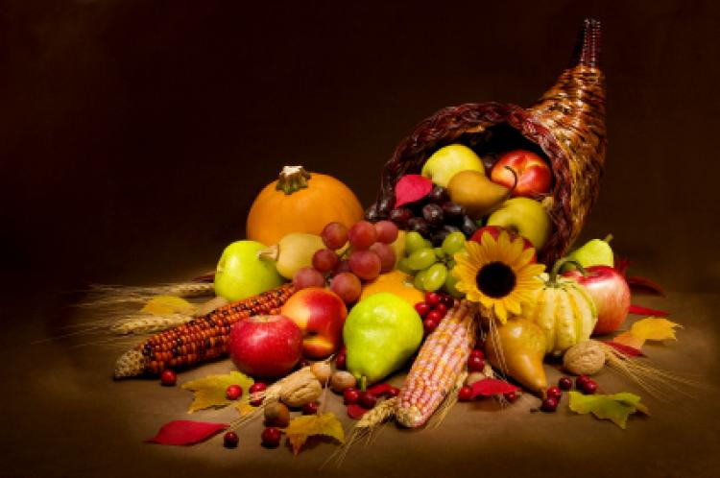

Thanksgiving Traditions

Many people trace the origins of the modern Thanksgiving Day to the harvest celebration that the Pilgrims held in Plymouth, Massachusetts in 1621. However, their first true thanksgiving was in 1623, when they gave thanks for rain that ended a drought. These early thanksgivings took the form of a special church service, rather than a feast.

In the second half of the 1600s, thanksgivings after the harvest became more common and started to become annual events. However, it was celebrated on different days in different communities and in some places, there were more than one thanksgiving each year. George Washington, the first president of the United States, proclaimed the first national Thanksgiving Day in 1789.

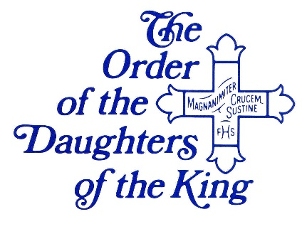**Daughters of the King**

The upcoming events for the Daughters are: chapter meetings November 12 and December 10, board meeting November 4, spring assembly at St. George's in Nashville April 27, a joint quiet day with the ECW February 24 at the Diocesan house and Triennial in Austin Texas June 20-24.

We will be singing Christmas carols with the residents at Celebration Way for the holidays. The date has not been determined. We wish all a wonderful loving holiday.

|  |  |  |  |  |  |  |
| --- | --- | --- | --- | --- | --- | --- |
| Advent Season Banner | | | | | | |
| **Sunday Monday Tuesday Wednesday Thursday Friday Saturday** | | | | | | |
| **[door-close-3.gif](http://www.usccb.org/prayer-and-worship/liturgical-year/advent/advent-december-3.cfm)** | **[door-close-4.gif](http://www.usccb.org/prayer-and-worship/liturgical-year/advent/advent-december-4.cfm)** | **[door-close-5.gif](http://www.usccb.org/prayer-and-worship/liturgical-year/advent/advent-december-5.cfm)** | **[door-close-6.gif](http://www.usccb.org/prayer-and-worship/liturgical-year/advent/advent-december-6.cfm)** | **[door-close-7.gif](http://www.usccb.org/prayer-and-worship/liturgical-year/advent/advent-december-7.cfm)** | **[door-close-8.gif](http://www.usccb.org/prayer-and-worship/liturgical-year/advent/advent-december-8.cfm)** | **[door-close-9.gif](http://www.usccb.org/prayer-and-worship/liturgical-year/advent/advent-december-9.cfm)** |
| **[door-close-10.gif](http://www.usccb.org/prayer-and-worship/liturgical-year/advent/advent-december-10.cfm)** | **[door-close-11.gif](http://www.usccb.org/prayer-and-worship/liturgical-year/advent/advent-december-11.cfm)** | **[door-close-12.gif](http://www.usccb.org/prayer-and-worship/liturgical-year/advent/advent-december-12.cfm)** | **[door-close-13.gif](http://www.usccb.org/prayer-and-worship/liturgical-year/advent/advent-december-13.cfm)** | **[door-close-14.gif](http://www.usccb.org/prayer-and-worship/liturgical-year/advent/advent-december-14.cfm)** | **[door-close-15.gif](http://www.usccb.org/prayer-and-worship/liturgical-year/advent/advent-december-15.cfm)** | **[door-close-16.gif](http://www.usccb.org/prayer-and-worship/liturgical-year/advent/advent-december-16.cfm)** |
| **[door-close-17.gif](http://www.usccb.org/prayer-and-worship/liturgical-year/advent/advent-december-17.cfm)** | **[door-close-18.gif](http://www.usccb.org/prayer-and-worship/liturgical-year/advent/advent-december-18.cfm)** | **[door-close-19.gif](http://www.usccb.org/prayer-and-worship/liturgical-year/advent/advent-december-19.cfm)** | **[door-close-20.gif](http://www.usccb.org/prayer-and-worship/liturgical-year/advent/advent-december-20.cfm)** | **[door-close-21.gif](http://www.usccb.org/prayer-and-worship/liturgical-year/advent/advent-december-21.cfm)** | **[door-close-22.gif](http://www.usccb.org/prayer-and-worship/liturgical-year/advent/advent-december-22.cfm)** | **[door-close-23.gif](http://www.usccb.org/prayer-and-worship/liturgical-year/advent/advent-december-23.cfm)** |
| **[door-close-24.gif](http://www.usccb.org/prayer-and-worship/liturgical-year/advent/advent-december-24.cfm)** | blank purple square | blank purple square | blank purple square | blank purple square | blank purple square | blank purple square |

Beginning the Church's liturgical year, Advent (from, "ad-venire" in Latin or "to come to") is the season encompassing the four Sundays (and weekdays) leading up to the celebration of **Christmas**. The Advent season is a time of preparation that directs our hearts and minds to Christ’s second coming at the end of time and also to the anniversary of the Lord’s birth on Christmas. The final days of Advent, from December 17 to December 24, focus particularly on our preparation for the celebrations of the Nativity of our Lord (Christmas). Our Advent calendar above can help you fully enter in to the season with daily activity and prayer suggestions to prepare you spiritually for the birth of Jesus Christ.

***You can CTRL+click on the dates for activities and prayer suggestions.***

##### episcopal sealThe Redeemer community exists to share the power of the Lord Jesus Christ through worship in the Anglican Tradition and through the demonstration of His love in our daily lives.

**Church Office Hours**

**Office Hours:**Thursday 10-12 noon

**Church:** 684-5506

The Church Office is located in the parish hall, next to the patio doors.

**VESTRY MEMBERS**

**Senior Warden:** Jamie Williams

**Junior Warden:** Cliff Hirst

**Clerk:** Rick Francis

**Treasurer:** Garrett Gordon

**Stewardship:** Gary Smith

**Asst Junior Warden:** George Krause

**Music:** Billie Crowell

**Inreach:** Babs Chicoine

**Outreach:** Ron Obenauf

**Inreach:** Mary Darwin

**Sextons:** David & Michelle Daley

**Prayer List**

**Members of the Congregation:**

Karen and Phil Phillips Linda Moore

Michelle Daley Garrett Gordon

Joe Hardison Marsha Sharp

Mary Marsh

Angie Davidson

Brittany Atnip

Jim Jobe

Bill Yancy

Linda Brodie – Peter’s friend

Jerry Jones – Friend of Scott and Alice

Karen – Friend of Mary Darwin

Ingle Family – Terry’s family

Mitch – Friend of Mary Darwin

The Very Rev.Tracey Lind (Dean of Trinity Cathedral, Cleveland, OH)- Marsha Sharp

David Bearden – Relative of Joe Hardison

Jayson Ashley – Nephew of Gary Ashley

Laurita Jordon – Daughter of Laurita Parker

Deb Lenning - Friend of Mary Darwin

Nancy Wagner – Rene’ Francis’ mother

Lee Young – Friend of Cliff Hirst

Vickie Waggoner- Ella Cauble’s God child

Ryan, Ashley, Miles, and Kay Wagner – Relatives of Ron Obenauf

Linda Lindsey – Friend of Cheryl Richardson

Sue Thetford – Friend of Cheryl Richardson

David Yow – Laurita Parker’s Brother in Law

Phyllis Brown – Cliff Hirst’s Aunt

James McAdams – Michelle Daley’s relative

Bob Garrett – Relative of Billie Crowell

Harvey and Doris Obenauf – Ron and Wanda’s parents

Rhonda Gray – Gary Ashley’s sister

Janice Raines – Friend of Marsha Sharp

Walter Bobo – Friend of Marsha Sharp

Good Samaritan

Women of Grace

Ministers of Jesus Organization

Cross Shelter

Come Unity Ministry

Participants in the AA Groups that meet here at the Redeemer

Justin Welby - The Archbishop of Canterbury

Michael Curry – Presiding Bishop

John C. Bauerschmidt – Bishop of Tennessee

Regan Schutz – Priest-in-Charge

Peter J. Whalen – Priest Emeritus

**Diocesan Cycle of Prayer**

November 5, 2017  
All Saints’ Church, Smyrna

November 12, 2017  
Church of the Messiah, Pulaski

November 19, 2017  
St. Augustine’s Chapel, Nashville

November 26, 2017  
St. Mark’s Church, Antioch

December 3, 2017  
Church of the Advent, Nashville

December 10, 2017  
Christ Church Cathedral, Nashville

December 17, 2017  
St. David’s Church, Nashville

**A Word from the Retired Rector**

**(circa 2014)**

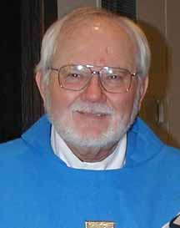

A spiritual writer wrote this, as far as my memory serves, “The world says, the more you take – the more you have… Christ says, the more you give – the more you are…” In doing some home repairs I had to dash to Lowe’s to pick up a few things to complete my project. Having collected the needed materials, I stepped up to the counter and looked into my wallet. And there in a flash, I perceived for the briefest moment the saying that we hear on so often on TV, “What’s in your wallet?” Everything in the leather pouch that I carry in my back pocket is a small snapshot of my life. There are just a few bits of paper, plastic, and photos that someone might arrange into a rough portrait of the person named Peter Whalen.

Standing there, wallet in hand, I also had a tiny glimpse of how God holds our lives in His Hands. All I am, all I have, all I call “me, myself, I”. The sum total, are held in the hands of another. The work, money, family, and good health, are merely on loan for a season thru God’s loving hands. Everything is returned at the exit.

Sometimes I am guilty of carrying my life and God’s blessings the way I carry my wallet; items packed for personal travel. I forget that I am a steward of all the good things that have been sent in my direction. Joy and freedom comes from giving them back to the one from whom they came. It is a matter of becoming a good steward, as Christ is a good and courageous steward to each of us. Every season of this life is a season of unpacking the blessings we thought were our own and offering them back to God with gratitude.

“Where am I sharing what I have received in this life?” Our duty, our opportunity for joy, lie in answering that question faithfully. Everyone’s path will be different. For some, it is to open wallets, portfolios, our best-laid financial plans so they might be shaped with the power of prayer. For others it is to open calendars filled with our best-laid plans. Everyone’s gift will be unique, but common to all is that we each have a gift to bring. In the end, our lives become our own when we have given them to God. As C.S. Lewis wrote, “Nothing is really ours until we share it.”

With Love,

*Peter*

**Server Schedule**

|  |  |  |  |  |  |  |
| --- | --- | --- | --- | --- | --- | --- |
| **Date** | **Chalice Bearer** | **Acolyte** | **Reader 1** | **Reader 2** | **Usher** | **Altar Guild** |
| Nov. 05 | Claudia Smith | Isaac Williams | Billie Crowell | Laura Williams | David Daley | Teri Smith |
| Nov. 12 | Gary Smith | Teri Smith | Charles Whitaker | Tamra Smith | Gary Ashley | Sue Morphis |
| Nov. 19 | Jamie Williams | Isaac Williams | Sue Morphis | Ardeth Obenauf | Laura Williams | Mary Carol Palmer |
| Nov. 26 | Garrett Gordon | Larry Morphis | Ron Obenauf | Sue Morphis | Cliff Hirst | Renee Gordon |
| Dec. 03 | Gary Smith | Isaac Williams | Laura Williams | Charles Whitaker | David Daley | Rene Francis |
| Dec. 10 | Jamie Williams | Teri Smith | Ardeth Obenauf | Ron Obenauf | Gary Ashley | Gary Ashley |
| Dec. 17 | Garrett Gordon | Isaac Williams | Tamra Smith | Laura Williams | Laura Williams | Teri Smith |
| Dec. 24 | Gary Smith | Teri Smith | Billie Crowell | Tamra Smith | Cliff Hirst | Mary Carol Palmer |
| Dec. 24 | **Christmas Eve** | **Need** | Volunteers |  |  |  |
| Dec. 25 | **Need** | **Volunteers** |  |  |  |  |
| Dec. 31 | Jamie Williams | Isaac Williams | Charles Whitaker | Ardeth Obenauf | David Daley | Sue Morphis |

***Monthly Events for November 2017***

***\*\*\* you can CTRL+click on the underlined titles to get the readings of the day***

|  |  |  |  |  |  |  |
| --- | --- | --- | --- | --- | --- | --- |
| **November 2017** | | | | | | |
| Sunday | Monday | Tuesday | Wednesday | Thursday | Friday | Saturday |
| Note: If All Saints Day is observed on the Sunday following, use white |  |  | 1 [All Saints](http://www.lectionarypage.net/YearA_RCL/HolyDays/AAllSaints_RCL.html)  Healing Service  Eucharist/Lunch  12:12 pm | 2 | 3 | 4 |
| 5 All Saints, (white)  [Proper 26](http://www.lectionarypage.net/YearA_RCL/Pentecost/AProp26_RCL.html)  Holy Eucharist  8:00 am  10:00 am | 6 | 7 | 8  Healing Service  Eucharist/Lunch  12:12 pm | 9 | 10 | 11 |
| 12 Twenty Third Sunday after Pentecost [Proper 27](http://www.lectionarypage.net/YearA_RCL/Pentecost/AProp27_RCL.html)  Holy Eucharist  8:00 am  10:00 am | 13 | 14 | 15  Healing Service  Eucharist/Lunch  12:12 pm | 16 | 17 | 18 |
| 19 Twenty Fourth Sunday after Pentecost [Proper 28](http://www.lectionarypage.net/YearA_RCL/Pentecost/AProp28_RCL.html)  Holy Eucharist  8:00 am  10:00 am  200th Anniversary  2-4 pm | 20 | 21 | 22  Healing Service  Eucharist/Lunch  12:12 pm | 23 [Thanksgiving Day](http://www.lectionarypage.net/YearA_RCL/HolyDays/Thanks_A_RCL.html)  Thanksgiving  Lunch  12:00 pm | 24 | 25 |
| 26 [Christ the King](http://www.lectionarypage.net/YearA_RCL/Pentecost/AProp29_RCL.html)  Holy Eucharist  8:00 am  10:00 am  Pledge Cards Due | 27 | 28 | 29  Healing Service  Eucharist/Lunch  12:12 pm | 30 [St Andrew, Apostle](http://www.lectionarypage.net/YearABC/HolyDays/Andrew.html) |  |  |

***Monthly Events for December 2017***

***\*\*\* you can CTRL+click on the underlined titles to get the readings of the day***

|  |  |  |  |  |  |  |
| --- | --- | --- | --- | --- | --- | --- |
| **December 2017** | | | | | | |
| Sunday | Monday | Tuesday | Wednesday | Thursday | Friday | Saturday |
|  |  |  |  |  | 1 | 2 |
| 3 [First Sunday of Advent](http://www.lectionarypage.net/YearB_RCL/Advent/BAdv1_RCL.html)  Holy Eucharist  8:00 am  10:00 am  Rev. Regan Schutz joins us | 4 | 5 | 6  Healing Service  Eucharist/Lunch  12:12 pm | 7 | 8 | 9 |
| 10 [Second Sunday of Advent](http://www.lectionarypage.net/YearB_RCL/Advent/BAdv2_RCL.html)  Holy Eucharist  8:00 am  10:00 am | 11 | 12 | 13  Healing Service  Eucharist/Lunch  12:12 pm | 14 | 15 | 16 |
| 17 [Third Sunday of Advent](http://www.lectionarypage.net/YearB_RCL/Advent/BAdv3_RCL.html)  Holy Eucharist  8:00 am  10:00 am | 18 | 19 | 20  Healing Service  Eucharist/Lunch  12:12 pm | 21 [St Thomas, Apostle](http://www.lectionarypage.net/YearABC/HolyDays/Thomas.html) | 22 | 23 |
| 24 [Fourth Sunday of Advent](http://www.lectionarypage.net/YearB_RCL/Advent/BAdv4_RCL.html) Holy Eucharist  8:00 am  10:00 am  Christmas Eve  5:00 pm | 25 Christmas Day [Christmas I](http://www.lectionarypage.net/YearABC_RCL/Christmas/ChrsDay1_RCL.html) [Christmas II](http://www.lectionarypage.net/YearABC_RCL/Christmas/ChrsDay2_RCL.html) [Christmas III](http://www.lectionarypage.net/YearABC_RCL/Christmas/ChrsDay3_RCL.html)  Holy Eucharist  9:00 am | 26 [St Stephen, Deacon and Martyr](http://www.lectionarypage.net/YearABC/HolyDays/Stephen.html) | 27 [St John, Apostle and Evangelist](http://www.lectionarypage.net/YearABC/HolyDays/John.html)  Healing Service  Eucharist/Lunch  12:12 pm | 28 [Holy Innocents](http://www.lectionarypage.net/YearABC/HolyDays/HolyInno.html) | 29 | 30 |
| 31 [First Sunday after Christmas](http://www.lectionarypage.net/YearABC/Christmas/Christmas1.html)  Holy Eucharist  8:00 am  10:00 am |  |  |  |  |  |  |



**Social Media**

**The Redeemer now has a website! Please check it out and subscribe for updates.**

[www.churchofredeemer.org](http://www.churchofredeemer.org)



The Church of the Redeemer is on Facebook!

[*https://www.facebook.com/ChurchOfRedeemer/*](https://www.facebook.com/ChurchOfRedeemer/)

Please like and share with your friends!

**November 2017**

**“Sharing the power of Christ through Worship and Love”**

|  |
| --- |
| Newsletter  The Episcopal  Church of the  Redeemer  203 East Lane Street  Shelbyville, TN 37160 |

Newsletter