

**March/April 2018**

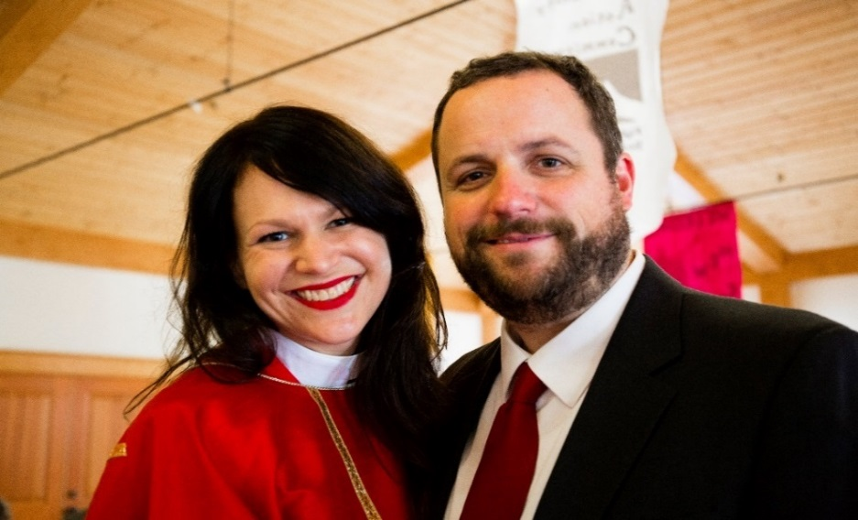**From Mother Regan**

Dear Ones,

Now three months into my time at Redeemer, I continue to be in awe that God called me to engage in ministry with such an incredible community! The vibrant, loving congregation that gathers at Redeemer is more inspiring than any priest could ask for, and I thank you for continuing to show up weekly for Eucharist even as life gets busy. Our corporate worship is integral to our ministry in the world—it is time out of time that each of us has set aside to worship as a community. And we worship more fully together than any of us can do alone.

In The Episcopal Church, Sunday morning is our primary church gathering. It is when we celebrate and participate in Christ’s suffering, death, and resurrection on the “8th day” and when we affirm our commitment to being the Body of Christ, those marked as “Christ’s own forever.” Importantly, we pray our prayers corporately, using “we” and “our” in the Nicene Creed, the Prayers of the People, and in Confession because our faith requires community. The words of these prayers will not resonate with each of us every time we say them; but when we pray the words corporately, we can rely on the faith of the whole community to carry us through times of dissonance or doubt to regain our personal theological conviction. Our communal prayers are what we hope to believe, and our belief is stronger in community.

Corporate liturgy is our response to God, and we bring our whole selves to God to worship in liturgy. As St. Paul exhorts, “true and proper worship” requires us to offer “our bodies as a living sacrifice, holy and pleasing to God” (Rom. 12:1). What we pray in worship influences and affects what we believe, traditionally expressed as *lex orandi lex credendi*. This Latin phrase means that the words and actions we use in prayer infiltrate our minds and bodies and provide a framework for the lens we construct to view the world. Our language in worship, both spoken and unspoken, simultaneously changes us and expresses our theological convictions. How we pray is indicative of what we believe, and what we believe determines how we pray. As Episcopalians, the Book of Common Prayer determines our worship, and therefore, the theology of our liturgy is an expression of our theology.

Your presence at church matters to all of us. And I am so grateful to each of you for offering your whole self to our community, the Body of Christ at Redeemer, every Sunday. Your presence inspires and sustains me and my ministry on both personal and professional levels, and I am beyond excited about the ways in which our future ministry together will participate in bringing the Kingdom of God!

Thank you for your continued warm and gracious welcome.

In Christ’s Love,



The Rev. Regan M. Schutz. Priest in Charge

**Lent**

We continue our observance of a Holy Lent together with Eucharist every Wednesday at 12:12p and every Sunday at 8a and 10a.



The [Good Book Club](http://www.goodbookclub.org/) meets on Sundays at 9a to discuss the Gospel according to Luke. Please join in even if you have not completed the week’s reading!

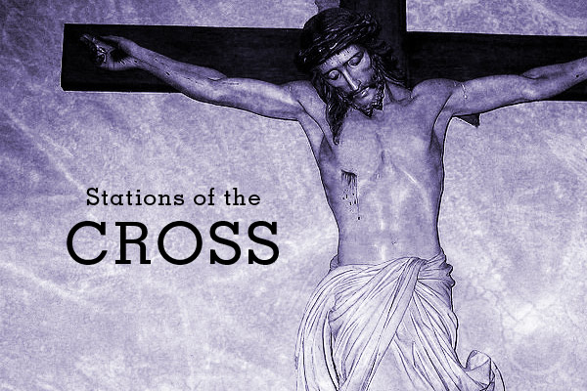Additionally, we will journey together through that stations of the cross in a Way of the Cross observance on both Friday, March 2nd at 5p and Friday, March 16th at 5p. Lent is a serious time of penitence and repentance, and we need our whole church community to do this work well—please join us!

**Holy Week and Easter Sunday Services at Redeemer**

Palm Sunday – March 25th at 9a

Maundy Thursday – March 29th at 5p

Good Friday – March 30th at 5p

Easter Sunday – April 1st at 9a

*A note about the* [*Paschal Triduum*](https://en.wikipedia.org/wiki/Paschal_Triduum) *(March 29-April 1): You will notice that Maundy Thursday, Good Friday, and Easter Sunday do not begin and end the same as other services. This is because these three church services are actually one liturgy called the Paschal Triduum (or Easter Triduum). Each of these three services are designed to flow into one another as one continuous liturgy in which the Body of Christ participates in the passion, death, and resurrection of our Lord Jesus Christ. Please plan to attend these services celebrating the Paschal Mystery over three days!*

**Eastertide: Holy Eucharist at 9a**

From March 25th through to May 13th, we will have one service at 9 am on Sunday mornings. One service at 9 am will enable the whole Body of Christ at Redeemer to be together for the celebration of Palm Sunday, Easter Sunday, and all of Eastertide!

**An Invitation from Christ Lutheran Church**

Christ Lutheran Church has invited us to a special liturgy of the table meal in which both churches will gather and worship while enjoying a meal together at the Lutheran church. Pastor Paul and the congregation at Christ Lutheran Church are excited for a wonderful evening of fellowship with the Redeemer congregation! More information coming soon.

**Bedford Builds Habitat for Humanity**

*Submitted by Ardeth Obenauf*

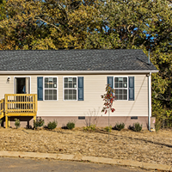Here in Bedford County, we are fortunate to be home to a very active, dedicated branch of the non-profit Habitat for Humanity International.

The origins of Habitat go back to a Christian community, Koinonia Farm, in Georgia founded by Clarence Jordan. A visit from the Walter Fuller family in 1965 sparked the beginning of the concept of “partnership housing”. Successful projects were launched in this country and one in Zaire. In 1976 Habitat for Humanity International was formed.

In 1984, Habitat received a huge boost when joined by President Jimmy Carter and his wife Rosalyn. Today Habitat has built or repaired more than 600,000 houses serving more than 3 million people worldwide.

Habitat is a Christian ministry operating on the premise that everyone should have a simple, decent place to live in dignity and safety. Habitat has an open-door policy. They build for people in need regardless of race or religious affiliation and welcome all volunteers. Their structure follows a few key theological concepts.

* Putting faith into action – to follow Christ, we must love and care for one another.
* The Economics of Jesus – When we respond to human need without seeking profit, God magnifies the effects of our efforts.
* 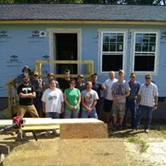The Theology of the Hammer - Everyone can use a hammer to manifest God’s love.

Bedford Builds is the local affiliate of Habitat for Humanity International. They build homes for individuals that meet their criteria of income, willingness to help build, inability to get a loan, and conditions of the current home.

Bedford Builds currently operates a store at 107 W. Cedar Street in Shelbyville. In March the store will be moving to 1210 Madison Street. Ms. Pam Birtcil is the current Executive Director. If you are interested in becoming involved with Bedford Builds as a volunteer or a donor, more information is available on their website, [www.BedfordBuildsHabitat.org](http://www.BedfordBuildsHabitat.org) or by phone at 931 684 4300.

**ANGELS WATCHING OVER YOU**

(Excerpt from Chapter 12 of Come Thirsty by Max Lucado)

Submitted by Ron Obenauf

When seventeen-year-old Jake Porter ran onto the football field, both teams cheered. Odd that they would. In three years on the Northwest High squad, he’d barely dirtied a game jersey. The McDermott, Ohio, fans had never seen Jake carry the ball or make a tackle. Nor had they seen him read a book or write much more than a sentence. Kids with chromosomal fragile X syndrome, a common cause of mental retardation, seldom do.

But Jake loved sports. Each day after his special-ed classes, he dashed off to some practice: track, baseball, basketball. Never missed. Never played, either.

Until the Waverly game.

Jake’s coach made his decision before the kickoff. If a lopsided score rendered the final seconds superfluous, Jake would come in. The lopsided part proved true. With five ticks remaining on the clock, his team was down 42-0. So the coach called a time-out.

He motioned to speak with the opposing coach. As his Waverly counterpart heard the plan, he began shaking his head and waving his hands. He disagreed with something. A referee intervened, and play resumed.

The quarterback took the ball and handed it to Jake. Jake knew what to do: take a knee and let the clock expire. They’d practiced this play all week. But, to his surprise, the players wouldn’t let him. His teammates told him to run. So he did. In the wrong direction. So the back judge stopped and turned him around.

That’s when the Waverly defense did their part. The visiting coach, as it turns out, wasn’t objecting to the play. He was happy for Porter to carry the ball but not for him just to run out the clock. He wanted Jake to score. Waverly players parted like the Red Sea for Moses and shouted for Jake to run. Run he did. Grinning and dancing and jumping all the way to the end zone.

Both sidelines celebrated. Moms cried, cheerleaders whooped, and Jake smiled as if he’d won the lottery without buying a ticket.

How often do such things happen? According to the Bible, more often than you might think. In fact, what Jake’s team did for him, the Lord of the universe does for you every day of your life. And you ought to see the team he coaches.

The angels keep their ancient places—

Turn but a stone and start a wing!

‘Tis ye, ‘tis your estranged faces,

That miss the many splendored thing.

Has your face missed the angels? With over three hundred scriptural references, theses celestial servants occupy an unquestioned role in the Bible. If you believe in God’s Word, you have to believe in angels.

***Postscript:*** *I shared this article because I thought how cool would it have been to be Jake? Or maybe his teammates or maybe his coach? Or even better on the defense or the opposing coach—how cool was he? Or the back judge who turned Jake around? Or at least someone in the stands watching all of this unfold? Or the radio broadcaster—bet he couldn’t even speak when Jake scored. You see, I have already asked God if I could be an angel someday.But maybe in some small way I have already been one—to somebody. How about you? Do you believe in angels?*

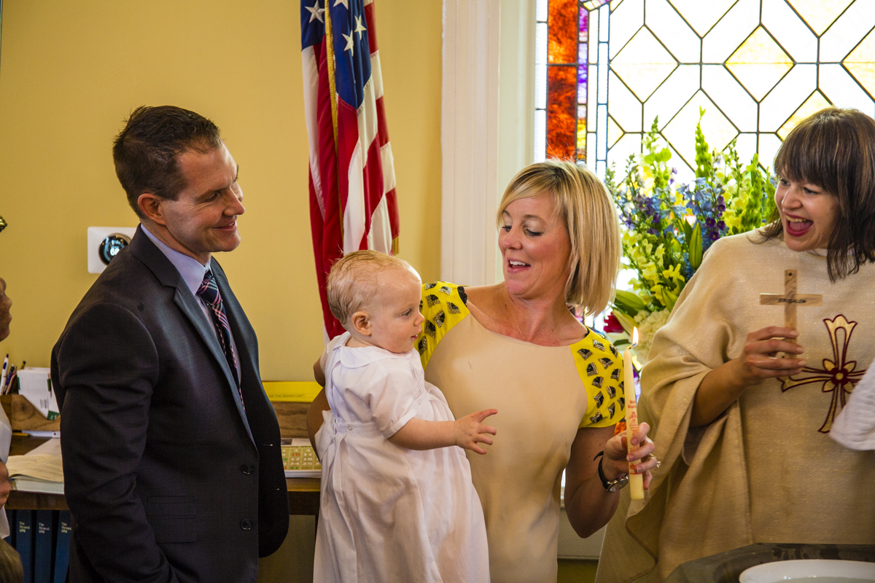

**William Gibson**

The Body of Christ grew through the work of the Redeemer community! Together we baptized an amazing child, William Gibson, marking him as Christ’s own forever. This is Mary Carol Palmer’s Grandson, son of Liza and Danny Gibson.

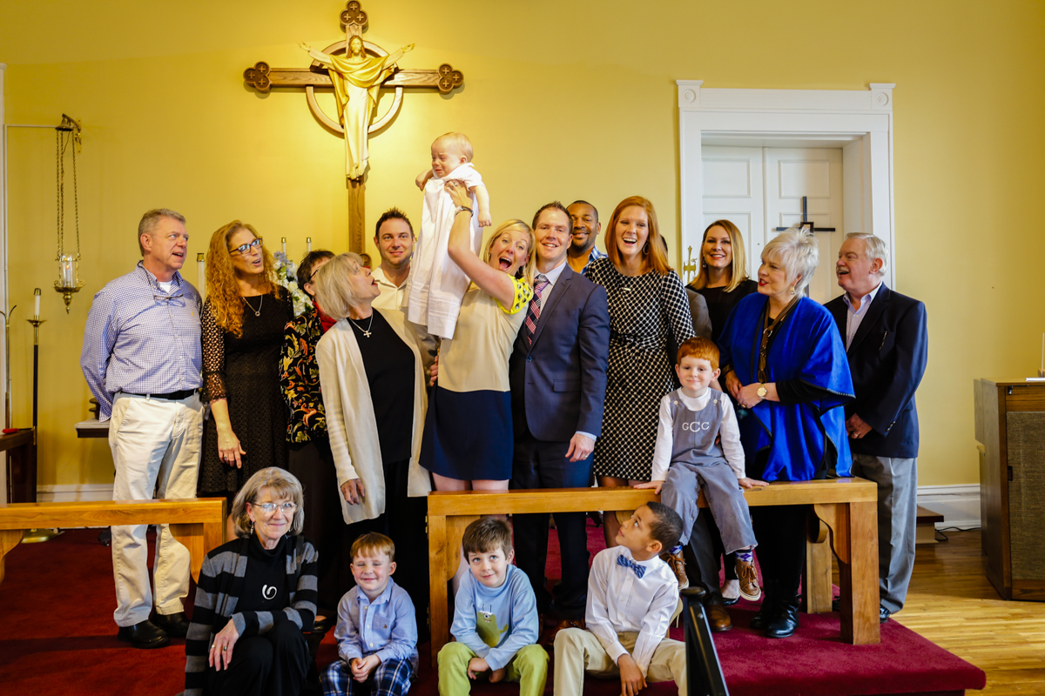

 **Notes on the Daughters of the King.**

We will be meeting at 11:30 on March 11, April 08 and May 13.

The Spring Assembly will be Saturday, April 21 at St. George's in Nashville. The speaker will be

Mia McDowell on a subject of creating sacred spaces. We will be setting up a car pool for those interested. As we get closer speak to Sue or Barbara to coordinate drivers.

**Calendar of Events**

I wanted to share the Google Calendar that has been set up for Redeemer—this will allow you (and new folks!) to integrate our service schedule into their own calendar app, complete with the church address automatically feeding to their Maps app! #accessibility #youngpeople #gettochurch!

The link is below and will be embedded on the website (have you been there recently?

[Calendar URL](https://calendar.google.com/calendar/embed?src=redeemershelbyville%40gmail.com&ctz=America%2FChicago)

[https://calendar.google.com/calendar/embed?src=redeemershelbyville%40gmail.com&ctz=America%2FChicago](https://calendar.google.com/calendar/embed?src=redeemershelbyville%40gmail.com&ctz=America%2FChicago%0c)

[](https://calendar.google.com/calendar/embed?src=redeemershelbyville%40gmail.com&ctz=America%2FChicago%0c)

**Redeemer has Wi-Fi!**

Yes, we now have Wi-Fi. Don’t waste your data when you can use the Redeemer Wi-Fi to check your Facebook page during the sermon. The network name is MySpectrumWifidc-2G. The password is livelytrain055.

##### episcopal sealThe Redeemer community exists to share the power of the Lord Jesus Christ through worship in the Anglican Tradition and through the demonstration of His love in our daily lives.

**Church Office Hours**

**Office Hours:**Thursday 10-12 noon

**Church:** 684-5506

**The Rev. Regan M. Schutz:** 503-915-5755

[motherregan@churchofredeemer.org](mailto:motherregan@churchofredeemer.org)

**PRIEST-IN-CHARGE**

Rev. Regan M. Schutz

**VESTRY MEMBERS**

**Senior Warden:** Jamie Williams

**Junior Warden:** Cliff Hirst

**Clerk:** Rick Francis

**Treasurer:** Garrett Gordon

**Stewardship:** Gary Smith

**Asst Junior Warden:** George Krause

**Music:** Billie Crowell

**Inreach:** Babs Chicoine

**Outreach:** Ardeth Obenauf

**Inreach:** Mary Darwin

**Sextons:** David & Michelle Daley

**Prayer List**

**Members of the Congregation:**

Karen Phillips Barbara Whalen

Michelle Daley Teri and Gary Smith

Joe Hardison Marsha Sharp

Gary Ashley Kelly Reed

Cliff Hirst Garrett Gordon

Bobbie Jean Mason – Friend of Gary Ashley

Nina Gay Segroves – Friend of the Redeemer

Alan Loveman – Friend of Marsha Sharp

Linda York – Friend of Marsha Sharp

Angie Davidson

Brittany Atnip

Bill Yancy

Jerry Jones – Friend of Scott and Alice

Karen – Friend of Mary Darwin

Johney Ingle – Terry’s family

Mitch – Friend of Mary Darwin

The Very Rev.Tracey Lind (Dean of Trinity Cathedral)- Marsha Sharp

David Bearden – Relative of Joe Hardison

Laurita Jordon – Daughter of Laurita Parker

Deb Lenning - Friend of Mary Darwin

Nancy Wagner – Rene’ Francis’ mother

Lee Young – Friend of Cliff Hirst

Vickie Waggoner- Ella Cauble’s God child

Ashley, Miles, and Kay Wagner – Relatives of Ron Obenauf

Linda Lindsey – Friend of Cheryl Richardson

Sue Thetford – Friend of Cheryl Richardson

David Yow – Laurita Parker’s Brother in Law

Phyllis Brown – Cliff Hirst’s Aunt

James McAdams – Michelle Daley’s relative

Bob Garrett – Relative of Billie Crowell

Harvey and Doris Obenauf – Ron and Wanda’s parents

Rhonda Gray – Gary Ashley’s sister

Janice Raines – Friend of Marsha Sharp

Walter Bobo – Friend of Marsha Sharp

Good Samaritan

Women of Grace

Cross Shelter

Participants in the AA Groups that meet here at the Redeemer

Justin Welby - The Archbishop of Canterbury

Michael Curry – Presiding Bishop

John C. Bauerschmidt – Bishop of Tennessee

Regan M. Schutz – Priest in Charge

**Diocesan Cycle of Prayer**

**March**  
**4  Lent III**  
Grace Chapel, Rossview *and*St. Luke’s Church, Springfield  
**11 Lent IV**  
Christ Church, Alto *and* Church of the Holy Comforter, Monteagle *and*Trinity Church, Winchester  
**18 Lent V**  
St. Andrew’s Church, New Johnsonville  
**25 Palm Sunday**  
The Church in Jerusalem

**April**  
**1  Easter Sunday**  
Episcopal Church Women in the Diocese of Tennessee  
**8  Easter II**  
Church of the Resurrection, Franklin *and*St. Andrew’s Sewanee School, Sewanee  
**15 Easter III**  
St. Paul’s Church, Franklin  
**22 Easter IV**  
Church of the Good Shepherd, Brentwood  
**29 Easter V**  
Otey Memorial Parish, Sewanee

**Server Schedule**

|  |  |  |  |  |  |  |
| --- | --- | --- | --- | --- | --- | --- |
| **Date** | **Chalice Bearer** | **Acolyte** | **Reader 1** | **Reader 2** | **Usher** | **Altar Guild** |
| **Mar. 04** | Jamie Williams | Isaac Williams | Ron Obenauf | Sue Morphis | Gary Ashley | Teri Smith |
| **Mar. 11** | Jamie Williams | larry Morphis | Ardeth Obenauf | Ron Obenauf | Laura Williams | Lee Russell |
| **Mar. 18** | Jamie Williams | Isaac Williams | Billie Crowell | Ardeth Obenauf | Cliff Hirst | Gary Ashley |
| **Mar. 25** | Jamie Williams | Rick Francis | Laura Williams | Ella Cauble | David Daley | Rene' Francis |
| **Mar. 29** | Gary Smith | Isaac Williams | Tamra Smith | Laura Williams | Gary Ashley | Teri Smith |
| **Mar. 30** | Marsha Sharp | Teri Smith | Charles Whitaker | Billie Crowell | Laura Williams | Sue Morphis |
| **Apr. 1** | Jamie Williams | Rick Francis | Ella Cauble | Tamra Smith | Cliff Hirst | Mary Carol Palmer |
| **Apr. 8** | Gary Smith | Isaac Williams | Barbara Whalen | Sue Morphis | David Daley | Renee Gordon |
| **Apr. 15** | Marsha Sharp | Larry Morphis | Sue Morphis | Charles Whitaker | Gary Ashley | Lee Russell |
| **Apr. 22** | Jamie Williams | Teri Smith | Ron Obenauf | Ardeth Obenauf | Laura Williams | Gary Ashley |
| **Apr. 29** | Gary Smith | Rick Francis | Ardeth Obenauf | Billie Crowell | Cliff Hirst | Rene' Francis |
| **May. 6** | Marsha Sharp | Isaac Williams | Billie Crowell | Ron Obenauf | David Daley | Teri Smith |
| **May. 13** | Jamie Williams | Larry Morphis | Laura Williams | Tamra Smith | Gary Ashley | Sue Morphis |

***Monthly Events for March 2018***

***\*\*\* you can CTRL+click on the underlined titles to get the readings of the day***

|  |  |  |  |  |  |  |
| --- | --- | --- | --- | --- | --- | --- |
| Sunday | Monday | Tuesday | Wednesday | Thursday | Friday | Saturday |
|  |  |  |  | 1 [Thursday in the Second Week of Lent](http://lectionarypage.net/WeekdaysOfLent/ThursSecondWeek.html) | 2 [Friday in the Second Week of Lent](http://lectionarypage.net/WeekdaysOfLent/FridaySecondWeek.html)  Stations of the Cross 5:00 pm | 3 [Saturday in the Second Week of Lent](http://lectionarypage.net/WeekdaysOfLent/SatSecondWeek.html) |
| 4  [Third Sunday in Lent](http://lectionarypage.net/YearB_RCL/Lent/BLent3_RCL.html)  Holy Eucharist  8:00 am  10:00 am  Good Book Club  9:00am  Vestry 11:30 am | 5 [Monday in the Third Week of Lent](http://lectionarypage.net/WeekdaysOfLent/MondayThirdWeek.html) | 6 [Tuesday in the Third Week of Lent](http://lectionarypage.net/WeekdaysOfLent/TuesdayThirdWeek.html) | 7 [Wednesday in the Third Week of Lent](http://lectionarypage.net/WeekdaysOfLent/WedThirdWeek.html)  Healing Service  Eucharist/Lunch  12:12 pm | 8 [Thursday in the Third Week of Lent](http://lectionarypage.net/WeekdaysOfLent/ThursThirdWeek.html) | 9 [Friday in the Third Week of Lent](http://lectionarypage.net/WeekdaysOfLent/FridayThirdWeek.html) | 10 [Saturday in the Third Week of Lent](http://lectionarypage.net/WeekdaysOfLent/SatThirdWeek.html) |
| 11 [Fourth Sunday in Lent](http://lectionarypage.net/YearB_RCL/Lent/BLent4_RCL.html)  Holy Eucharist  8:00 am  10:00 am  Good Book Club  9:00am  Daughters of the King 11:30 am | 12 [Monday in the Fourth Week of Lent](http://lectionarypage.net/WeekdaysOfLent/MondayFourthWeek.html) | 13 [Tuesday in the Fourth Week of Lent](http://lectionarypage.net/WeekdaysOfLent/TuesdayFourthWeek.html) | 14 [Wednesday in the Fourth Week of Lent](http://lectionarypage.net/WeekdaysOfLent/WedFourthWeek.html)  Healing Service  Eucharist/Lunch  12:12 pm | 15 [Thursday in the Fourth Week of Lent](http://lectionarypage.net/WeekdaysOfLent/ThursFourthWeek.html) | 16 [Friday in the Fourth Week of Lent](http://lectionarypage.net/WeekdaysOfLent/FridayFourthWeek.html)  Stations of the Cross 5:00 pm | 17 [Saturday in the Fourth Week of Lent](http://lectionarypage.net/WeekdaysOfLent/SatFourthWeek.html) |
| 18 [Fifth Sunday in Lent](http://lectionarypage.net/YearB_RCL/Lent/BLent5_RCL.html)  Holy Eucharist  8:00 am  10:00 am  Good Book Club  9:00am | 19 [St Joseph](http://lectionarypage.net/YearABC/HolyDays/Joseph.html) | 20 [Tuesday in the Fifth Week of Lent](http://lectionarypage.net/WeekdaysOfLent/TuesdayFifthWeek.html) | 21 [Wednesday in the Fifth Week of Lent](http://lectionarypage.net/WeekdaysOfLent/WedFifthWeek.html)  Healing Service  Eucharist/Lunch  12:12 pm | 22 [Thursday in the Fifth Week of Lent](http://lectionarypage.net/WeekdaysOfLent/ThursFifthWeek.html) | 23 [Friday in the Fifth Week of Lent](http://lectionarypage.net/WeekdaysOfLent/FridayFifthWeek.html) | 24 [Saturday in the Fifth Week of Lent](http://lectionarypage.net/WeekdaysOfLent/SatFifthWeek.html) |
| 25 [Sunday of the Passion: Palm Sunday](http://lectionarypage.net/YearB_RCL/HolyWeek/BPalmSun_RCL.html)  Holy Eucharist  9:00 am | 26 [Monday in Holy Week](http://lectionarypage.net/YearABC_RCL/HolyWk/HolyMon_RCL.html) | 27 [Tuesday in Holy Week](http://lectionarypage.net/YearABC_RCL/HolyWk/HolyTue_RCL.html) | 28 [Wednesday in Holy Week](http://lectionarypage.net/YearABC_RCL/HolyWk/HolyWed_RCL.html)  Healing Service  Eucharist/Lunch  12:12 pm | 29 [Maundy Thursday](http://lectionarypage.net/YearABC_RCL/HolyWk/MaundyTh_RCL.html)  Service 5:00 pm | 30 [Good Friday](http://lectionarypage.net/YearABC_RCL/HolyWk/GoodFri_RCL.html)  Service 5:00 pm | 31 [Holy Saturday](http://lectionarypage.net/YearABC_RCL/HolyWk/HolySat_RCL.html) [Easter Vigil](http://lectionarypage.net/YearB_RCL/Easter/BEasVigil_RCL.html) |

***Monthly Events for April 2018***

***\*\*\* you can CTRL+click on the underlined titles to get the readings of the day***

|  |
| --- |
|  |
| Sunday | Monday | Tuesday | Wednesday | Thursday | Friday | Saturday |
|  |  |  |  |  |  |  |
| 1 Easter Day [Early](http://lectionarypage.net/YearABC/Easter/EasterEarly.html) [Principal](http://lectionarypage.net/YearB_RCL/Easter/BEasterPrin_RCL.html) [Evening](http://lectionarypage.net/YearABC_RCL/Easter/EasterEven_RCL.html)  Holy Eucharist  9:00 am | 2 [Monday in Easter Week](http://lectionarypage.net/YearABC/Easter/EasMon.html) | 3 [Tuesday in Easter Week](http://lectionarypage.net/YearABC/Easter/EasTues.html) | 4 [Wednesday in Easter Week](http://lectionarypage.net/YearABC/Easter/EasWed.html)  Healing Service  Eucharist/Lunch  12:12 pm | 5 [Thursday in Easter Week](http://lectionarypage.net/YearABC/Easter/EasThur.html) | 6 [Friday in Easter Week](http://lectionarypage.net/YearABC/Easter/EasFri.html) | 7 [Saturday in Easter Week](http://lectionarypage.net/YearABC/Easter/EasSat.html) |
| 8 [Second Sunday of Easter](http://lectionarypage.net/YearB_RCL/Easter/BEaster2_RCL.html)  Holy Eucharist  9:00 am  Good Book Club 8:00 am | 9 [The Annunciation](http://lectionarypage.net/YearABC_RCL/HolyDays/Annunc_RCL.html) (transferred) | 10 | 11  Healing Service  Eucharist/Lunch  12:12 pm | 12 | 13 | 14 |
| 15 [Third Sunday of Easter](http://lectionarypage.net/YearB_RCL/Easter/BEaster3_RCL.html)  Holy Eucharist  9:00 am  Good Book Club 8:00 am | 16 | 17 | 18  Healing Service  Eucharist/Lunch  12:12 pm | 19 | 20 | 21 |
| 22 [Fourth Sunday of Easter](http://lectionarypage.net/YearB_RCL/Easter/BEaster4_RCL.html)  Holy Eucharist  9:00 am  Good Book Club 8:00 am | 23 | 24 | 25 [St Mark, Evangelist](http://lectionarypage.net/YearABC/HolyDays/Mark.html)  Healing Service  Eucharist/Lunch  12:12 pm | 26 | 27 | 28 |
| 29 [Fifth Sunday of Easter](http://lectionarypage.net/YearB_RCL/Easter/BEaster5_RCL.html)  Holy Eucharist  9:00 am  Good Book Club 8:00 am | 30 |  |  |  |  |  |

**Social Media**

**The Redeemer now has a website! Please check it out and subscribe for updates.**

[www.churchofredeemer.org](http://www.churchofredeemer.org)



The Church of the Redeemer is on Facebook!

[*https://www.facebook.com/ChurchOfRedeemer/*](https://www.facebook.com/ChurchOfRedeemer/)

Please like and share with your friends!

**March/April 2018**

**“Sharing the power of Christ through Worship and Love”**

|  |
| --- |
| Newsletter  The Episcopal  Church of the  Redeemer  203 East Lane Street  Shelbyville, TN 37160 |

Newsletter