Volunteer Fire Department
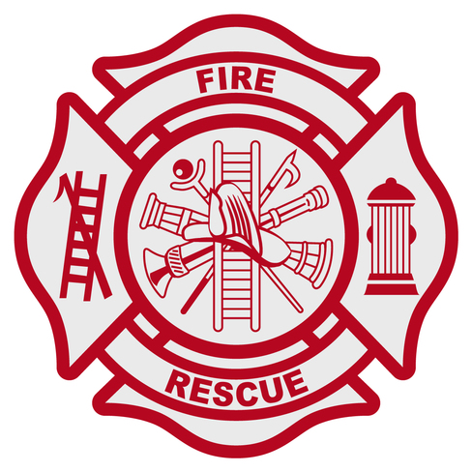
Membership Application

The Marion County Chief’s Association Retention and Recruitment program is a great opportunity for you to help your local fire and emergency services departments as well your community. In order to ensure that your time and talents will be best utilized, fill out the following form and return it to: Marioncountyvfd@gmail.com.

Name Date of Birth: / / ____
Address: City: State: Zip: Phone Number: E-mail:
Driver’s License Number ________________ Education Level: _________________________
Employer: __________________________________________ Length of Employment_______
Job Title: ____________________________________________________________________

Have you ever been convicted of a crime? yes no
If yes, please explain:

Have you ever been a member of a fire department before? ___ Yes __ No
If yes, please provide contact information: ________________________________________________
_________________________________________________________________________________

Are you legally permitted to work in the United States? ____________________________________
Do you have any physical or mental disabilities that we need to be aware of? ____________________
Do you consent to a drug analysis? _____________________________________________________
Do you consent to a background check? _________________________________________________
Do you consent to a driver’s license background check? ____________________________________

Please provide a list of any training you have already completed. _____________________________
_________________________________________________________________________________
_________________________________________________________________________________

Please provide three references with phone numbers: ______________________________________
__________________________________________________________________________________ ___________________________________________________________________________________

Please list any special talents or skills.

Which Fire Department are you interested in joining:_________________________________________________

I have answered all of the above questions honestly and to the best of my ability.

Signature Date

Parent or guardian signature if applicant is under 18 years of age.

Signature Date

On behalf of the Marion County Volunteer Chief’s Association Recruitment and Retention efforts, we would like to thank you for supporting your local fire and emergency services.

