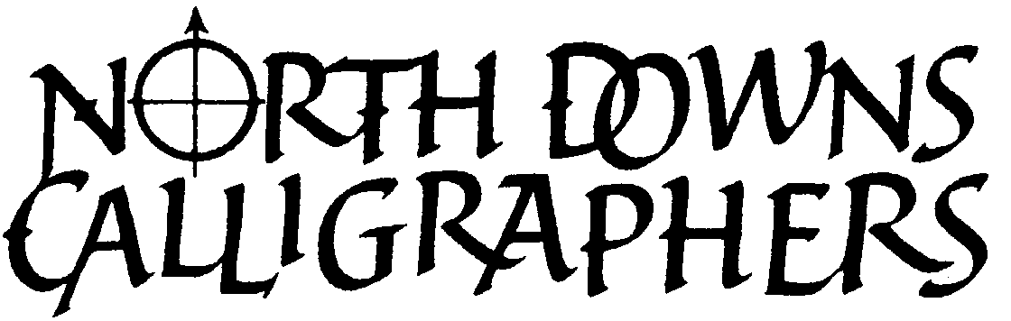 | WORKSHOPS 2022/23  Booking Form

NAME .................................................................................. TELEPHONE .....................................................

E-MAIL DATE SENT

I would like to apply for a place on the workshop(s) I have ticked in the box(es), below.

 | Saturday 12 November 2022  10.00 am - 4pm | Christmas decorations with Uncials £28 / £33  Claire Secrett Honeywood
 | Saturday 21 January 2023  zoom only 10am - 12pm + 2 - 3pm | Mouse Roman £15 / £20  Ann Mason
 | Saturday 25 February 2023  10.00 am - 4pm | Family Tree £28 / £33  Carole Thomann
 | Saturday 1 April 2023  10.00 am - 4pm | Modern Gothic £28 / £33  Julia Baxter
 | Saturday 13 May 2023  10.00 am - 4pm | Tunnel Book £28 / £33  Sophie Artemis

Workshops will run at the St Lawrence Church Hall except Mouse Roman which is online.

Preferred payment option is online with your name as reference to help us identify the payments.
You can schedule the payments to the date of the workshop if you prefer but please let me know.

Online payment Account name: North Downs Calligraphers
Account number: 76892807
Sort Code: 09-01-55

Cheque - Please enclose a separate post-dated cheque, made payable to NDC for the appropriate fee, for each workshop you have requested.

Please return this form by email to northdownscalligraphers@gmail.com
or post (or a handwritten note of your workshop choices) with your cheques to:
Carole Thomann, 7 Oakhill Road, Reigate, RH2 7HA

Refunds will be given only when your place can be filled by another member.
We will confirm by e-mail and send you the Tools and Material lists as attachments.
Please bring a packed lunch and a mug with you. Members are asked to help tidy the hall before they leave. A list of tools and materials to be brought will be sent to you before the date of the workshop. Tea/coffee £1 on the day.
CT 4.11.2022

