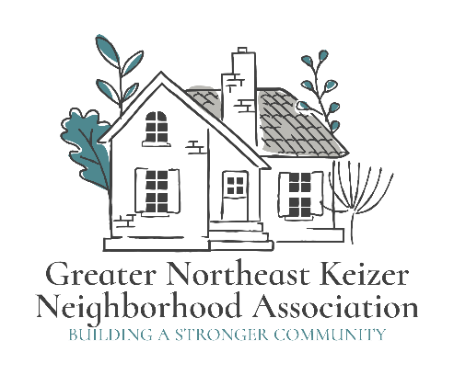

Greater NE Keizer Neighborhood Association November 14th meeting minutes
11/4/2025 Meeting Started at 5:00 P.M to 6pm Board meeting
Zoom Tammy Kunz, Jacqueline Green, Nancy G, Lisa L Lisa L, William, Jackie T, Jean G, Teams Lead by: Thomas D, Nancy G, Jacque T,
Tammy Shared Election in Jan 2026.
Equity statement; GNEKNA is committed to reducing the equity gaps, increasing access for all creating a safe community for Everyone. Safety and belonging for all Keizer residents is vital. We must be inclusive in our policies that protect age, race, gender, sexual orientation, ability and any other individual identities. GNEKNA commits to equity into our fabric which allows us to serve everyone in our community.
Are there any changes we want to make for 2026 Motion from Nancy to leave as is, 2nd came from William and motion carries Unanimously
Next, we covered some of the Multi-Modal projects to focus on. I respectfully ask that the City's Traffic Engineering Department/Public Works Department conduct a traffic study to evaluate the conditions on Keizer Road. Based on the results, I urge you to install proper speed limit signs and consider other traffic calming solutions, such as speed bumps or increased police enforcement.
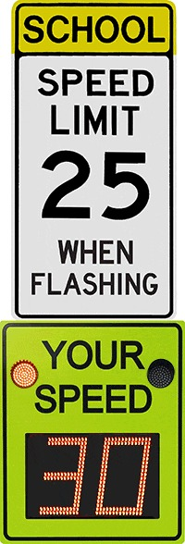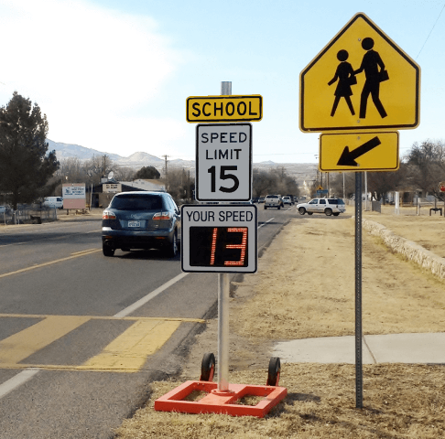
Our goal is to seek this kind of educational sign to inform drivers of the speed. School Zone Signs alert and educate drivers within the school zone. Some of the most critical signs are:
- Speed limit signs announce school zone speed limits, which typically range from 15 to 25 mph.
- School zone advance warning and end school zone signs alert drivers that they are entering or leaving the reduced speed limit area.
- School crossing signs notify drivers of crosswalks.
- Flashers may be installed at speed limit signs or crosswalks to call attention to critical traffic points.
- Radar speed signs (driver feedback signs) alert drivers to their actual speed, remind them of the speed limit and are Scientifically Proven to help reduce speeding.
- Hyper-Alerts™ are compact clusters of flashing LED lights built into the “YOUR SPEED” faceplate of radar speed signs.
William shared this may be a good time for us to follow-up a few months ago. Tammy shared we have a work group working on this kind of project and she is hoping this will be ready in Feb or March to share the progress for feedback.
Meeting ended and we open our reg monthly meeting;

Monthly meeting;
Zoom Tammy Kunz, Jacqueline Green, Nancy G, Lisa L Teams Lead by: Lisa L, William, Jackie T, Jean G, Thomas D, Nancy G, Jacque T, Jacque T Amy L, Nancy G, Lillian, Antonio, Linda M, Karen, Alice T, Alice M, Lisa B, Lizzy, Ken, Thomas K, Rebecca S, Kimberly N, Kevin
Teams Nancy, Williams, Gavin M, Lydia B, Kathleen L, Donna D, Lauria F, Ryan, Barbara, Kevin, Laytoya C, Kimberly H, Kellie, Sorrida came in late, No police, No Fire
Monthly meeting;
Approval Of Minutes; Nancy G motion Jacque G Second Approved Unanimously
Then we discussed our long- & short-term goals. Any changes to them Question was stated we would like to engage more in the long-term goals Sorrida Cross Came in Tammy copied the email Shane from planning about the property on Chemawa and McCloud by Bonaventure. A broad idea of who's doing what to that property.
A question was asked if the CDEC Committee can do something different and have a person at our meeting. Tammy answered she is the CDEC liaison for this group. Then the group said they wanted someone else from the group also to be present. Jane is on the CDEC Committee also. We feel like we don’t matter to the city. Our council liaison is either late or a no show. We want to feel like we belong in this city. So, we can have a voice in this city. These are the things that were said.
We have a planning meeting schedule this month about middle housing. Who is willing to go live to the meeting or listen to it on tv or the internet. It is the 2nd Tuesday of every month. Kellie will watch it.
Who is willing to listen or watch or go to Rebecca for Parks,
Tammy & Jacqueline will do the next planning meeting live.
Jacqueline, can you please do the next Traffic meeting. Yes, I will answer.
The next was Collaboration metric for engagement no changes need to be made
Question on the Traffic Management Plan Are we doing that again. Answered was Yes please send traffic plans to Traffic Bikeway and Pedestrian Committee. And include the City Council.
Everyone in this group is concerned with bikes on Lockhaven coming off Chemawa heading to the Interstate, and speeding on Chemawa and near the roundabout it is about safety. The flag program I know of 5 families has used them. Lisa said she knows 7 from this group. No one they know has used the survey. Please use the survey.
Council Liaison report from Sorrida Garbage service is going up 2% to 4%
The Tree Lighting is Dec 7th the Christmas light Parade is coming up. The Miracle of Lights in Gubser will be coming soon.
Tammy sent us all an email on the fee’s changes
Tammy, we want a warning on this. There is help for this.
Can you please share what's going up near the Chick- A- li? It will be a Marriot Hotel.
Other Business; Tammy reviewed; The main goals for this project are to include promoting literacy and family engagement, encouraging physical activity outdoors, and fostering a love of reading through interactive, community-based experiences.
Here's a more detailed breakdown of potential project objectives:
- Promoting Literacy and Reading Support parent-child interactions and language learning: Literacy walks can encourage parents and children to read together and discuss stories, fostering a love of reading and language development.
- Highlight valuable community resources: Literacy walks can showcase local parks, libraries, and other community spaces, encouraging families to spend time outdoors and explore their surroundings.
- Promote a love of reading: By creating a fun and engaging environment, literacy walks can help children develop a lifelong love of reading.
Tammy looked for more ideas to add into the 2026 year,
Some ideas are back pack buddies for readers; resources with books and activities for those who may fall behind in school.

Meeting adjourned at 7:12 P.M



