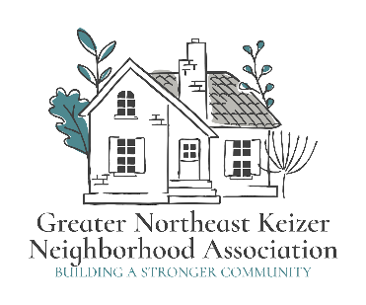
Greater Northeast Keizer Neighborhood Association Meeting Agenda

Date: February 3rd, 2026 Time: 600 pm Location: Online
gnekna.com 503-991-1671 nekna2022@gmail.com Keizeror.org
Join Zoom Meeting
https://us06web.zoom.us/j/89485136753?pwd=kd4H21M7Q24jFbrKFccloPK2m35bCY.1
Meeting ID: 894 8513 6753 Passcode: 934295
- Approval of Minutes
- City Council Update;
- Welcome packet update review
- Marketing Plan update for review
- Focus and Values 2026
- Long range plan for our group review 2026
- Multi-modal work
- Guest speakers
- Goals and Objectives Spreadsheet update
- Annual report work group (Tammy, Jacqueline, Lisa, Nancy)
- Fun Friday July 17th / 24th TBD
- National Night Out Aug 4th 2026
- Safe Street Grant (work group update Meeting)
- Other Business
Next meeting: March 3rd 2026 6pm Join Zoom Meeting
Annual Report (April 13th 2026)

GNEKNW Feb 4th 2026 6:30 pm
https://us06web.zoom.us/j/89485136753?pwd=kd4H21M7Q24jFbrKFccloPK2m35bCY.1
Meeting ID: 894 8513 6753 Passcode: 934295

Equity statement; GNEKNA is committed to reducing the equity gaps, increasing access for all creating a safe community for Everyone. Safety and belonging for all Keizer residents is vital. We must be inclusive in our policies that protect age, race, gender, sexual orientation, ability and any other individual identities. GNEKNA commits to equity into our fabric which allows us to serve everyone in our community.
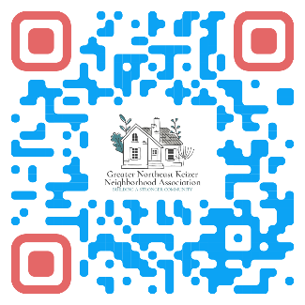
Notes;

