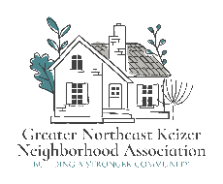 

## Greater Northeast Keizer Neighborhood Association

## Watch Meeting Agenda

**Date:** 1ST Wednesday of each Month June 4th 2025

**Time:** 630 pm **Location:** Online

This meeting will be held the 1st Wednesday of each month @6:30 pm. through Zoom; Join Zoom  
<https://us06web.zoom.us/j/87654418812?pwd=DWiPJosdxanDXlcBaW0qFVaKblUbF4.1>  
Meeting ID: 876 5441 8812 Passcode: 845817

1. Introductions
2. National Night out Planning
3. Block captain reports
4. Goals and objectives: to add to the ongoing spreadsheet for community engagement.
5. Police log of items tracking results cover to see if we want to keep using or tracking
6. Future meeting topics: speakers
7. Other business; Fun Friday 25th 2025

Equity statement; GNEKNA is committed to reducing the equity gaps, increasing access for all creating a safe community for Everyone. Safety and belonging for all Keizer residents is vital. We must be inclusive in our policies that protect age, race, gender, sexual orientation, ability and any other individual identities. GNEKNA commits to equity into our fabric which allows us to serve everyone in our community