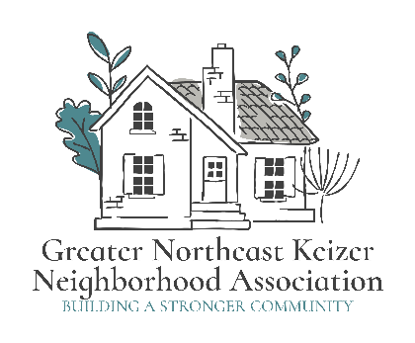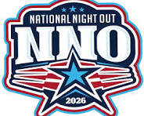

Greater Northeast Keizer Neighborhood Association (GNEKNA)
Contact: gnekna.com | 503-991-1671 | nekna2022@gmail.com

Donation Request: National Night Out 2026
Subject: Support Our Community: Donation Request for National Night Out
Dear [Business Name or Contact Person],
On Tuesday, August 4, 2026, the Greater Northeast Keizer Neighborhood Association (GNEKNA) and Southeast Keizer Neighborhood Association (SEKNA) will join communities across the country in celebrating National Night Out. This annual event is dedicated to promoting public safety, strengthening neighborhood spirit, and fostering positive relationships between residents and local law enforcement.
Our goal is to create a welcoming environment where neighbors can connect, share a meal, and build a stronger sense of belonging. To make this event a success for our local families, we are seeking support from community-minded partners like you.
How You Can Help We are currently looking for donations in the following areas:
- Food and Beverages: Bottled water, sodas, or pre-packaged snacks.
- Prizes and Giveaways: Gift cards, merchandise, or services to be used for our community raffle.
- Activities: Sponsorship of family-friendly entertainment or educational resources.
Why Partner with Us? As a donor, your business will be recognized during the event as a key supporter of Keizer’s safety and community health. It is a fantastic opportunity to showcase your commitment to the residents who live and shop in our neighborhood.
Your contribution no matter the size directly impacts our ability to provide a safe, fun, and inclusive evening for our youth and families.
Next Steps If you are interested in contributing, please contact us by July 9th 2026 so we can include your business in our event coordination. We are happy to arrange a time to pick up any physical donations at your convenience.
Thank you for your time and for everything you do to make Keizer a wonderful place to live.
Sincerely,
The Board of Directors Greater Northeast Keizer Neighborhood Association
Tammy Kunz President; 503-991-1671 Phone /Email : nekna2022@gmail.com Website: gnekna.com

