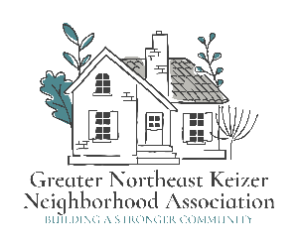

Greater Northeast Keizer Neighborhood Association Newsletter
02/2026 to 03/2026
Quarterly in person meetings  We have the dates set for our in-person quarterly meeting. March 24th 2026, June 23rd 2026, and Sept 22nd, 2026. These meeting will be held at the Keizer Event Center. 930 Chemawa road NE Keizer.  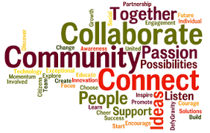  Monthly Meetings Zoom  Join us the 1st Tuesday of each month @ 6:00 pm Join Zoom: Meeting https://us06web.zoom.us/j/89485136753?pwd=kd4H21M7Q24jFbrKFccloPK2m35bCY.1 Meeting ID: 894 8513 6753 Passcode: 934295  nekna2022@gmail.com or 503-991-1671  gnekna.com  Keizer Little League Park Facility Management Agreement is in the works!  The agreement with The Sports Facilities Companies is expected to provide additional transient lodging tax at our local hotels and additional commerce at our local businesses through greater utilization rates.  The financial impact is that we will need to have working capital to begin the operation of the facility. The net yearly impact is $0, but an amount sufficient to keep the operations liquid (i.e. enough to cover expenses and revenues) throughout the year is needed up front. The current financial projection expects a $17,736 profit during the first year.  Working with the City SFC anticipates that $145,000 will provide enough funds to remain liquid. That could come by moving $125,000 of the transient lodging tax currently targeted for the artificial turf fields phase III to the Little League Complex, plus adding the $20,000 already budgeted to the park this year for a capital improvement plan.  The $125,000 will need to be replaced with transient lodging tax from the next fiscal year so that the artificial turf project can be completed. The Keizer Little League Field Complex will have a direct impact on the transient lodging tax collected from the new hotel coming into operation in the next fiscal year, which provides a good rationale for using those funds. More information: keizeror.gov  Keizer Fire District Community Engagement Coordinator!  Maddie Alsum has been hired as Community Engagement Coordinator at Keizer Fire. Her mission is to help strengthen the connection between KFD and the community through public education, outreach, social media and events. She will coordinate volunteer efforts and support safety programs aimed at keeping Keizer residents informed and prepared. Before joining KFD, Ms. Aslum was a Spanish teacher at McNary High School and has experience planning events that bring people together. Welcome to Maddie!  GNEKNA GOALS  Importance Focus 2026  - Membership & Growth: Attracts new residents and retains current members by highlighting benefits like events, safety, and shared interests, ensuring steady revenue and participation.  - Community Building: Connects neighbors, fostering relationships, trust, and a sense of belonging, which encourages residents to help each other.  - Property Value & Appeal: Marketing efforts can address issues like blight, showcase improvements, and attract buyers, combating vacant homes and boosting curb appeal.  - Voice & Influence: A well-marketed association has a stronger, recognized voice to represent residents' interests to city officials and other bodies.  - Sustainability: Consistent engagement and positive messaging fund operations and ensure the association's long-term viability.  Meet the GNEKNA Board!  Tammy Kunz, President  Jacqueline Green, Vice President,  Nancy Grace Secretary  James Jones, Board Member,  Alice Thompson, Board Member,  Lisa Little, Board Member  Catharine Williamson, Board Member,  Jean Greenwood Board member  Rebecca Daniels, Board Member  Message from the Board!  We are members of the community and live and work in our communities who value your voice. We want to provide the support needed to help share concerns, praise for things we are all doing well. Educate for places where we can improve! We are here to serve you and your business, families in the best ways we can!  20 is plenty Campaign!  "20 is Plenty" is a, safe-streets campaign and policy initiative aimed at reducing speed limits in residential, urban, and high-pedestrian areas from 25—30 mph down to 20 mph (approx. 32 km/h). It seeks to improve safety, decrease traffic fatalities, and encourage walking/biking as part of Vision Zero efforts in cities like Portland and Eugene, Oregon. We are joining the fight for safer streets! |  |  | 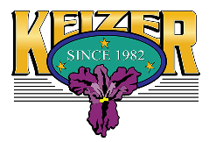
As Bill Lawyer Retires; City of Keizer Announces Keara Blaylock as Public Works Director

The City of Keizer is excited to announce the hire of Keara Blaylock as Keizer’s next Public Works Director, replacing long-time Public Works Director Bill Lawyer, who will be retiring in February of 2026. She will begin with the City on January 20, 2026.

Blaylock has served the City of Keizer Public Works Department, most recently as Public Works Division Manager. In that capacity, she provided leadership, directed division operations, managed environmental permit compliance, and developed both short- and long-range plans aligned with City and departmental goals.
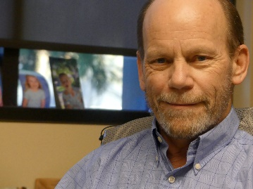

Bill We are going to miss you! Happy Retirement!

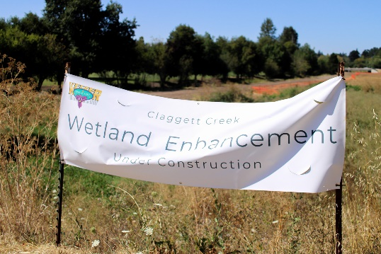

Claggett Creek to get boardwalk as part of wetlands restoration
A new boardwalk will allow pedestrians to stroll along a prime Keizer wetland when finished. The path will stretch from Northeast Chemawa Road to Dearborn Avenue, below the Verda Crossing Apartments.
Importance of Wetlands
Wetlands are vital to the health of wildlife and humans everywhere. They play several important roles, including:
- Flood Control: Wetlands help control flooding by absorbing excess water.
- Supporting Rivers and Streams: They aid the function of surrounding rivers and streams.
- Providing Habitat: Wetlands offer habitat for native plant and animal species.
- Water Purification: They help purify water by filtering out pollutants.
- Erosion Control: Wetlands help control erosion by stabilizing soil.
Wetlands are often restored on land that was previously drained to create agricultural land. The resulting drier land is more vulnerable to invasion by nonnative species. By returning wetlands to these areas, we can make the site less hospitable to invasive species and more welcoming to native species.

Possible Pavilion at KRP
An unspecified “facility” at Keizer Rapids Park is the subject of a current study being conducted by consultants hired by the city to look at the Parks Master Plan. When the plan was updated in 2021, an earlier provision for a facility was omitted. The Master Plan dictates what amenities can be developed in Keizer parks. This year, the facility idea resurfaced in relation to the large tent being rented annually by Keizer Chamber of Commerce for its Keizer Fest. The consultant case study of 7 facility options was reviewed Oct. 14 by the Parks Advisory Board.
Specifications for any KRP facility, including general use, size, location and other issues, are unresolved, along with the question of whether more citizen input is needed. City Council held a short discussion at its Nov. 17 meeting and directed staff to bring more information to the Dec. 1 meeting. At that meeting, Council directed staff to work with the consultants to organize additional public engagement via town hall meetings as well as the City's public media platform to provide more feedback on size, location in KRP and range of uses. A work session and Town Hall are being scheduled!
TOWN HALL; COMMUNITY LISTENING SESSION; Keizer Event Center
The City of Keizer is seeking your input. This is great opportunity to share your thoughts!
6:00 PM; Monday, February 23
You’re invited! Should the City of Keizer add a pavilion at Keizer Rapids Park to the Parks Master Plan and where should it be located?

Police Fee Task Force
Keizer has a group of City Councilors and staff working to fund our Keizer Police Department. They are looking for ways to pick up the short fall and not have a huge impact our communities. We currently pay about $ 6.90 to help fund our Police Department. They have not increased this budget since around 2017. They are looking for ways to increase cost as the cost of living has risen and they have chosen not to add this on to our Keizer families. Now this may have to change to meet the needs. More Infor. @ keizeror.gov

Upcoming Meetings! GNEKNA
We will meet the 1st Tuesday of each month on Zoom.
In person meetings; Keizer Event Center
930 Chemawa rd. NE Keizer
March 24th 6pm; June 23rd 6pm; Sept 22nd 6pm

City meetings!
Keizer City Council regular session 1st and 3rd weeks of each month
Keizer City Council work sessions 2 and 4th weeks of each month as needed.
Keizer Community Diversity Engagement Committee meets the 1st Thursday of each month
Parks meets 2nd Tuesday of each month
Planning meets the 2nd Wednesday of each month
Multi-Modal meets 3rd Wednesday of each month

