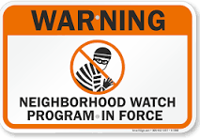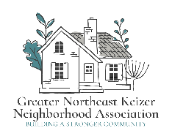
Greater Northeast Keizer Neighborhood Watch Meeting Agenda

Date: 1ST Wednesday of each Month April 1st 2026
Time: 6:30 pm Location: Online
This meeting will be held the 1st Wednesday of each month @6:30 pm. through Zoom; Join Zoom
https://us06web.zoom.us/j/87654418812?pwd=DWiPJosdxanDXlcBaW0qFVaKblUbF4.1
Meeting ID: 876 5441 8812 Passcode: 845817
- Introductions
- Approval of Minutes from March
- Block Captain reports
- Cover Resource item for Binder (NW)
- Multi -Modal Update input for NTMP
- Agenda item E (SKATS PC)
- Members attending or listening to city meetings
- Community Engagement Plan
- Fun Friday July 24th (Community Engagement Plan)

- National Night Out Planning
- Speakers List;
- Other;

Next Meetings: GNEKNA May 5th, 2026
https://us06web.zoom.us/j/89485136753?pwd=kd4H21M7Q24jFbrKFccloPK2m35bCY.1
Meeting ID: 894 8513 6753 Passcode: 934295
GNEK NW May 6th, 2026 2026 6:30 pm
https://us06web.zoom.us/j/87654418812?pwd=DWiPJosdxanDXlcBaW0qFVaKblUbF4.1
Meeting ID: 876 5441 8812 Passcode: 845817

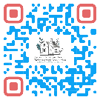

Equity statement; GNEKNA is committed to reducing the equity gaps, increasing access for all creating a safe community for Everyone. Safety and belonging for all Keizer residents is vital. We must be inclusive in our policies that protect age, race, gender, sexual orientation, ability and any other individual identities. GNEKNA commits to equity into our fabric which allows us to serve everyone in our community.
Notes:

