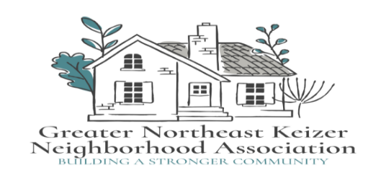

Greater Northeast Keizer Neighborhood Association

Meeting Agenda

**Date:** June 3rd, 2025 **Time:** 600 pm **Location:** Online

Join Zoom Meeting

<https://us06web.zoom.us/j/89485136753?pwd=kd4H21M7Q24jFbrKFccloPK2m35bCY.1>

 Meeting ID: 894 8513 6753                       Passcode: 934295

1. Approval of minutes
2. Checking in
3. City Council Update
4. Keizer Fire update
5. Keizer Planning update
6. Keizer Parks update
7. Traffic/ Bikeways and Peds Update
8. Long range plan for our group

Next Meeting; July is a joint meeting with our Neighborhood Watch for National night out! July 2nd 2025

Join Zoom Meeting

<https://us06web.zoom.us/j/89485136753?pwd=kd4H21M7Q24jFbrKFccloPK2m35bCY.1>

 Meeting ID: 894 8513 6753                       Passcode: 934295

Notes;

Equity statement; GNEKNA is committed to reducing the equity gaps, increasing access for all creating a safe community for Everyone. Safety and belonging for all Keizer residents is vital. We must be inclusive in our policies that protect age, race, gender, sexual orientation, ability and any other individual identities. GNEKNA commits to equity into our fabric which allows us to serve everyone in our community