Greater Northeast Keizer Neighborhood Association

[genkna.com](http://genkna.com)

[nekna2022@gmail.com](mailto:nekna2022@gmail.com)

503-991-1671

 GNEKNA Community Update **Newsletter update; August and September 2025**



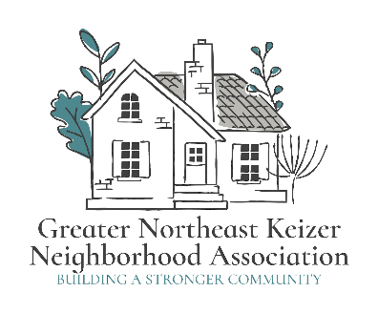                           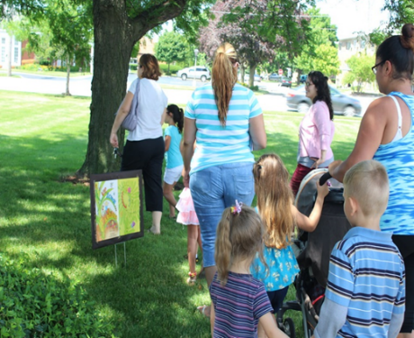

**Story Walk**

Story Walks promote early literacy, physical activity, and family time together in nature.  They are also an opportunity to reach community members who may not come to the library. The Greater N.E Keizer Neighborhood Association is focusing on Story Walks throughout our Keizer Community. We are featuring these books and there may be others soon: Let's Eat by Pat Mora: Plantos Go with Everything by Lissette Norman; Ten Ways to Hear Snow Written by Cathy Camper. Kennedy Elementary and surrounding Community.

<https://forms.gle/WvNBUcRTYh93x3GH6>

**Story walks August 2nd 2025; 11:30 @980 Chemawa rd. Ne. Keizer**

**Story time 10:30am with Keizer Community Library; then join us for a walk in the park with a Story Walk! 980 Chemawa RD. N.E. Keizer, Or.**

**Neighborhood Watch Program**

Neighborhood Crime Prevention: A Joint Responsibility

The prevention of crime, particularly crime involving residential neighborhoods is a responsibility that must be shared equally by law enforcement and private citizens. The fact is, the impact on crime prevention by law enforcement alone is minimal when compared with the power of private citizens working with law enforcement and with each other.

For more information; [gnekna.com](http://gnekna.com)

**Hello, Community**

Neighborhood Watch is a very effective program to prevent many crimes such as burglaries, assaults, and drug dealing. Neighborhood Watch promotes awareness that will help ensure the safety of you, your loved ones, and your neighbors. I want to see if there is interest in joining our Neighborhood Watch group. I hope you will join us online. The 1st Wednesday of each month at 6:30pm

[**keizerneighborhoodwatch1@gmail.comail.com**](mailto:keizerneighborhoodwatch1@gmail.com)

<https://us06web.zoom.us/i/87654418812?pwd=DWiPJosdxanDXIcBaWOqFVaKblUbF4.1>

Meeting ID: 876 5441 available to attend. 971-701-3008

  503-991-1671

**We will be hosting a National Night Out with SE Keizer Neighborhood on August 5th at Keizer Elks Lodge at 4250 Cherry Ave. From 6 p. m to 8 p. m** Please come and join us. We will have the Keizer Fire & Keizer Police there. We will have food and refreshment and kids’ games, snow cones. Plus, there are other National Night Out Celebrations in the Greater N. E Keizer Neighborhood. Come and join us. Get to know your neighbors and others in the community.

**Be aware of this**

The Verda Lane project from SKATS [Salem Keizer Area Transportation Study] is still in the works. So please be aware of this. It will be about ¾ of a mile on Verda Lane. It will be with bike lanes, sidewalks, an intersection realignment and storm water improvement.

**And still be aware of the Center Street Bridge Project.**

It will begin soon. It will close down lanes. For those who go to West Salem Clinic, The Beaches, Or have any other business. It will make it difficult to get there. They are working with ODOT on this. We will let you know more in another Newsletter. When we get more information.

**The Gold Star Memorial**. Is still in the process of being completed. At Ryan J. Park. In Keizer Station. Ground was broken for it.

Effective immediately by order of the Public Works Director: Fires, open flames and charcoal barbecues are prohibited at all times in all areas of the parks. Propane barbeques are allowed for cooking purposes only. This restriction shall remain in effect until further notice.

**Keizer City Council Approves Contract for Claggett Creek Wetland Enhancement Project.** The City Council has approved a contract with K& E Excavating INC. for the Claggett Creek Wetland Enhancement project. It is a major step towards improving local water quality, restoring natural floodplain functions by removing artificial barriers, enhancing native wildlife habitat, expanding passive recreation opportunities and supporting educational programming. The project site encompasses 5.78 acres of the city-owned property along the east side of Claggett Creek between Chemawa Road and Dearborn Avenue. Construction has begun and will be completed in November 2025