Who We Are & What We Stand for!
Neighborhood associations play an integral part in the civic life of Keizer, Oregon. Officially recognized by city ordinance to represent nearly every square foot of our city, we are independent, grassroots groups supported by the city government but driven entirely by residents like you.
Our Community Impact:
When neighbors collaborate, real change happens right where we live. Through volunteer dedication and partnership with the City of Keizer, our association directly impacts our neighborhood's safety, livability, and connection.
Traffic & Pedestrian Safety: We actively submit Neighborhood Traffic Management Plans (NTMP) to advocate for traffic-calming devices, safer sidewalks, and crosswalk visibility to protect our families and school zones.
Fostering Community Spirit: From hosting vibrant National Night Out gatherings to multi-cultural celebrations, we organize events that build lasting friendships and cross-cultural unity.

Meeting Schedule & Details
Date: Tuesday, September 15, 2026
Time: 6:00 PM – 8:00 PM In-Person: Join us at the Keizer Event Center (930 Chemawa Rd. NE, Keizer).
Virtually: Join us remotely via Zoom using the link below.
Time | Segment
6:00 PM – 7:00 PM | Neighborhood Association Meeting  Community updates, local projects, and open discussion.
7:00 PM – 8:00 PM | Neighborhood Watch Meeting  Public safety updates, neighborhood coordination, and crime prevention strategies.

How to Join via Zoom:
Join Zoom Meeting
https://us06web.zoom.us/j/82240780565?pwd=9EJ3BMgi9tJ0uNyJ9UUOOgGKE1Xwco.1

Meeting ID: 822 4078 0565
Passcode: 087191

Mission; Your voice matters and when you cannot speak, we do this for you and with you, as you are not alone. The Greater Northeast Keizer Neighborhood Association (GNEKNA) exists to advocate for, protect, and improve the quality of life for everyone who lives, works, and plays in our neighborhood.

What We Do:
- Advocate & Influence: We advise on city planning and ensure our neighborhood's unique voice directly influences the decisions made by the Keizer City Council and local government.
- Listen & Educate: We provide an open forum to listen to community concerns, share updates on issues affecting our neighborhood, and keep residents informed.
- Connect & Build: We work continuously to enhance local amenities and organize community activities that bring neighbors together.
Come and Join us;
GNEKNA meeting the 1st Tuesday of each month 6:00 pm Join Zoom Meeting https://us06web.zoom.us/j/89485136753?pwd=kd4H21M7Q24jFbrKFccloPK2m35bCY.1
Meeting ID: 894 8513 6753 Passcode: 934295
Contact Information: Tammy Kunz
503-991-1671
nekna2022@gmail.com or gnekna.com

Together, We Work to:
Prevent & Reduce Crime: Active neighbors create a watchful, secure environment.
Enhance Our Community: We strive to develop a cleaner, safer, and healthier neighborhood.
Foster Communication: We provide a platform for open discussion and shared solutions.
Empowering Neighborhood Safety: By revitalizing our Neighborhood Watch programs and collaborating with local law enforcement, we give residents the tools to prevent crime block by block.
Safety is a Shared Responsibility
People like you are what make a community safety program successful. Your neighbors need your help, and you need theirs. The small steps you take today build a strong community spirit, paying big dividends down the road by keeping all of us safer and more secure.


Block Captain; Assists the chairperson in passing information to and from the residents on their block. Keep in touch with the chairperson.
A co-block captain for a Neighborhood Watch program helps organize and communicate with neighbors. They work with the block captain to keep the program active and to help prevent crime in the neighborhood.

Are always needed!

Join us 1ST Wednesday of each Month
Time: 630 pm Location: Online
https://us06web.zoom.us/j/87654418812?pwd=DWiPJosdxanDXlcBaW0qFVaKblUbF4.1
Meeting ID: 876 5441 8812
Passcode: 845817

Contact information: Tammy Kunz
503-991-1671
keizerneighborhoodwatch1@gmail.com
gnekna.com

Meeting ID: 822 4078 0565
Passcode: 087191

Greater Northeast Keizer Neighborhood Watch

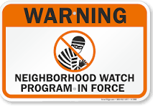

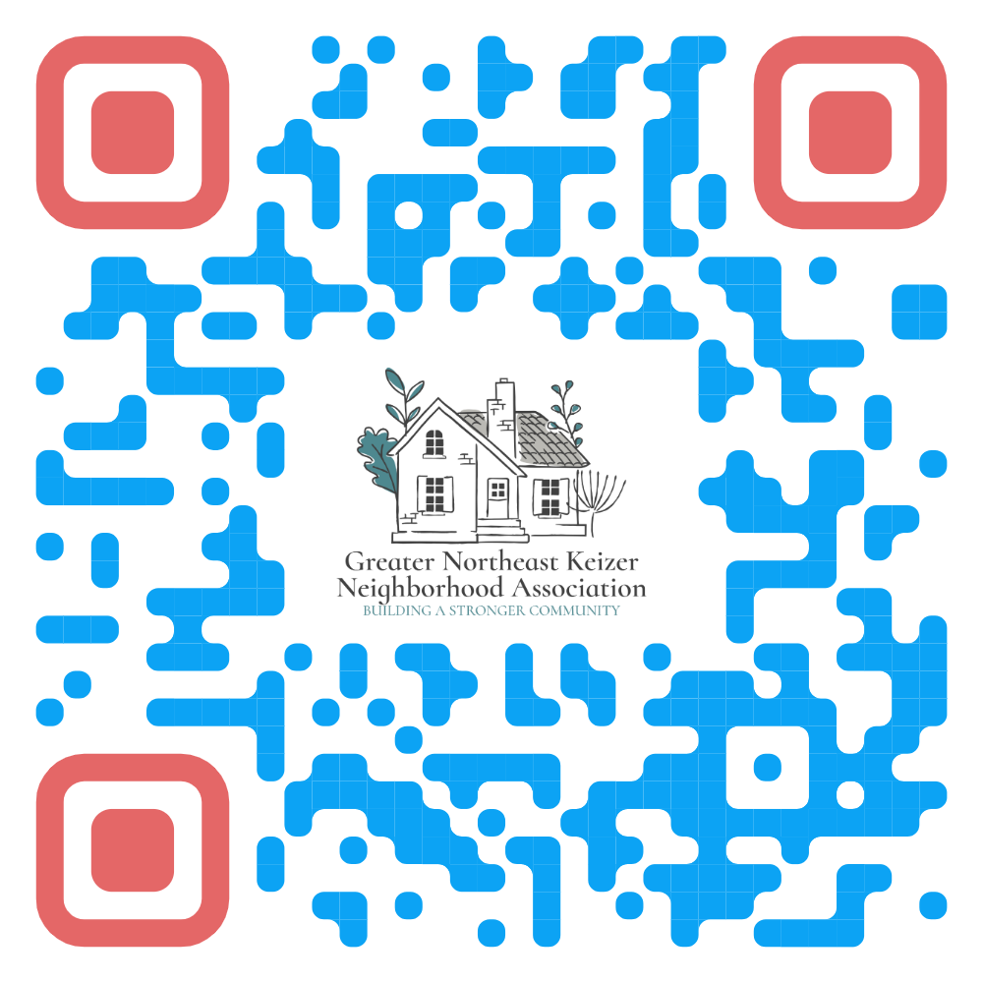

Greater Northeast Keizer Neighborhood
Association
