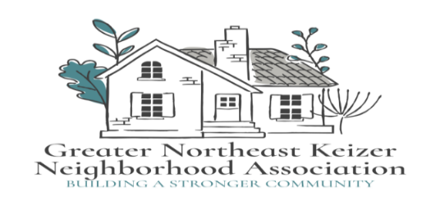

Greater Northeast Keizer Neighborhood Association

Meeting Agenda

**Date:** April 1st, 2025 **Time:** 600 pm **Location:** Online

Join Zoom Meeting

<https://us06web.zoom.us/j/89485136753?pwd=kd4H21M7Q24jFbrKFccloPK2m35bCY.1>

 Meeting ID: 894 8513 6753                       Passcode: 934295

1. Approval of Minutes (Feb minutes and work session notes)
2. Keizer Fire update (Hector)
3. City Council Update (S. Cross)
4. Books club; Advocacy in Action: 9 Practical Actions for Allies in Social Justice by Raymond White
5. Getting Kids back to school; Pilot Program
6. Traffic/ Bikeways and Peds Update (Matt Myers)
7. Long range plan for our group
8. CDEC update; Call for Engagement (Jane)
9. Public Art policy for art in our parks

* Neighborhood Watch Program
* Look at our Goals and Project Evaluation

Next Meeting; May 6th 2025

Join Zoom Meeting

<https://us06web.zoom.us/j/89485136753?pwd=kd4H21M7Q24jFbrKFccloPK2m35bCY.1>

 Meeting ID: 894 8513 6753                       Passcode: 934295

Notes;

Equity statement; GNEKNA is committed to reducing the equity gaps, increasing access for all creating a safe community for Everyone. Safety and belonging for all Keizer residents is vital. We must be inclusive in our policies that protect age, race, gender, sexual orientation, ability and any other individual identities. GNEKNA commits to equity into our fabric which allows us to serve everyone in our community