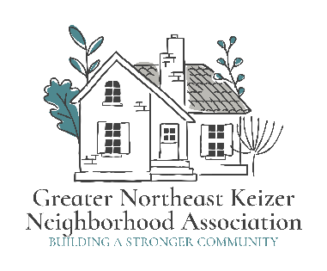 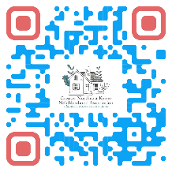 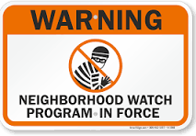

Greater Northeast Keizer Neighborhood Association and

Greater Northeast Keizer Neighborhood Watch

[keizerneighborhoodwatch1@gmail.com](mailto:keizerneighborhoodwatch1@gmail.com)

[nekna2022@gmail.com](mailto:nekna2022@gmail.com) and [gnekna.com](http://gnekna.com)

503-991-1671

**Date:** Aug 12, 2025 **Time:** 600 pm **Location:** ELKS

People in Attendance; Tammy Kunz, Jacqueline Green, Andi from Elks, Tony from Elks, Colleen, Don, Jessica, Korina, one other guest.

* National Night out results from SEKNA Partnership

The total number for this event is about 557 people who GNEKNA counted! GNEKNA 1100 flyers given out!

What did we do right?

For the 1st partnership with this event, it went really well. We had 12 partners who had set up for information, they were all happy to be part of this event. We had enough things to do and people seemed happy to have this joint gathering.

What do we need to do differently?

Communication for partners, making sure they have canopies and items to hold the canopies from wind. We also talked about having a water station for bottled water, places for a picnic area for families to sit and relax while kids play games, eat and just time to talk to one another. One thing is to have another generator for items that need power so we have back up, as well as backup for cooking area. Add other community Partners to join us next year. Start planning earlier for this event was suggested by SEKNA as Partnering.

Better ways to track families; create a sheet to help identify school and number of people in the family is one of the things we are going to create for partnering with other groups. We also talked about creating a pass port and using this as a way to receive a raffle ticket when you visit booths get a stamp and then 20 minutes before raffle turn it in and receive an extra ticket. This will also help track families and have a place on the pass port to count number in the family and school which is being served.

Leave more space available for police and fire to access in and out better for on call services.

GNEKNA Cost: $900.00 for resource kits and raffles and supplies donated that were not donated. Each resource kit had a number of resources and books, one for reading and an activity book, fidgets and other items for kids. $400.00 was a grant from Keizer untied to help with our event. This was a great help on gathering books and activity books for resources kits, as well as candy and fidgets and other items. We also used this funding to order 3 games, ring toss, and bean bag can game and small corn hole came. These items we will use at other events.

Kits or bags; resources

Distracted driving English and Spanish flyer (KPD), Center for hope and safety flyer, Early Learning Hub flyer, 988 (Marion Co), Mental health Awareness information (Marion Co. and GNEKNA), Slap bracelets for kids (GNEKNA), Fidgets; Bracelets ( GNEKNA), Stickers ; Chalk  ( GNEKNA), Book; Activity book ( GNEKNA), Back to school items ( GNEKNA), Liberty house flyer, Safe routes to school flyer, GNEKNA flyer Information  ( GNEKNA), Pop its ( GNEKNA), Valor mentoring flyer, Keizer Cert resources for emergencies a special thank you goes out to all these partners this was truly a partnership from love and concern to help share resources to all the community. s

Feedback from ELKS; They would like us to do this again. They also would like more community partnerships to join and for us to spread out for better access to each both. They enjoyed the farmers market style and would like to continue this style. Andi and Tony talked about adding extra space for next year and getting larger cones to keep other people away from play area better. Better outreach to communities for this event.

* Community Feedback; We heard from folks would like to have bottles of water, Bathroom access outside for our kids, games should be better placed; More partners; Places to sit for food with our families; flow of tables needs to be better to move from one to another, (each one in a parking place). Better access for slushy machines and not running out of power. Covering for each partner to protect from Sun and share the wind picks up for was to hold down covering. Better community communication. We live in this community and did not know of this until we walked by.

 Number of Sausages / chips served? We served about 120 plates of food with chips.

Ø   Neighborhood Watch Program we added 25 new people who want to learn more and attend meetings.

GNEKNA story walk 67 responses to our story walk on Everything goes with Platanos. They very from we love it and would like to see more story walks. (47)

20 people shared this was the first walk and they would attend more for another language other than English and Spanish.

What we can do different? 12 would like better placement of the story boards to allow more space between them.

15 said no changes needed other than more books and it was great.

22 Said they would like to see activities around the story topic or a craft.

All 67 said they would attend more story walks.

Ø   Looking at National night out! **Aug 4th 2026**