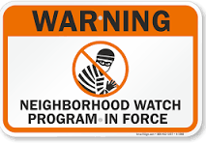
Greater Northeast Keizer Neighborhood Watch
503-991-1671 gnekna.com
keizerneighborhoodwatch1@gmail.com

Date | Time | Offense | Address | Neighborhood Association | Source

