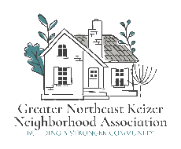 

## Greater Northeast Keizer Neighborhood Association

## Neighborhood Watch

This meeting will be held the 1st Wednesday of each month @6:30 pm. through Zoom;



Join Zoom

<https://us06web.zoom.us/j/87654418812?pwd=DWiPJosdxanDXlcBaW0qFVaKblUbF4.1>

Meeting ID: 876 5441 8812 Passcode: 845817

For more information; Tammy Kunz 503-991-1671

Email; keizerneighborhoodwatch1@gmail.com