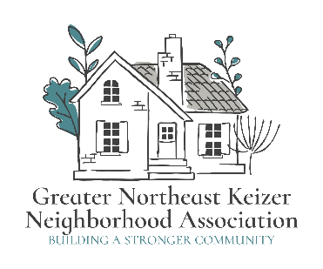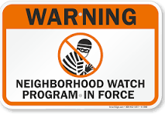
Greater Northeast Keizer Neighborhood Association
Greater Northeast Keizer Neighborhood Watch Meeting Agenda
Date: January 6th, 2026 Time: 600 pm Location: Online
Join Zoom Meeting
https://us06web.zoom.us/j/89485136753?pwd=kd4H21M7Q24jFbrKFccloPK2m35bCY.1
Meeting ID: 894 8513 6753 Passcode: 934295
- Approval of Minutes
- Cover layout of NW Log
- Cover Little League Contract
- Welcome packet update
- Market Plan update for review
- Long range plan for our group
- Goals and Objectives Spreadsheet
- Document update layout; Newsletter, Projects and Goals, Neighborhood Watch program, and agenda (February)
- GNEKNA and GNEKNW meeting schedule (Jacqueline)
- Annual report work group (Tammy, Jacqueline, Lisa, Nancy)
- Safe Street Grant (February Meeting)
Next meeting Feb 3rd 2026 6pm Join Zoom Meeting
GNEKNW Feb 4th 2026 6:30 pm
https://us06web.zoom.us/j/89485136753?pwd=kd4H21M7Q24jFbrKFccloPK2m35bCY.1
Meeting ID: 894 8513 6753 Passcode: 934295
Equity statement; GNEKNA is committed to reducing the equity gaps, increasing access for all creating a safe community for Everyone. Safety and belonging for all Keizer residents is vital. We must be inclusive in our policies that protect age, race, gender, sexual orientation, ability and any other individual identities. GNEKNA commits to equity into our fabric which allows us to serve everyone in our community.
Notes;

