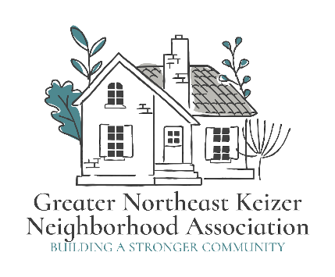
Greater Northeast Keizer Neighborhood Association
gnekna.com
503-991-1671
nekna2022@gmail.com

A long-term vision for our community is a vital step in guiding the future growth and success of Our Neighborhood Association (NA). A well-crafted vision not only provides a sense of direction but also inspires and unites residents towards common goals for our community.
The Greater Northeast Keizer Neighborhood Association is part of a community long-term strategic plan.
- Infrastructure and Capital Improvements
  - Establishing a timeline for road repairs, sidewalk replacements, or community gathering spaces renovations.
  - Budgeting for new amenities, such as better parks, roadways, pickleball courts, or walking trails.
- Technological Upgrades
  - Enhancing communication platforms with a community app or upgraded website.
  - Installing security cameras, or other technology to improve safety.
- Emergency Preparedness
  - Creating a disaster response plan to address events like droughts, wildfires, natural disasters or power outages.
  - Stocking emergency supplies for shared community spaces.
- Environmental Sustainability
  - Implementing water conservation measures, such as drought-resistant landscaping or smart irrigation systems.
  - Investing in renewable energy sources, like solar panels for community buildings or parking structures.

Long-term strategic planning is an invaluable tool for a community, and Neighborhood Association that is looking to ensure the longevity and prosperity of its community. By focusing on future needs, financial preparedness, and proactive governance, a community association can navigate challenges effectively while enhancing the quality of life for the community members. Ultimately, a well-thought-out strategic plan not only protects property values but also builds a strong, cohesive community that community members are proud to call home.

How will this be done?
A long-range plan for a Neighborhood Association involves defining vision, assessing needs (via surveys/meetings), setting prioritized goals (short & long-term), creating actionable steps with budgets & timelines, and ensuring regular review and transparent communication, focusing on community engagement to build credibility for sustainable improvements like asset maintenance, safety, and upgrades.
Tracking our meeting and events will share results;
Measure and Optimize:
- Listen to member feedback: Regularly assess what members need from the association and ensure your offerings align with their needs.
- Share valuable content: Provide information relevant to your community, such as news, updates, educational resources, or even lighthearted posts that foster community engagement.
- Track key metrics: Monitor email open rates, event registrations, new member acquisition, and member retention rates to measure your marketing success.

- Refine our strategy: Use the data you gather to identify areas for improvement and maximize your return on investment.
Community Engagement using Multiple Marketing Channels:
- Social media: Use platforms like Facebook, Next-door, or Instagram to share news, promote events, and connect with residents.
- Email Marketing: Utilize emails to keep members informed, personalized communications, and for targeted outreach.
- Website: Ensure your website is mobile-friendly, easy to navigate, and contains relevant information.
- Community Events: Host or sponsor events to raise awareness and connect with residents in person.
- Local media: Utilize local newspapers, radio stations, or community websites to reach your target audience.
- Direct Mail: Consider using flyers, newsletters, or promotional products to reach residents in your local area.
- Partnerships: Collaborate with local businesses or other organizations to leverage shared resources and networks.
By consistently implementing these strategies and engaging with our community, our Neighborhood Association can build a strong brand, increase membership, and foster long-term loyalty and support.
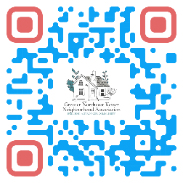

Equity statement; GNEKNA is committed to reducing the equity gaps, increasing access for all creating a safe community for Everyone. Safety and belonging for all Keizer residents is vital. We must be inclusive in our policies that protect age, race, gender, sexual orientation, ability and any other individual identities. GNEKNA commits to equity into our fabric which allows us to serve everyone in our community.

