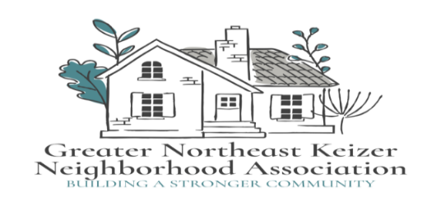

Greater Northeast Keizer Neighborhood Association

Meeting Agenda

**Date:** March 4th, 2025 **Time:** 600 pm **Location:** Online

Join Zoom Meeting

<https://us06web.zoom.us/j/89485136753?pwd=kd4H21M7Q24jFbrKFccloPK2m35bCY.1>

Meeting ID: 894 8513 6753 Passcode: 934295

* Approval of Minutes

1. City Council Update
2. Keizer Fire update
3. Keizer Planning update
4. Keizer Parks update
5. Traffic/ Bikeways and Peds Update
6. Long range plan for our group

* Neighborhood Watch Program
* Look at our Goals and Project Evaluation
* State of the City with Mayor Clark (March 13th 2025)

Next meeting; April 1st 2025 6pm

Join Zoom Meeting

https://us06web.zoom.us/j/89485136753?pwd=kd4H21M7Q24jFbrKFccloPK2m35bCY.1

Meeting ID: 894 8513 6753 Passcode: 934295

Equity statement; GNEKNA is committed to reducing the equity gaps, increasing access for all creating a safe community for Everyone. Safety and belonging for all Keizer residents is vital. We must be inclusive in our policies that protect age, race, gender, sexual orientation, ability and any other individual identities. GNEKNA commits to equity into our fabric which allows us to serve everyone in our community

Notes;