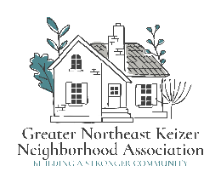 ****

GNEKNA NW Meeting Minutes; for Dec 18th 2024

People in Attendance: Ben, Beverly, Lizzy, Ken, Lillian, Antionio, Linda M, Karen, Alice T, Lisa, James D, Shawn, Thomas M, Nancy B, Jackie T, Jean G, Tammy Kunz and Jacqueline Green.

For all of you who could not make it, we are sorry and hope you will sign up and join our committee.

We covered a number of concerns:

* Break-ins Speeding Child Safety
* Dogs Parking Issues Teens Destroying Personal Property.

Here are some of the solutions we came up with:

1. Kids and Speeding -

* Please Write Down
* Description of the Car
* License Plate Number

Give it to the Our Keizer Police department or point of contact for the Neighborhood Watch Program

We Will Address Each One.

2. Lighting

* We are Working on Getting a Bulk Prices on Outdoor Solar Sensor Lights.
* You Can put them on the Back of Your Homes to Promote Safety and Detour Crime.

3. Zoom link

This meeting will be held the 3rd Wednesday of each month @6:30 pm. through Zoom; Join Zoom Meeting

https://us06web.zoom.us/j/87654418812?pwd=DWiPJosdxanDXlcBaW0qFVaKblUbF4.1

Meeting ID: 876 5441 8812 Passcode: 845817

This link will stay the same for the next year and I will look into keep this as our link from this point on.