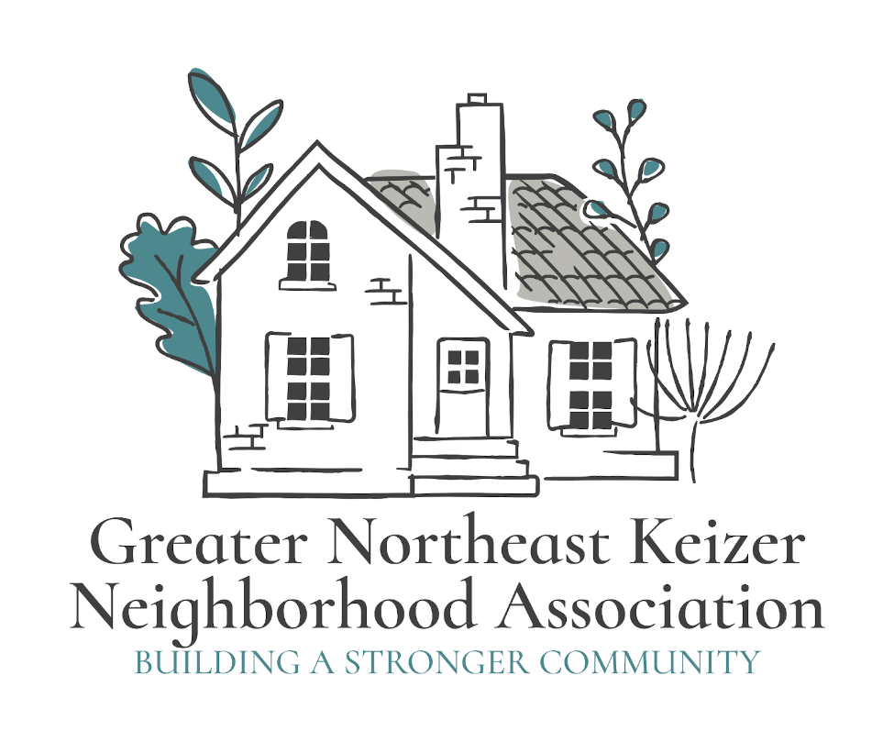

GNEKNA

Greater Northeast Keizer Neighborhood Association
Website; gnekna.com Email: nekna2022@gmail.com
Phone; 503-991-1671 or 971-701-3008

President: Tammy Kunz Vice President: Jacqueline Green
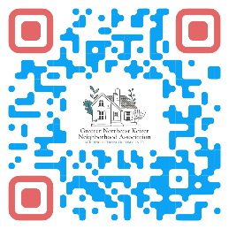
Greater Northeast Keizer Neighborhood Association;
Greater Northeast Keizer Neighborhood Association focuses on enhancing livability, safety, community connection, and civic engagement, guided by values like spirit, pride, volunteerism, inclusion, and trust, acting as a bridge to local government.
Neighborhood-specific concerns like development, public spaces, and quality of life. Key goals include fostering neighborly relationships, improving public areas, promoting responsible growth, and providing a unified voice to the City of Keizer. Neighborhood Associations offer a place to meet friends, exchange information, create projects and priorities, propose solutions, and have time to build stronger community connections.
Our Neighborhood Association was formed based on the needs and desires of its residents. The association will give residents a forum to discuss common concerns and to brainstorm possible solutions. Some potential outcomes may be: improved street lighting, bike paths, sidewalks, traffic calming devices, parks and open spaces, zoning and land-use planning, park amenities, beautification projects and neighborhood clean-ups. Many neighborhood associations have summer picnics, holiday parties and other special events in order to have fun as well as to keep the lines of communication open with their neighbors.
Core Focus Areas
- Civic Engagement: Informing residents about city issues and encouraging participation in local government.
- Advocacy & Communication: Serving as a channel for resident input to city officials and advocating for neighborhood-friendly development.
- Community Building: Organizing events (picnics, clean-ups) to connect neighbors and create a friendly atmosphere.
- Quality of Life: Addressing issues like public safety, nuisance concerns, and enhancing public spaces and amenities.
- Neighborhood Identity: Protecting and promoting the unique characteristics and history of the area.

Key Values
- Trust: Building community trust and strong relationships.
- Livability: Promoting a high quality of life through good planning and resources.
- Spirit & Pride: Celebrating community identity and accomplishments.
- Volunteerism: Encouraging resident participation in initiatives.
- Inclusion & Equity: Ensuring all residents (renters, owners, diverse backgrounds) are welcome and represented.
- Sustainability and Resiliency: Long-term viability and balancing present needs with future needs. Resource conservation, reducing environmental impact, and economic viability for lasting benefit.
- Connected and Resilient Infrastructure: Roadways and vehicles that communicate to manage traffic flow, reduce congestion, and adapt to flooded routes.
- Protecting our Culture and heritage: This includes acknowledging and incorporating diverse perspectives, including Indigenous history and more recent cultural additions to the community.

